Java Full Stack Development
Phase 1
Agile
GIT
MYSQL
HTML
CSS
Javascript
Angular
Cucumber

SDLC
Software Development Life Cycle - it is a process used by software industries to design, develop, test and maintain applications
Agile model
- It is an iterative and incremental model
Agile principles
- Customers don’t have to wait for long time because they get the features early
- You will develop, test and release only a few features to the customers
- Changes can be done at the earlier stage based on the customer’s feedback.
- Standup meetings between the customers, business analysts, developers and testers
Benefits
- Releasing the features early - weekly
- Changes are allowed in the middle
- Good communication between the teams
Challenges of Agile
- Inadequate documentation
Scrum
- It is a framework that follows agile principles
Scrum includes group people
- Product owner - gathers requirements and accept/reject the features
- Scrum master - ensures everyone follows agile
- Developers
- QA
Scrum events
- Daily standup meetings
- Sprint planning
- Sprint review
- Backlog refinements
Jira:
It is a tool used by software and business teams for project management.
Scrum terms
- User stories
- User stories acceptance criteria
Example of user stories on product catalogue
- As a customer, I want to filter products by category, price range and brand
- As a customer, I want to sort products based on ratings
GIT
It is a distributed version controlling system that can remember every change made by the user, it also helps users to collaborate other user work
Pre-requisites
- Git hub account
- Git bash
Installing Git bash -> Just follow the steps
git init : It initializes the folder as a git repository so that it can track the changes.
You need to configure name and email to commit the changes and also you need to authorize to push the changes to the remote repository
To configure the user
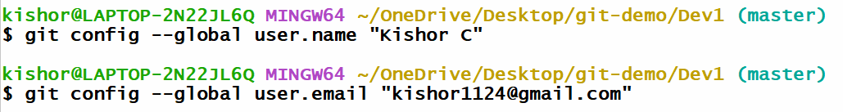
To push the changes to the remote repository, git bash must know the repository should be uploaded to which remote repository
Command to push the changes to the remote
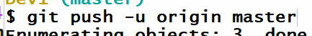

Summary
- touch b.txt
- git add b.txt
- git commit -m ‘second commit’
- git push -u origin master

Git clone: it is used to clone the remote repository to the local machine
command: git clone <<remote-repo-url>>
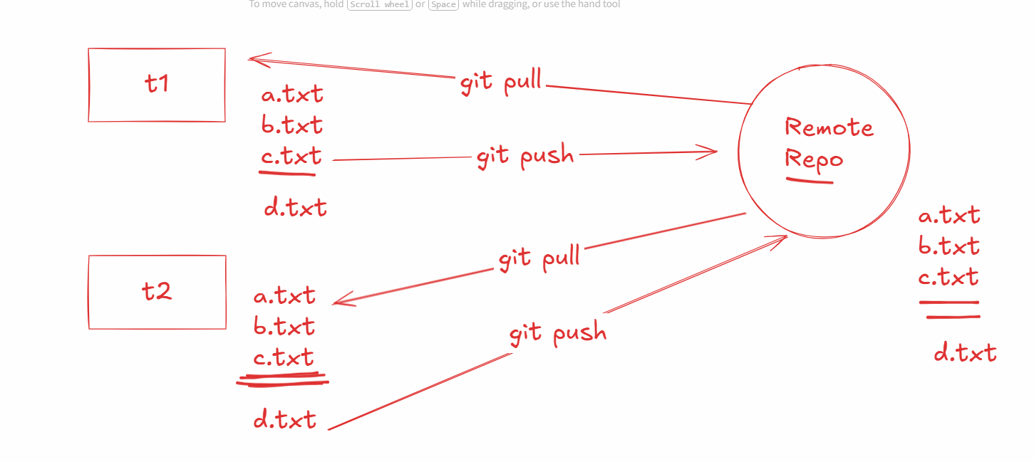
Activity:
Create d.txt in the 2nd terminal push that to the remote & in the 1st terminal pull the changes, and in both the terminal use ls to observe d.txt file
How does git knows what files to pull & merge to the local repository
Git creates a commit-id which is unique using that it can understand what version to pull and merge
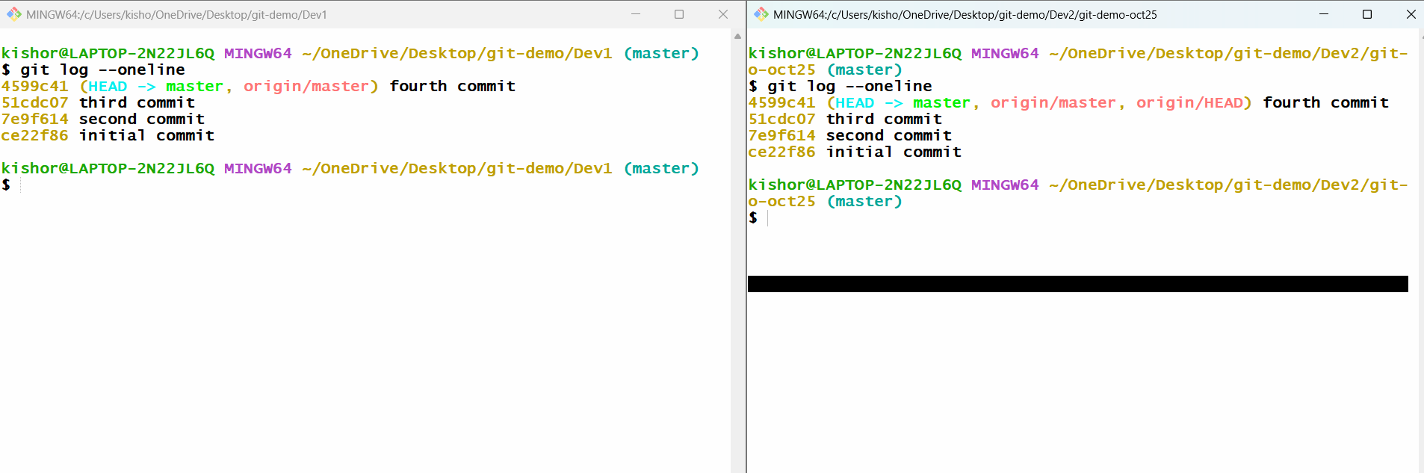

Summary:
- git init
- git config --global user.name “username”
- git config --global user.email “emailid”
- git add filename
- git commit -m ‘message’
- git push -u origin master
- git pull
- git log --online
- git log
- git clone <<remote-url>>

Day 2 Agenda
- Creating remote repository
- Cloning the remote repository
- Understand branches in GIT
- Merge conflicts
- Stashing
- Resetting
- Fetch vs Merge
Step 1: Create a repository in the git hub account and clone it
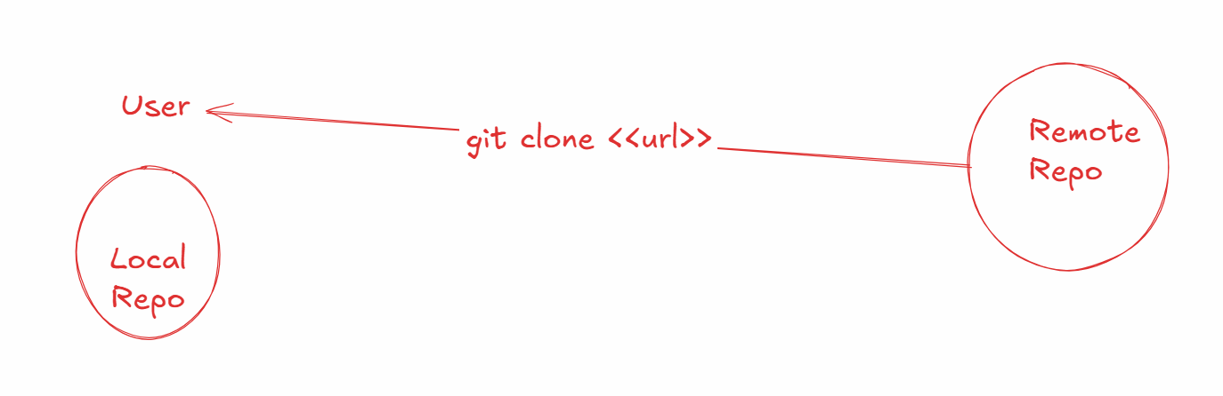
Step 2:
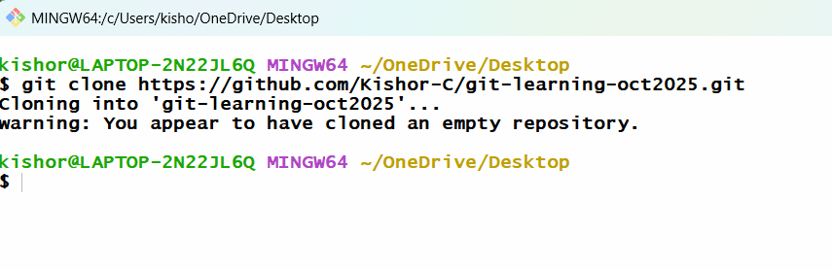
Step 3: navigate to the repository
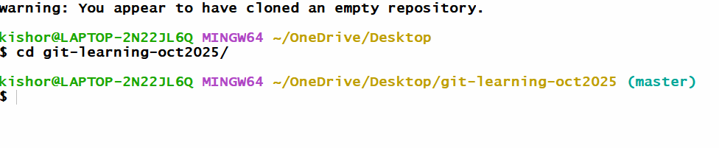
How to avoid conflicts
- User needs to always create a separate branch called as feature branch instead of working in the main/master branch
- In the feature branch users must do the changes and push to the remote repository
- In the remote repository there will be a notification when changes are pushed
- These changes must be merged with the master branch
- If the changes doesn’t have conflict it can be merged successfully else it will be rejected
- If the merge is rejected, then the user must pull the remote master changes to their local master which will merge the changes and then they must create a feature branch and make the changes and then push the changes to the remote
Create a 2 folders
- user1
- user2
In User1 folder open git bash and clone the remote repository
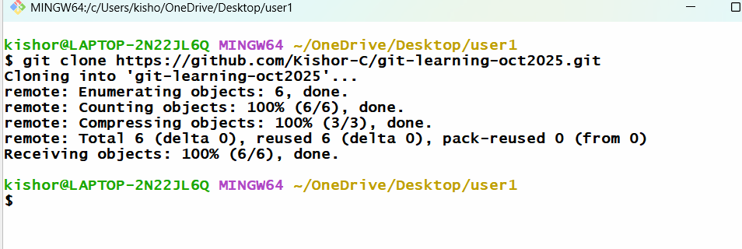
Navigate to repository
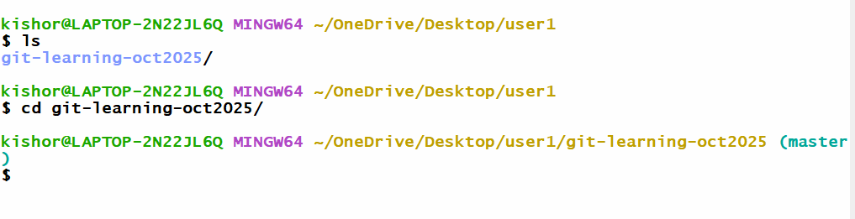
In User2 folder clone the same repository and navigate to the repository
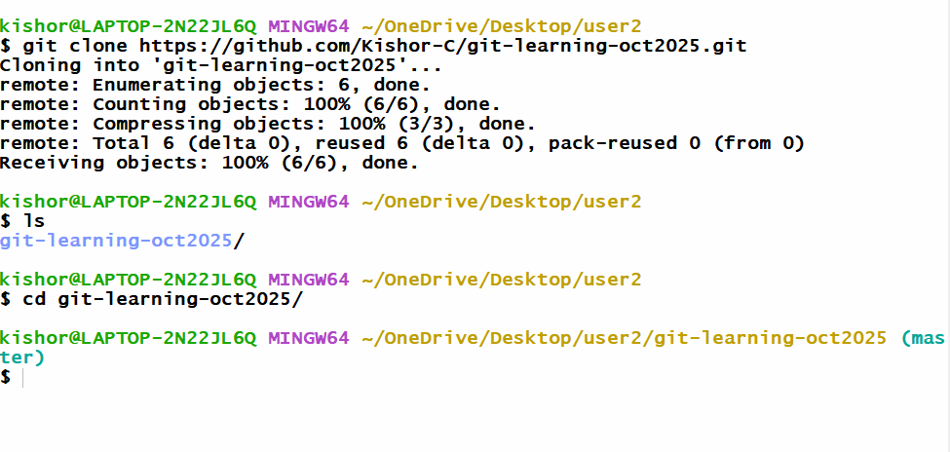
How to create a branch and switch to that branch
git branch branch-name: This creates the branch
git checkout branch-name: This switches to the branch
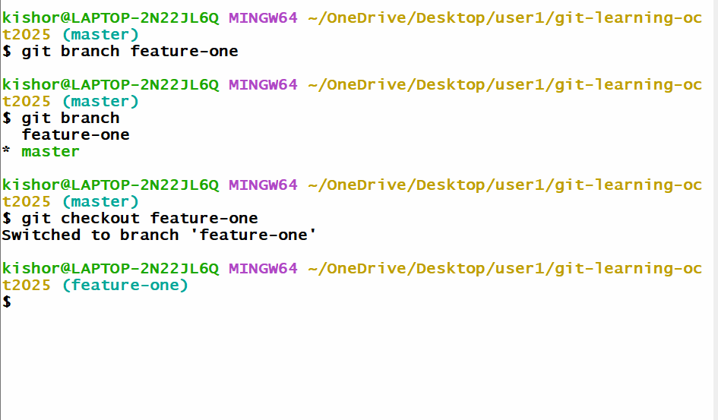
In User1 -> feature-one >> edit A.txt
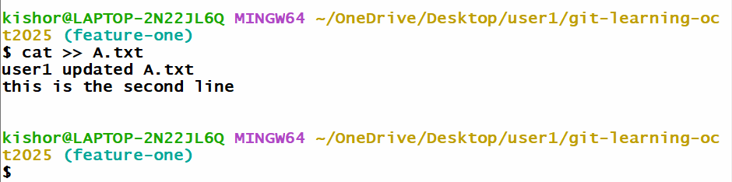

Push the feature-one to the remote
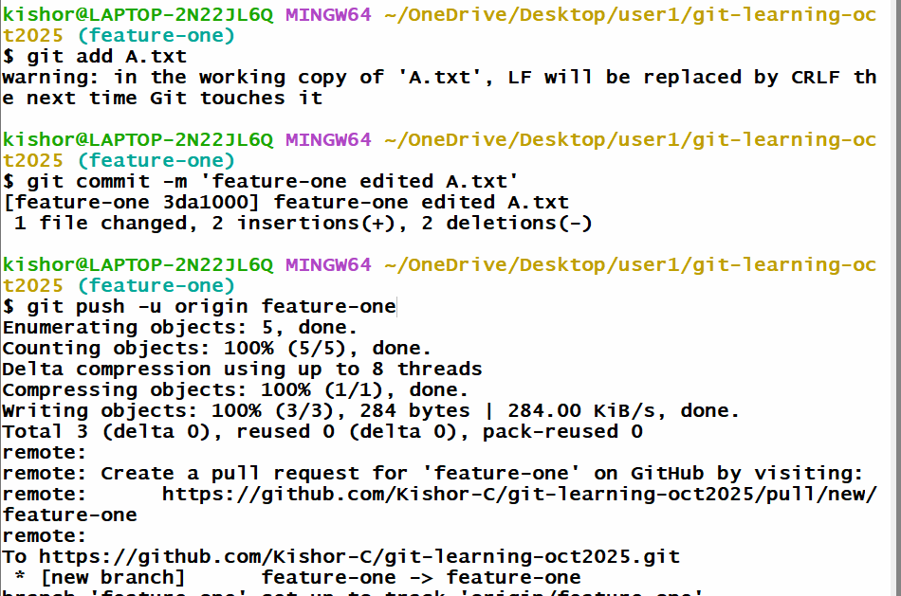
Create a branch in User2 and update A.txt and push to the remote
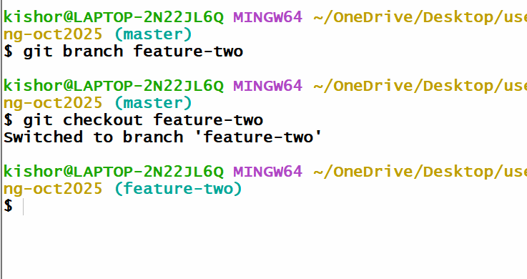
Push the feature-two to the remote
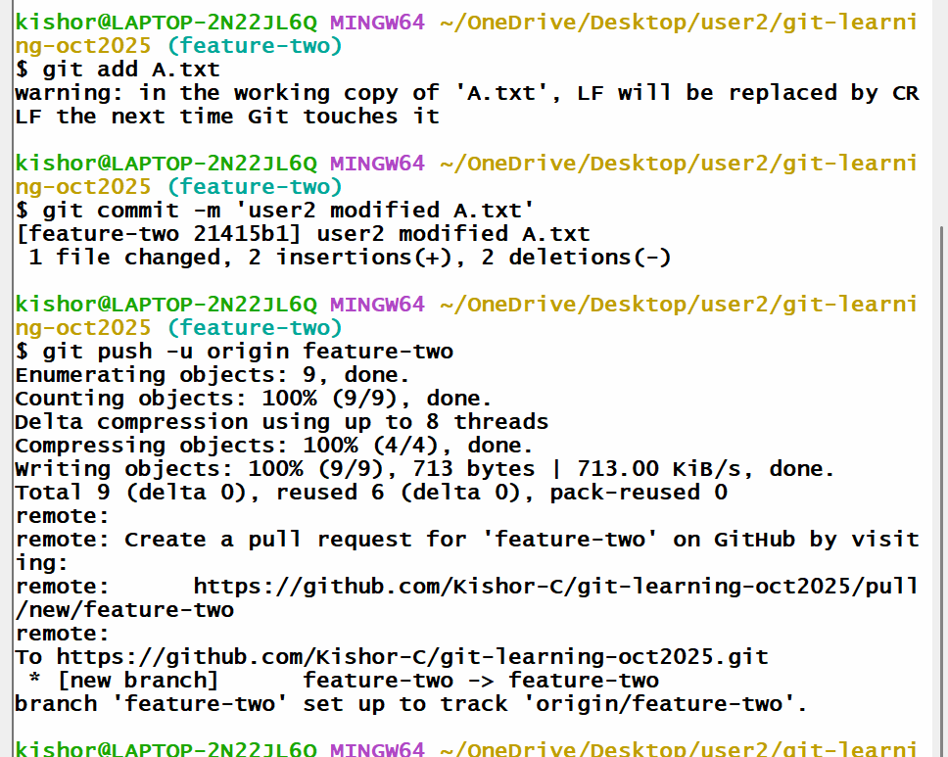
Note: Remote master can’t merge feature-two because of version mismatch
User2 must pull the remote master which will merge local master with remote master versions and then checkout to the feature-two and merge the local master with feature-two, here you will get the conflict which you will resolve with a new commit and then you will push
Steps to resolve
- git checkout master
- git pull -> this will merge local master with remote master
- git checkout feature-two
- git merge master -> gives conflict error -> resolve -> commit -> push the feature-two
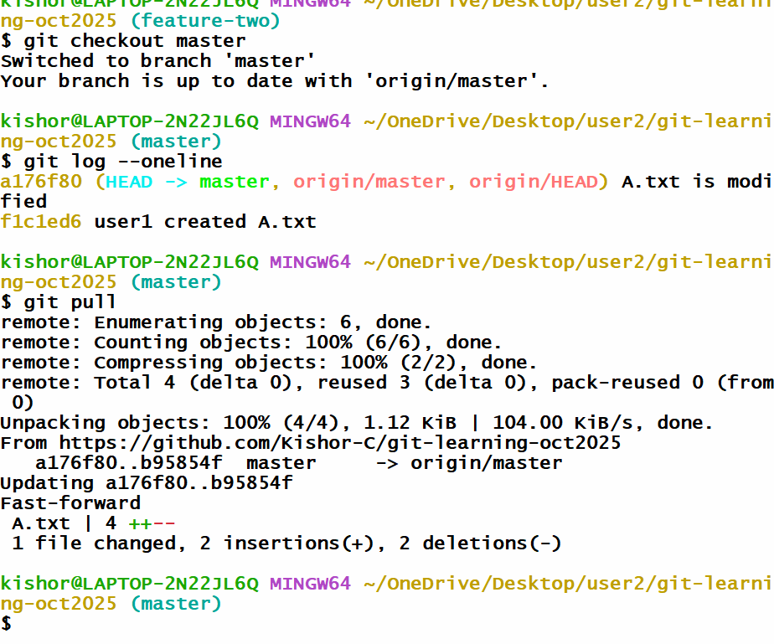
Checkout to feature-two and merge - you will get conflict error - which you must resolve
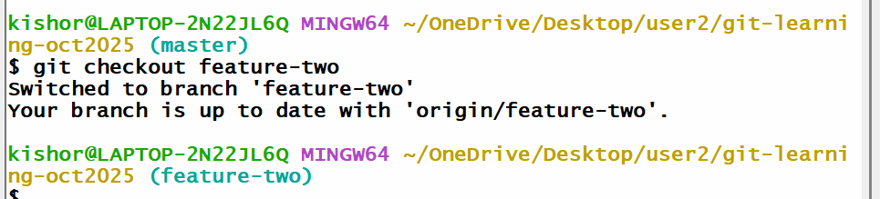
Once you resolve you can push the feature-two
Note: If git-hub doesn’t show the notification you can click on Pull request tab

Day 3 agenda
- Git stash
- Git Reset
- Fetch vs Merge
- MySQL

Download MySQL 8 LTS version & Install it, ensure you install full products

Git stash
Sometimes untracked files appear in other branches, to hide those untracked files you can use git stash push --include-untracked -m ‘some message’
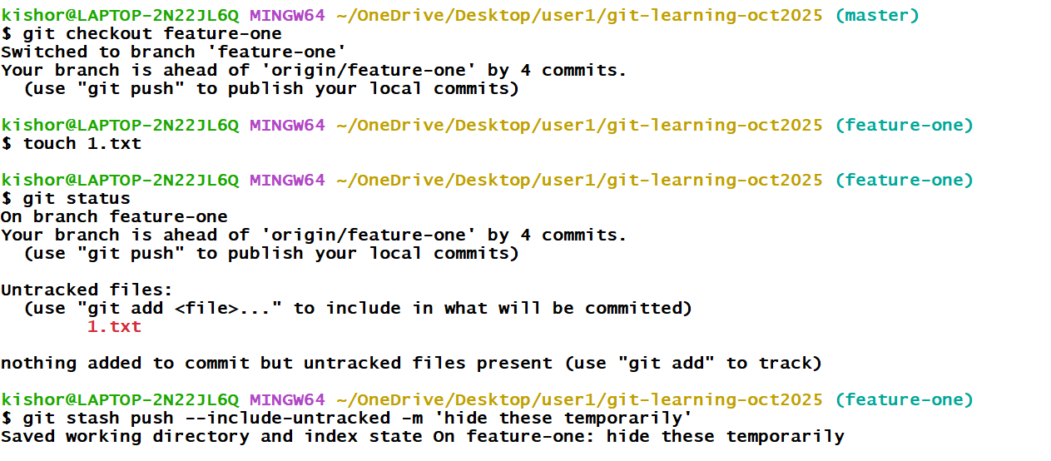
Now you can create a new branch and checkout to the new branch and you don’t see the untracked files
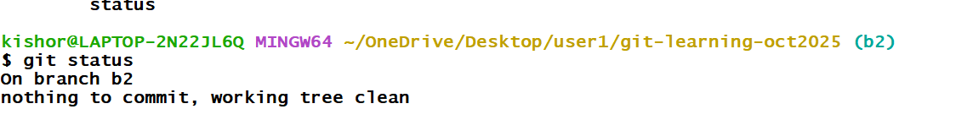Now you can checkout to the feature-one get those untracked files using git stash pop
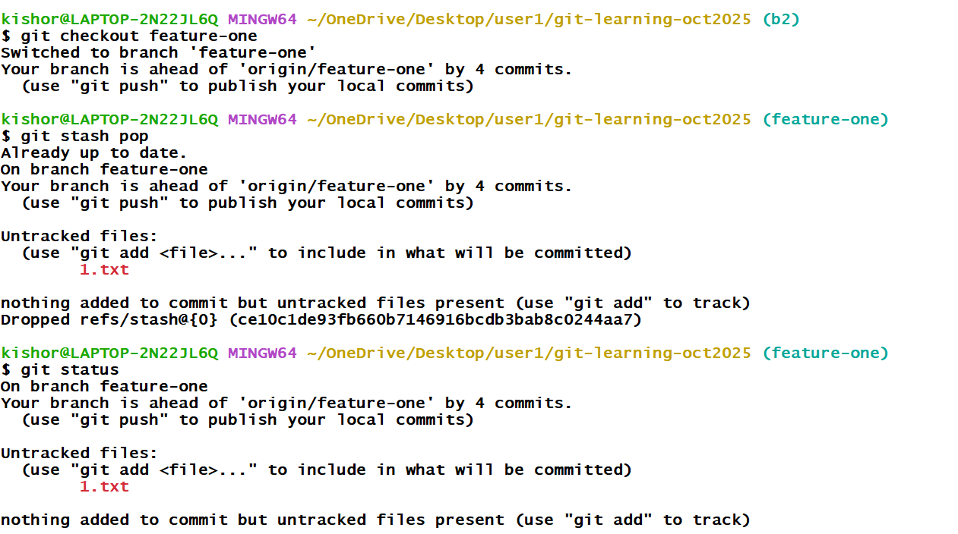

Stash commands steps
- git checkout feature-one
- touch 1.txt
- git stash push --include-untracked -m ‘some message
- git checkout -B b2
- git status
- git checkout feature-one
- git stash pop
Git Reset:
This command gives the version you want in your project, this done whenever you want to go back to old version of the project
syntax:
git reset --hard commit-id
Once you reset the version, this is updated locally, but you may need to update the version to the remote, that is done using
git push -u origin master --force
Other users must also get these changes for that they need to use git pull & get reset below command
git pull
git reset --hard origin/master
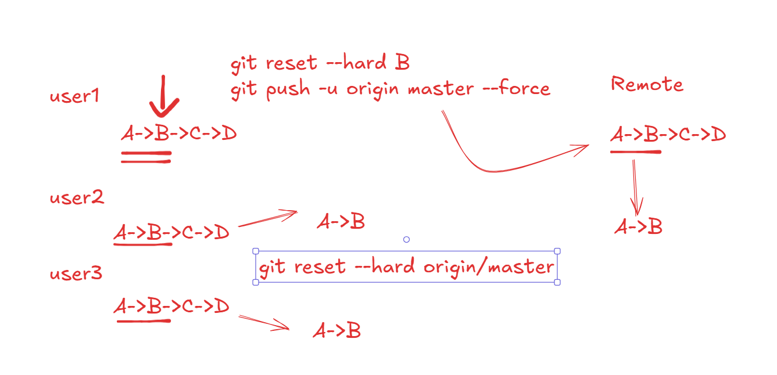

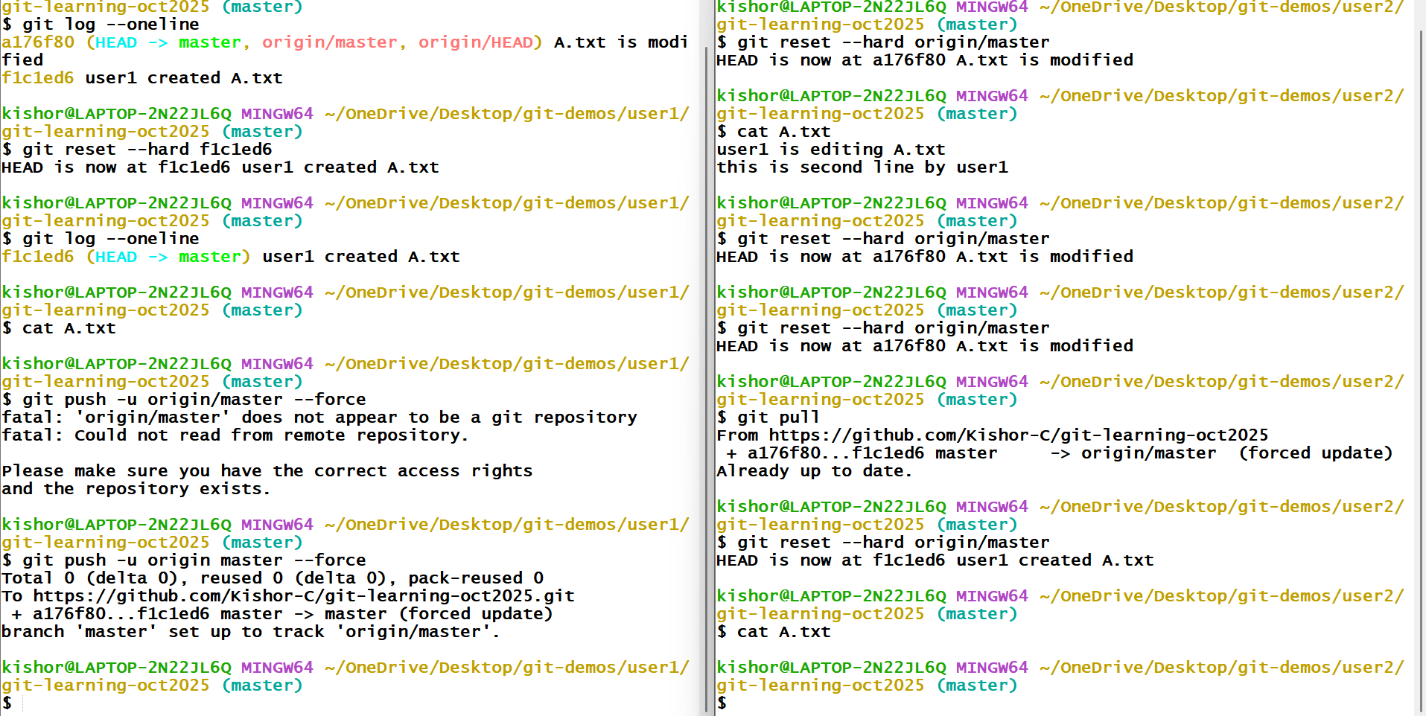
git fetch vs git merge
fetch: get remote changes without merging the local branch, it stores the changes in the .git folder so later you can merge, this is a safe way of merging without immediately getting the conflicts, it is not risky
pull: get remote changes and merges, if there’s a conflict you need to resolve, here the risk of conflicts will be there
git pull = git fetch + git merge
MySQL database
Database: it is a collection of data or a record keeping system
DBMS: Database Management System, it is a software that helps to access the database to maintain the data like store, update, delete, read
RDBMS: Relational Database Management System, that maintains the data in a table format
We have many RDBMS software’s like
- MySQL
- Oracle
- PostgreSQL
All these database understand a language called SQL (Structured Query Language)
SQL has sub types
- DDL - Data Definition Language - create, alter, truncate, drop
- DML - Data Manipulation Language - insert, update, delete
- DQL - Data Query Language - select
- DCL - Data Control Language - grant, revoke
- TCL - Transaction Control Language - commit, rollback
MySQL gives you a terminal and also it gives you a workbench (auto-suggestions)
In MySQL you need to create a database
Syntax: create database database_name;
You can list all the database names using following command
show databases;
Switch to the database
Syntax: use database_name;
Show databases
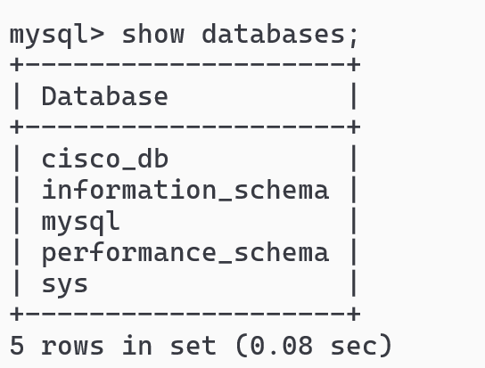
Create a database and switch to the database
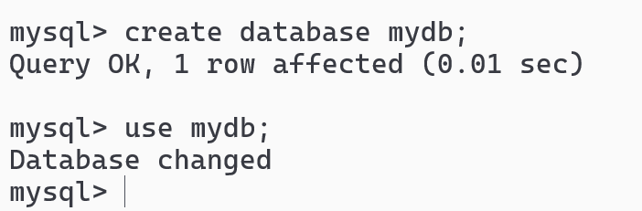
Syntax to create table
create table table_name (column_name type [constraint], column_name type [constraint]);
table_name can be like employee, customer, loan, profiles and etc
type: these are built-in types supported by the database which specifies what kind of value you can store like int, bigint, double, float, varchar, char, date, timestamp.

Insert & Select commands
Syntax: insert into table_name values(v1, v2, v3,…)
Syntax: select column, column from table_name or select * from table_name;
Note: Date must be stored in quotes in a yyyy-MM-dd format which is an ISO format that is globally supported
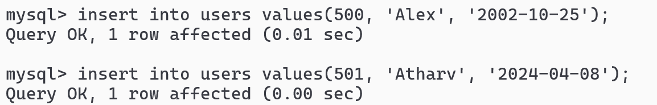
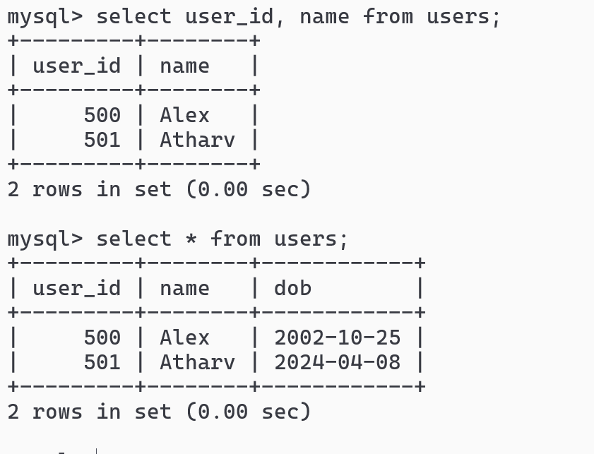
Suppose you want to add columns then you can use alter command
Syntax:
alter table table_name add column column_name type, column column_name type,…
Example
alter table users add column phone_no bigint, add column gender varchar(6);
Note: if the table is already present then the new columns get default values like NULL
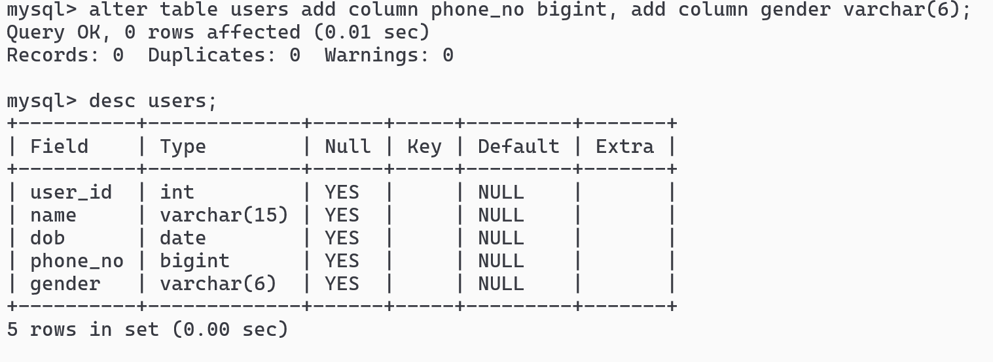
Update command:
You can update one or more columns
Syntax:
- update table_name set column_name=value;
- update table_name set column_name=value, column_name=value;
- update table_name set column_name=value where column_name=value;
- update table_name set column_name=value, column_name=value where column_name=value;
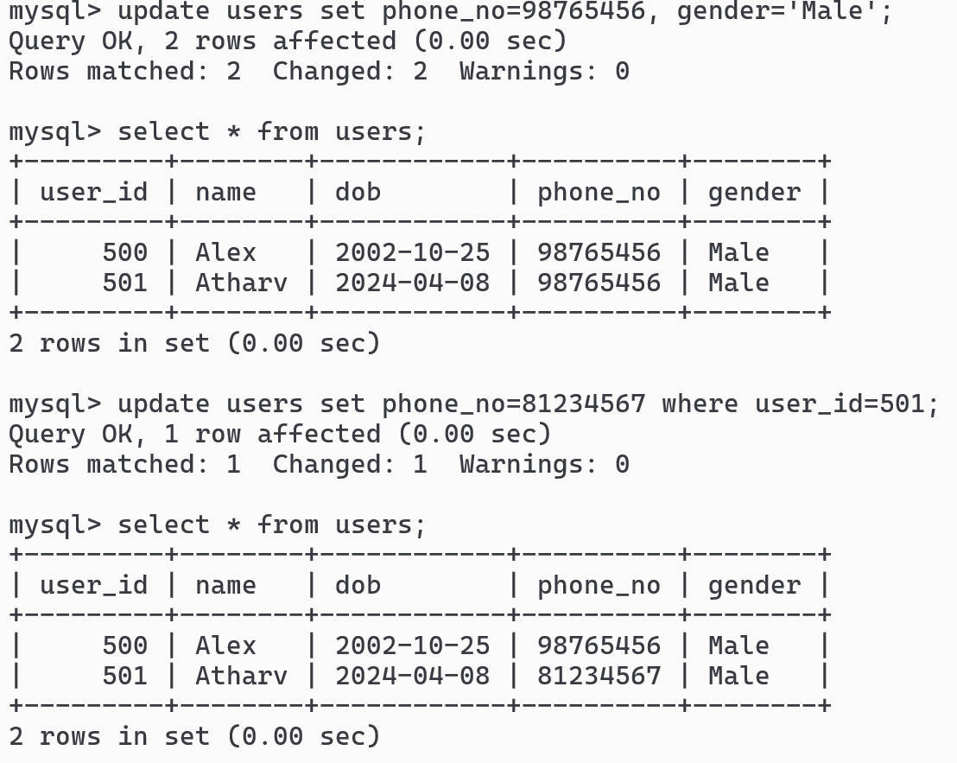
Alter command to remove the columns
Syntax:
- alter table table_name drop column column_name;
- alter table table_name drop column column_name, drop column column_name;
Example:
alter table users drop column phone_no, drop column gender;
Note: If you drop the columns all of its data associated with the columns are also deleted

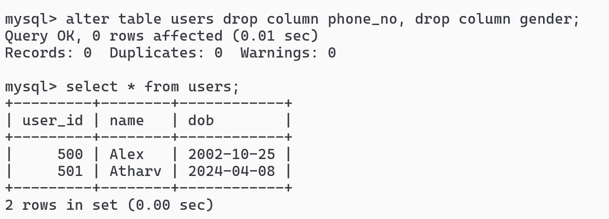
Truncate:
It is used to permanently delete all the records in a table, which you can’t undo, it retains the structure of the table
Syntax: truncate table table_name;
Example: truncate table users;
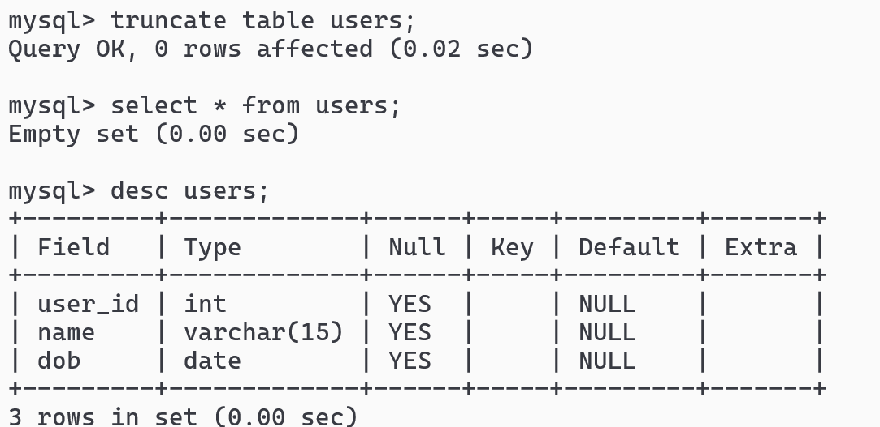

Note: We also have delete command, but delete command can delete based on the conditions like one or more records and also delete command can be rolled back i.e., you can undo the delete
Note: truncate command deletes all the records and you can’t delete based on the condition, you can’t rollback the truncate
Drop:
It is used to permanently delete the table
Syntax: drop table table_name;
Example: drop table users;
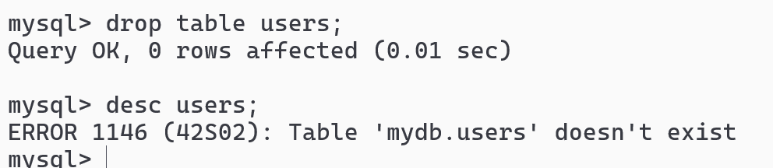

Constraints:
Constraints are the rules that can be applied for a table or a column, below are the constraints many database support
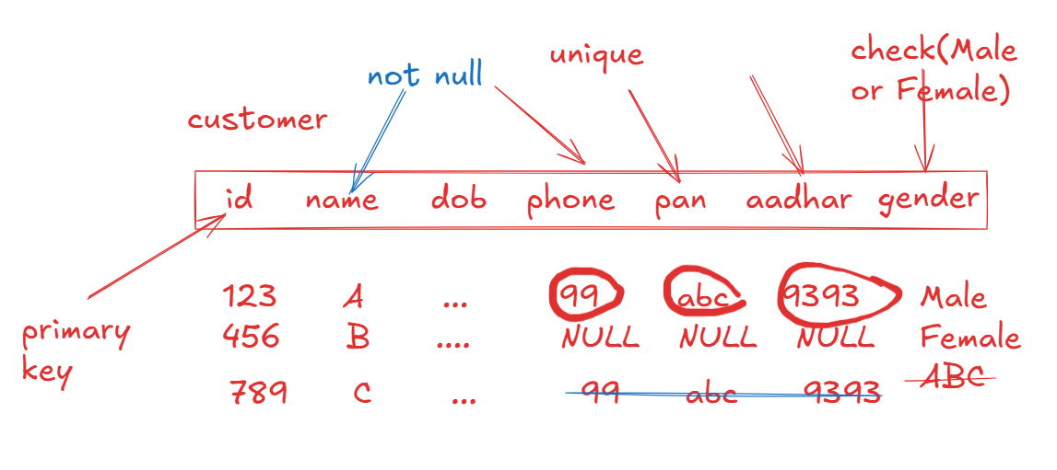
- primary key: it can’t be duplicate, it is used to uniquely identify the records & it doesn’t support null
- unique: it can’t be duplicate, however it supports null
- not null: a column that mandatorily needs a value
- check: a column that must have values that are defined in the check
- foreign key: a table that is linked with another table

auto_increment: It is a keyword that can be used for a primary key to automatically generate the value, by default it starts from 1, but you can start from any value.
Create command with constraints and auto_increment
Syntax:
- CREATE TABLE table_name (column_name type PRIMARY KEY AUTO_INCREMENT, column_name type NOT NULL, column_name type CHECK( condition ), column_name type UNIQUE)
The above table starts primary key from 1
- CREATE TABLE table_name (column_name type PRIMARY KEY AUTO_INCREMENT, column_name type NOT NULL, column_name type CHECK( condition ), column_name type UNIQUE) AUTO_INCREMENT=500
Example
CREATE TABLE customers(customer_id int PRIMARY KEY AUTO_INCREMENT, name varchar(20) NOT NULL, gender varchar(6) CHECK (gender IN (‘MALE’,’FEMALE’)), phone_no bigint UNIQUE)AUTO_INCREMENT=500;
To store the records
INSERT INTO customers (name, gender, phone_no) values (‘Alex’, ‘Male’, 939393)
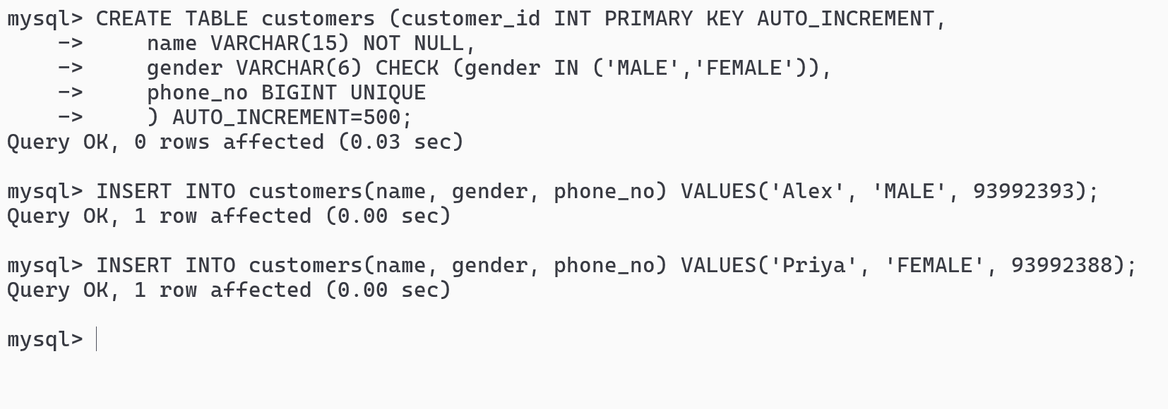
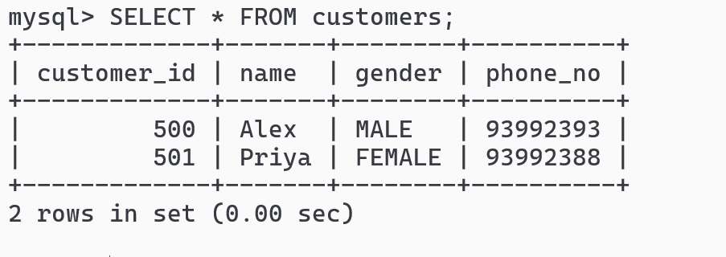

Foreign key constraints
It is used to link a child table from the parent table using the primary key of the parent table.
Syntax:
CREATE TABLE table_name(column type, … column type, foreign key references parent_table(primary_key_column));
Example
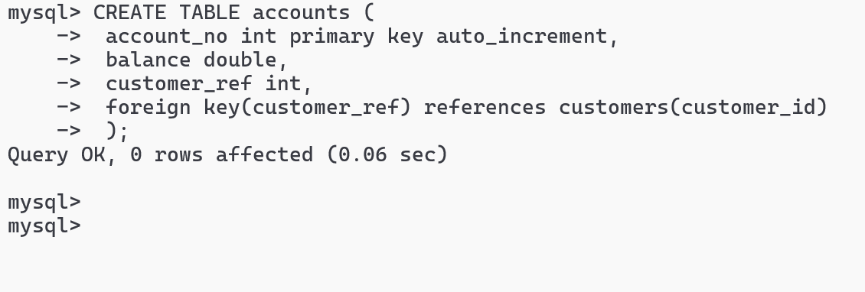
Note: Foreign key column must be the entries present in the parent table, it can be null and you can also have duplicate values to the foreign key
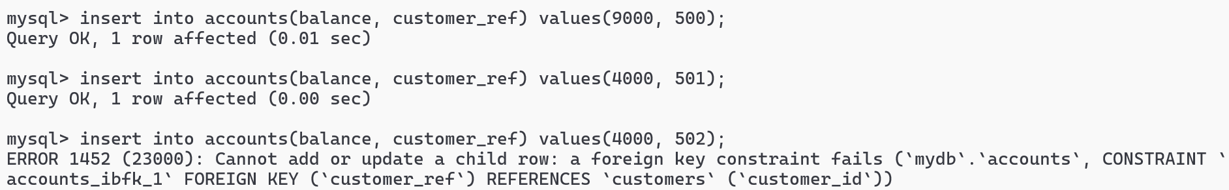
Backup and Restore
Backup is required to ensure that when anything goes wrong you could able to recover the data
The command used to take the backup is
mysqldump -u root -p database_name > file_name.sql
To restore the command is
mysql -u root -p database_name < file_name.sql
Note: mysqldump is the command present in the C:\Program Files\MySQL\MySQL Server 8.0\bin in windows, for mac users it will be present in /usr/local/mysql/bin

Open the command prompt in the admin privilege, for mac use sudo
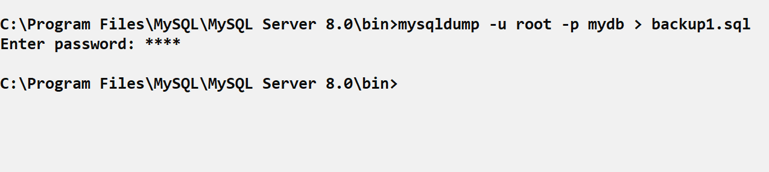
Now drop all the tables in mydb and then issue the following command from the command prompt.
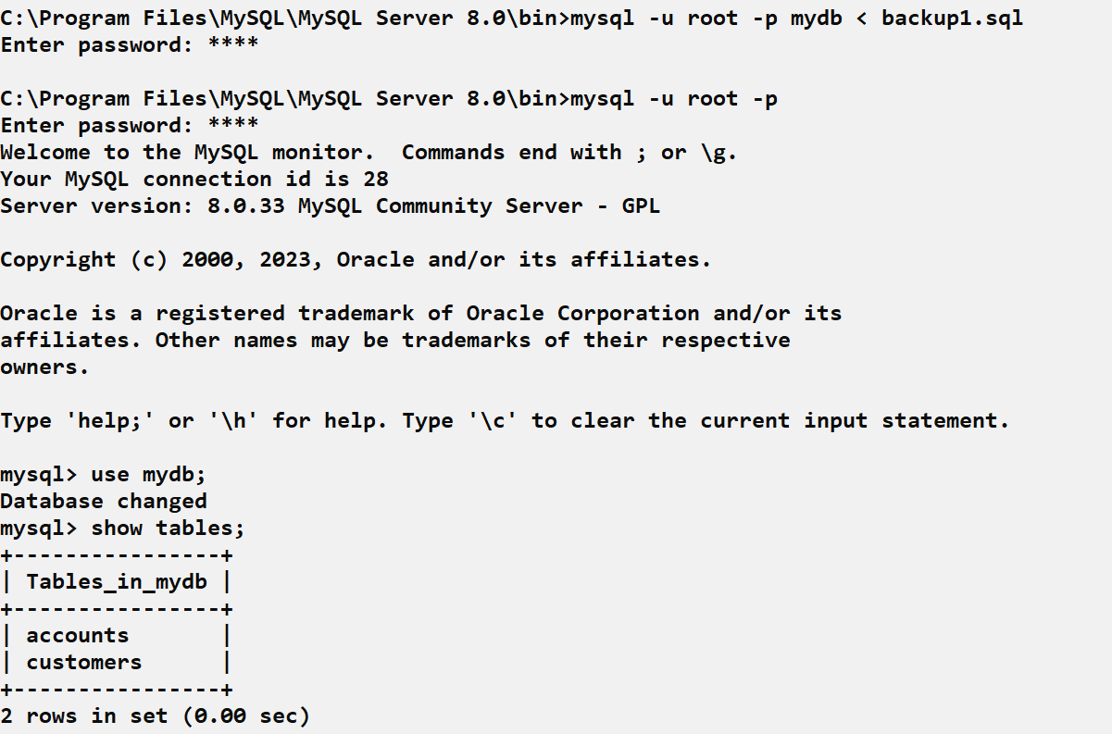
Running the SQL script files
Script file: It is an SQL file that will have SQL commands which you can run to execute all the commands present in it
You can create demo.sql file in any location
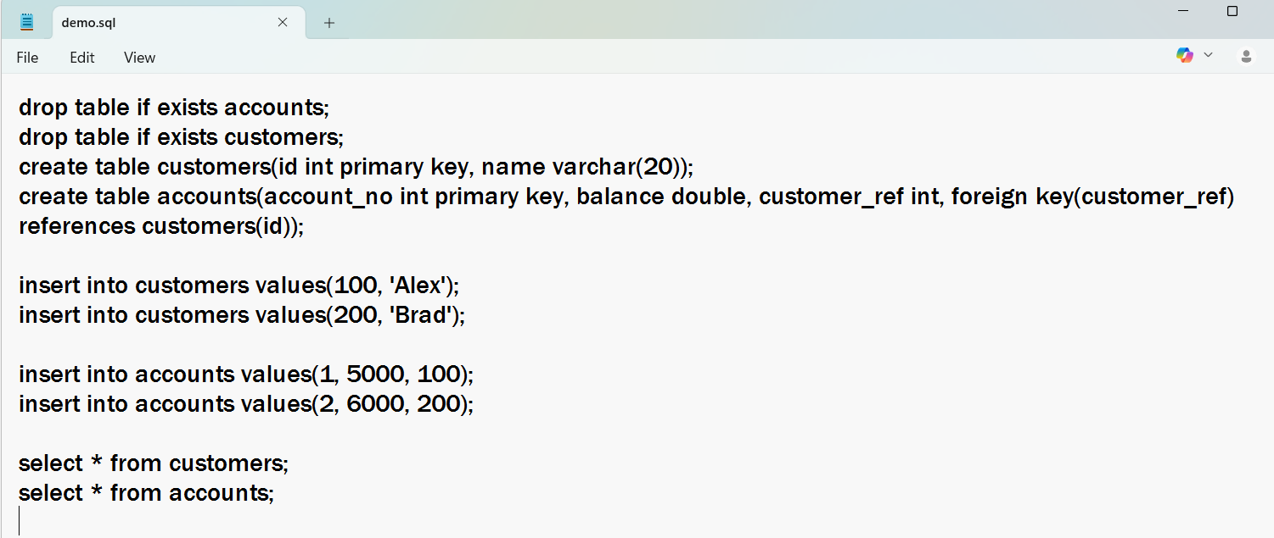
To run the script file user source path
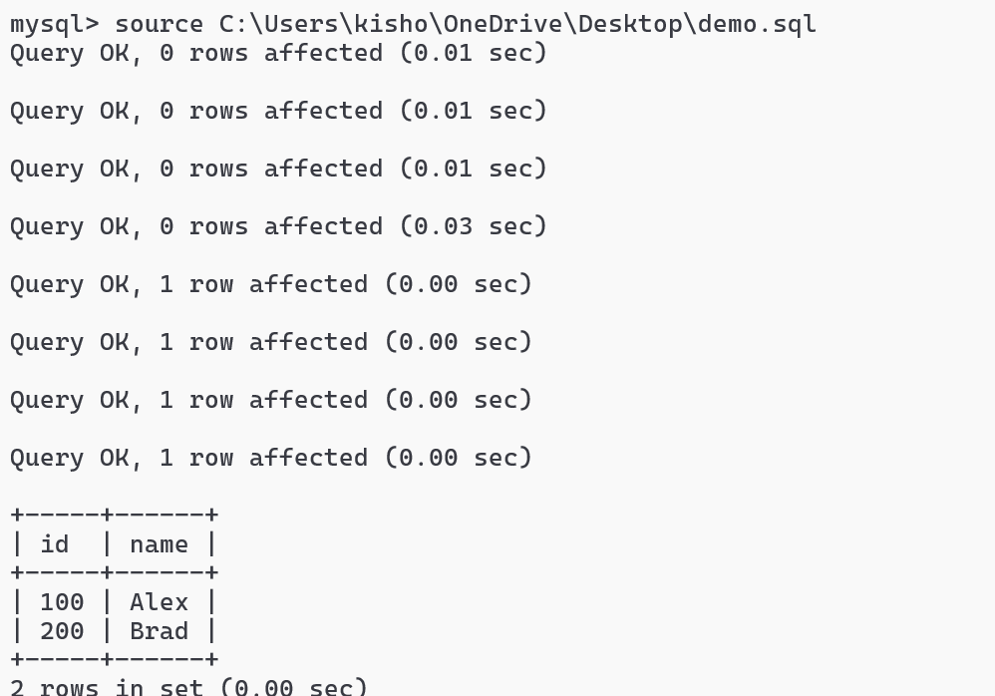
HR schema: it has some tables like employees, departments, jobs and etc with some records
Built-in functions in MySQL
There are two types of built-in functions
- Single row functions: these functions return single result for each row
upper(), lower(), concat(), length(), date_format()
- Aggregate functions: these functions combine all the rows and return a single result
count(), sum(), max(), min(), avg()
Using count
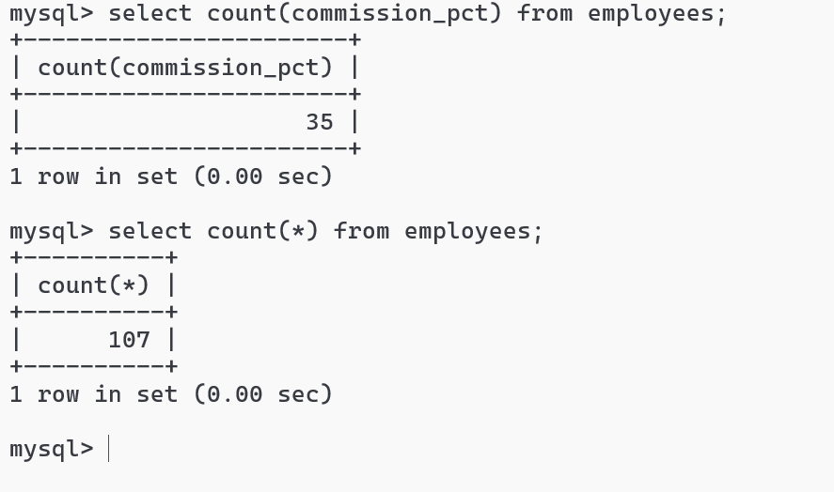
upper()
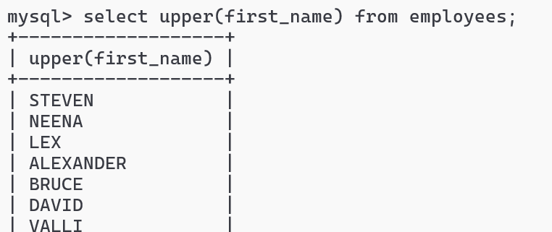
concat(arg, arg, arg): this concatenates multiple arguments and returns result for each row
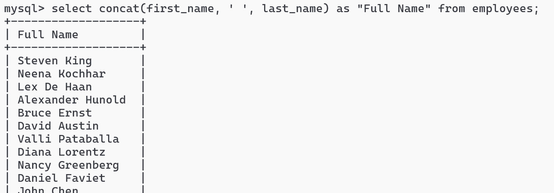
Select comes with various clauses like - where, order by, between, or, in, and, having, group by and etc.
Order by salary:
select first_name, last_name, salary from employees order by salary;
Where
select employee_id, first_name, last_name, salary from employees where employee_id = 105;
Between
select employee_id, first_name, last_name, salary from employees where employee_id between 100 and 110;
Like operator
% any number of characters
_ a single character that can be anything.
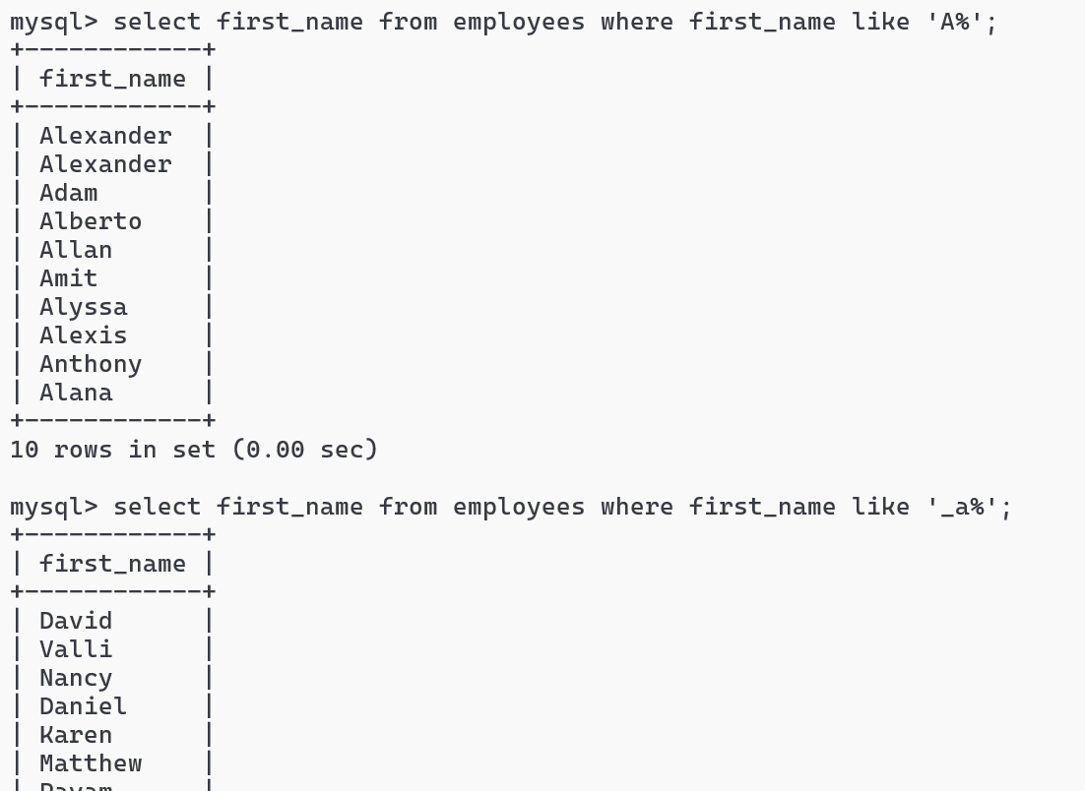

IN operator
select employee_id, first_name from employees where employee_id IN (101, 102, 120);
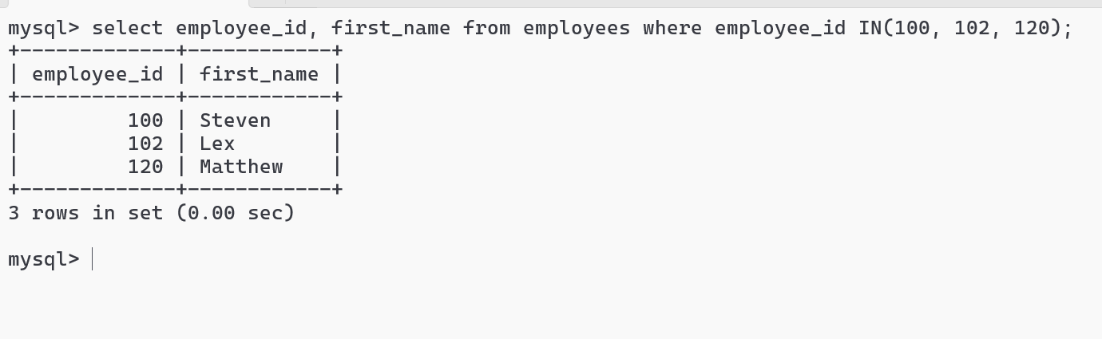

Sub queries or Nested queries
Sometimes a query needs a condition after executing another query
ex: You want all the employees belonging to IT or SALES, ACCOUNT department
Syntax:
outer query condition (inner query)
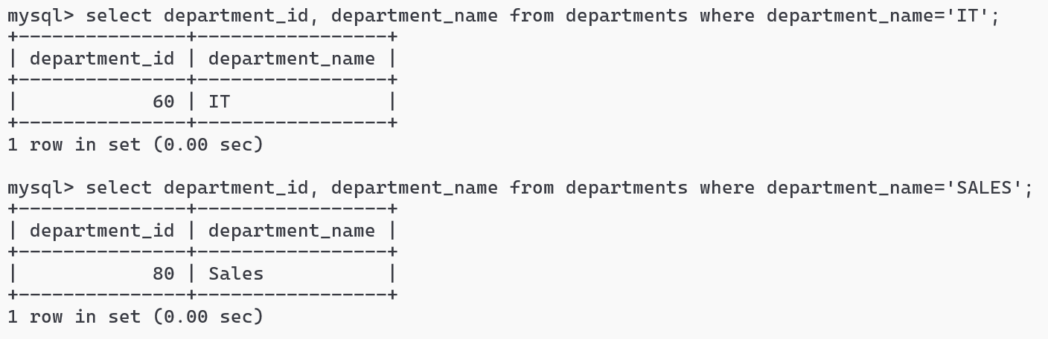

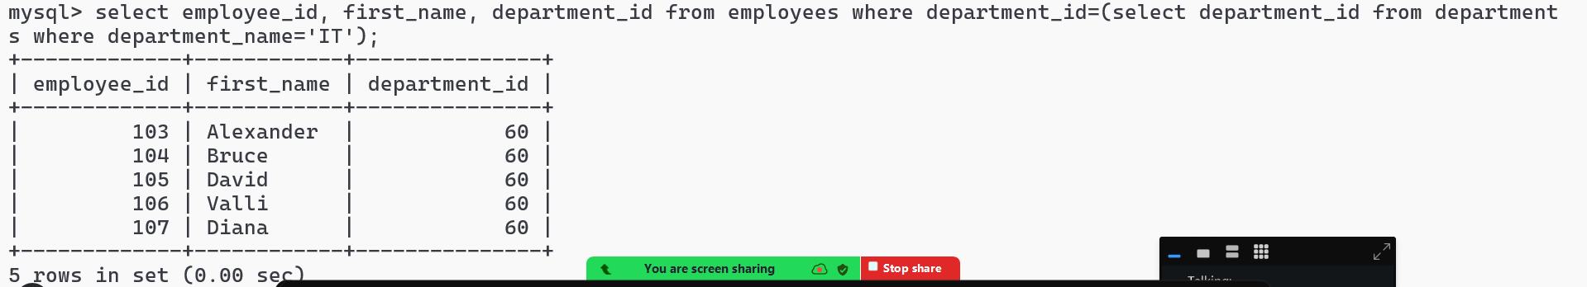
Activity:
- Show all the employees working is Canada
- Show all the employees working in UK
- Show all the employees belonging to FINANCE, IT and ACCOUNTING

GROUP BY & HAVING
It is used to group rows that have same values in one or more columns, it is often combined with aggregate functions.
HAVING is used when you want to apply condition with aggregation function
Total number of employees in each department and having count > 20.
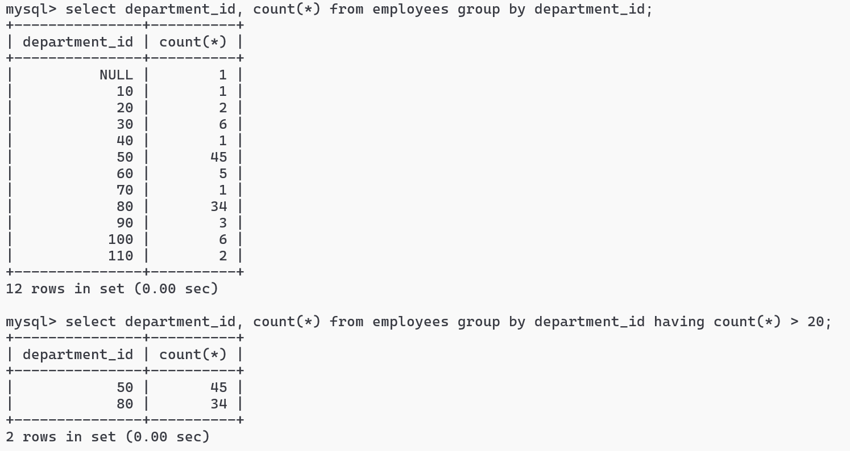

SQL Joins
It is used to join two or more tables and generate result based on some common value, following are the types of join
- INNER JOIN
- LEFT JOIN
- RIGHT JOIN
- FULL JOIN
- CROSS JOIN
JOIN syntax
INNER JOIN: produces the result of left & right table of matching values
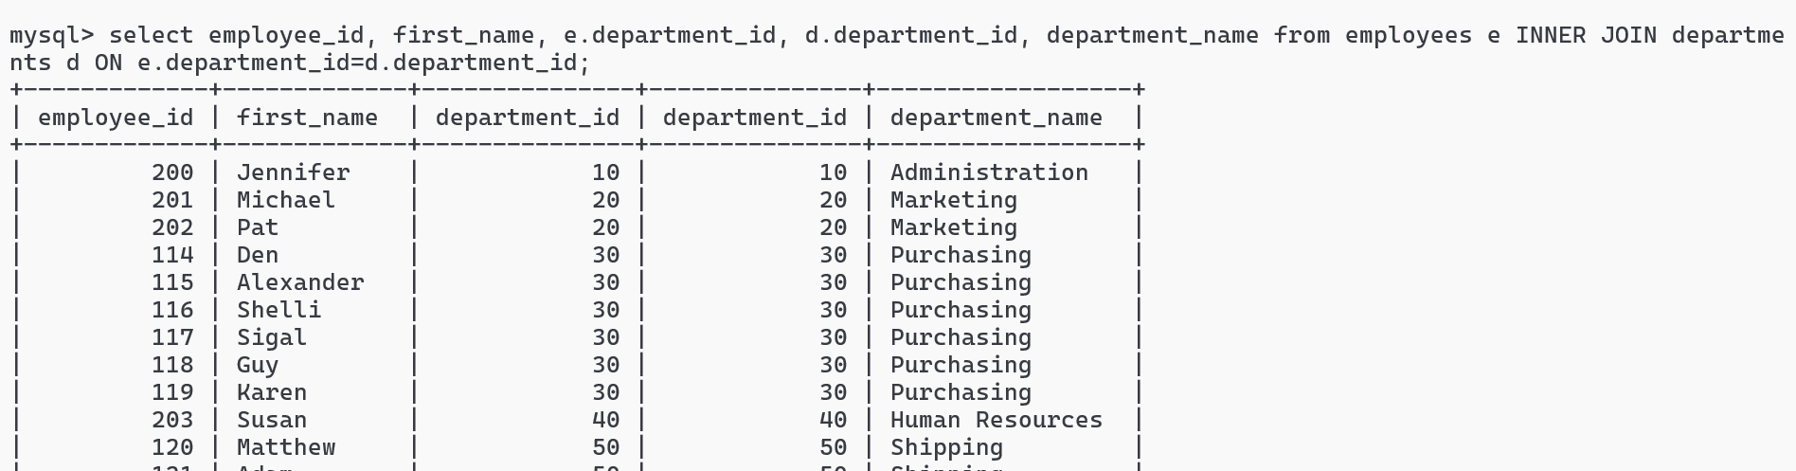
Activity:
Try LEFT, RIGHT and CROSS JOIN for employees & departments table and observe the output
Note: FULL JOIN is not supported in MySQL

CROSS JOIN: This gives you the cartesian product of two tables, where every row of a table is combined with every row of another table
Suppose you have 2 tables, A & B
A has 2 rows
B has 3 rows
Then A cross join B results 6
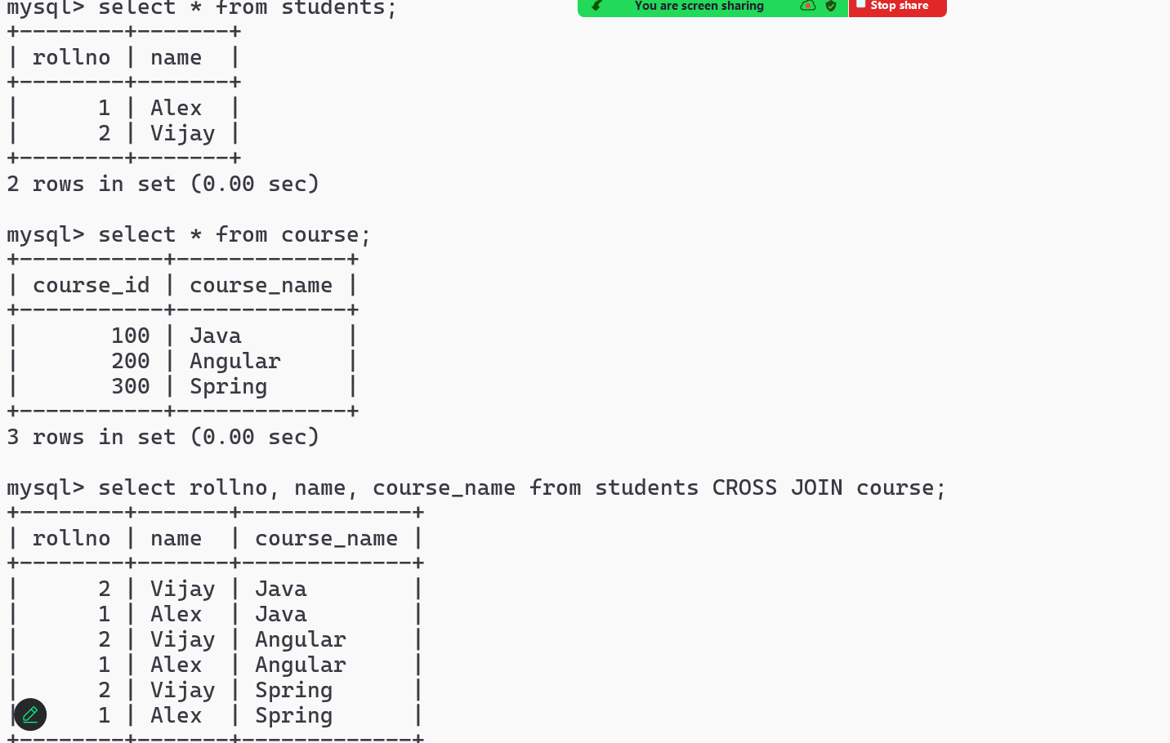

DCL: Data Control Language - It is mainly used to GRANT or REOVKE permissions
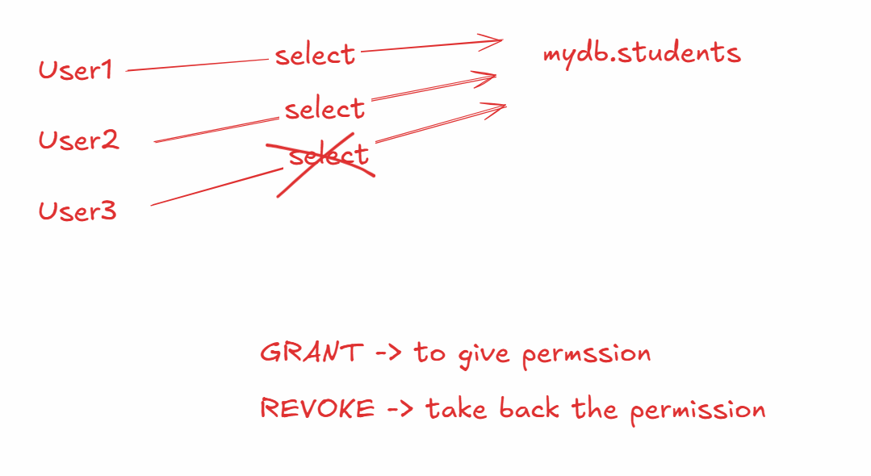
Firstly you must create a user and provide a password for the user to login
Creating the user
CREATE USER ‘user1’@’localhost’ IDENTIFIED BY ‘Welcome123’;
GRANT permission
GRANT SELECT ON mydb.students to ‘user1’@’localhost’;
USER can login using mysql -u username
REVOKE permission
REVOKE SELECT on mydb.students from ‘user1’@’localhost’;
NOTE: You must use FLUSH PRIVILEGES to apply the permission after grant or revoke
NOTE: You can provide user to perform more than one operation using GRANT SELECT, INSERT on mydb.students to ‘user1’@’localhost’;
NOTE: You can use database_name.* if you want to select all the tables
ex: mydb.* will select all the tables

From the command prompt navigate to the mysql-server/bin folder
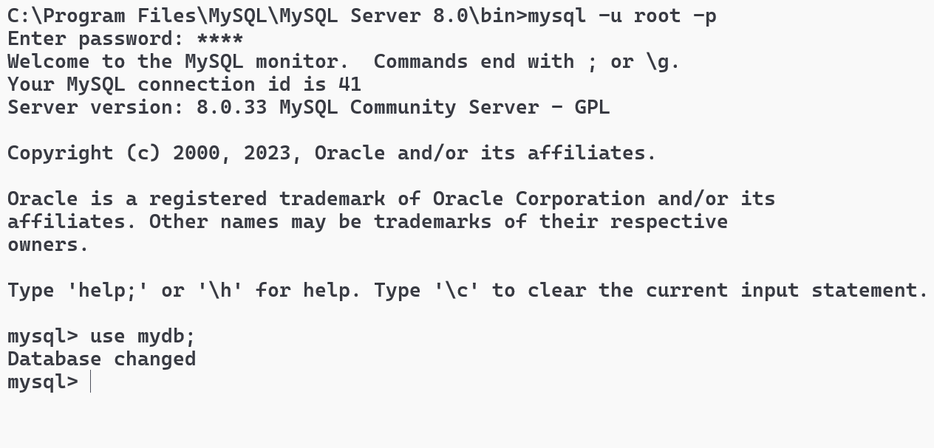

Grant SELECT permission & FLUSH privileges
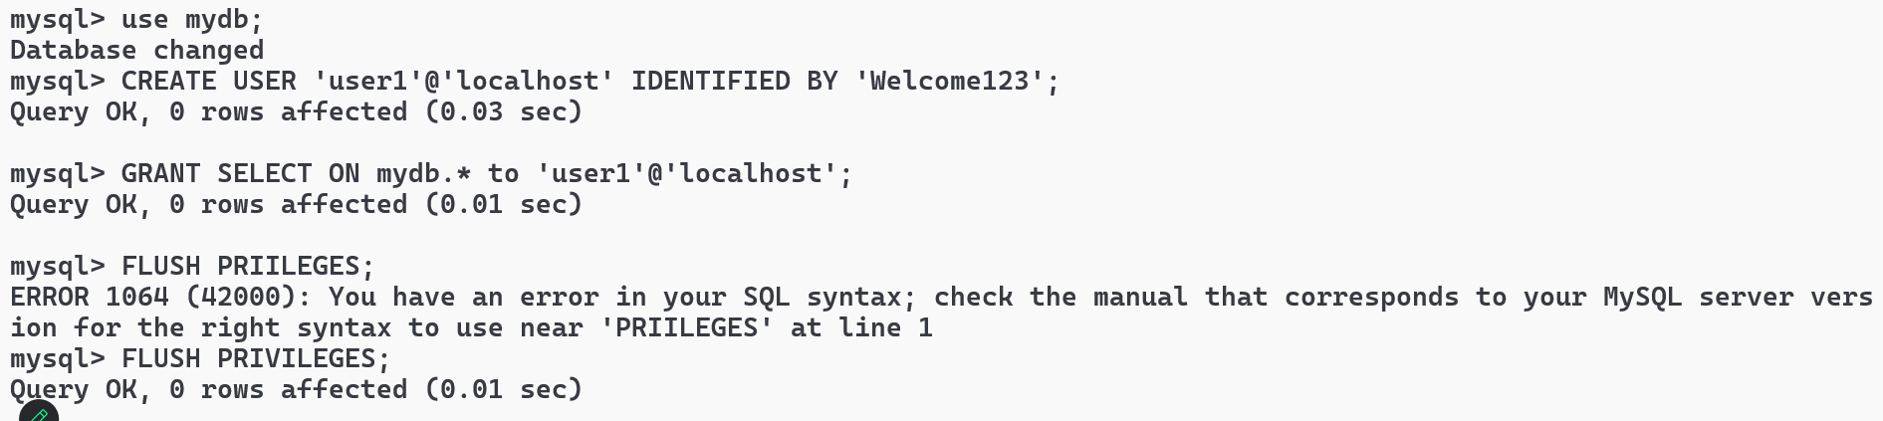
LOGIN as a user1 and try select & other commands on a table present in mydb
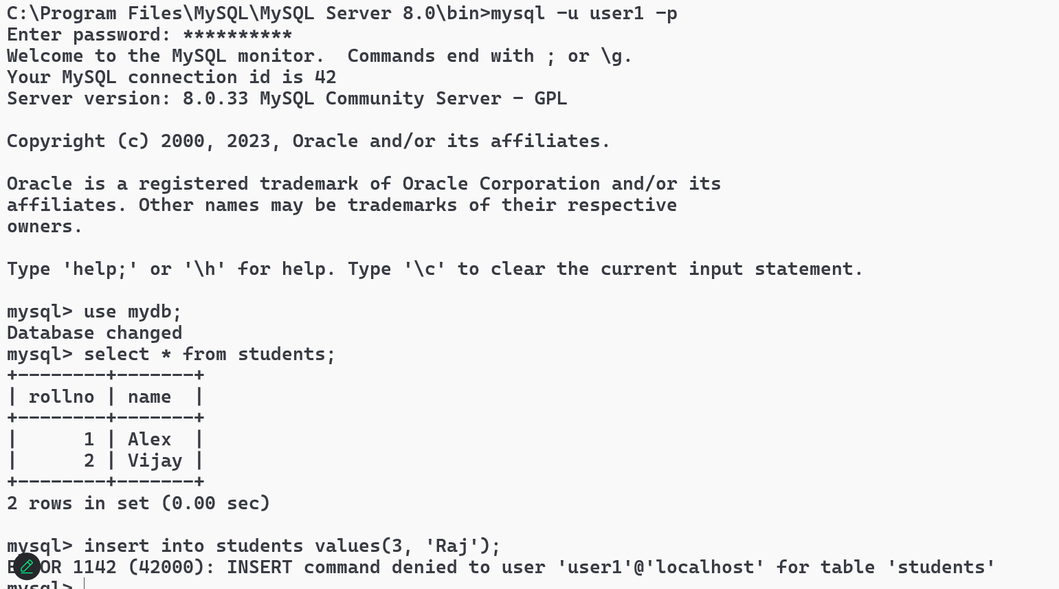
Note: You can see the permission denied error to user1
SHOW GRANTS to view what permissions the user has
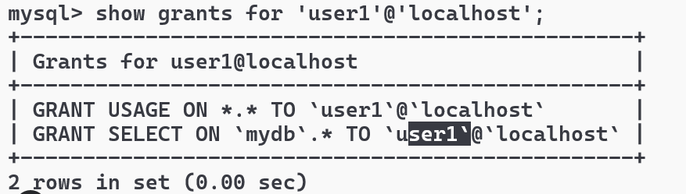
REVOKE Command
Firstly you must login as root and then revoke, later login as the user1 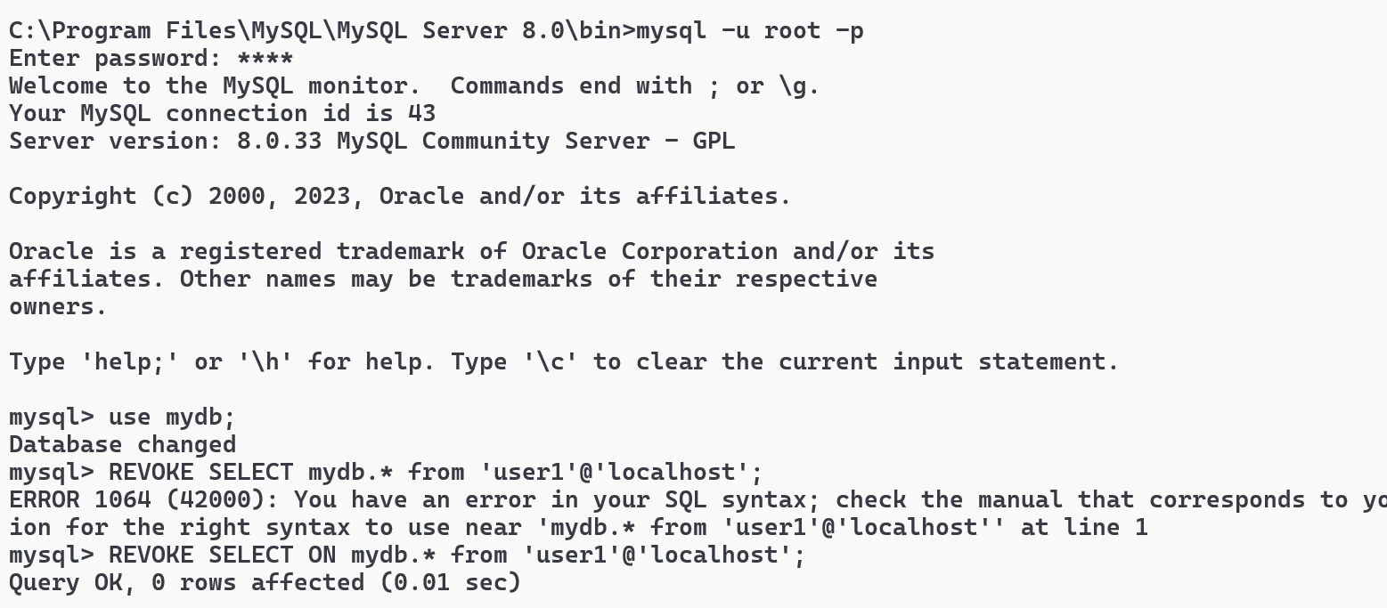
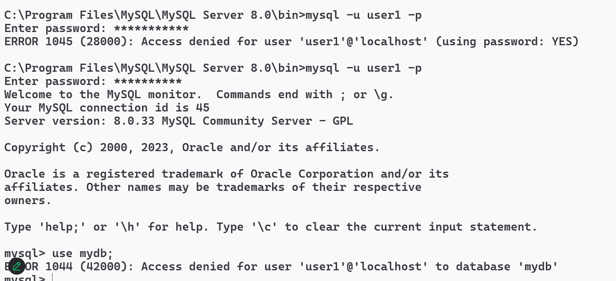
Note: Since user1 doesn’t have access to any tables in mydb, it is not allowing to use mydb
Finally you can drop the user so that he can’t login
Activity: Login as root & drop the user1 and then try to login as user1
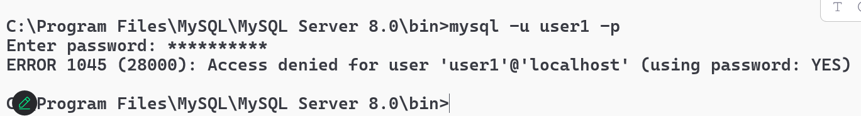

Web technologies
- HTML
- CSS
- Javascript
HTML: It is mainly to display the content
CSS: It is mainly to style the content
Javascript: It is used to add interactivity to the websites
HTML
Hyper Text Markup Language, it provides built-in tags to structure the web page
<html>
<head>
<title>some title</title>
<link>..</link>
</head>
<body>
content of the web page
</body>
</html>
Software requirement
- VS Code

HTML headings
There are 6 heading tags
<h1>, <h2>, <h3>, <h4>, <h5>, <h6>
main.html
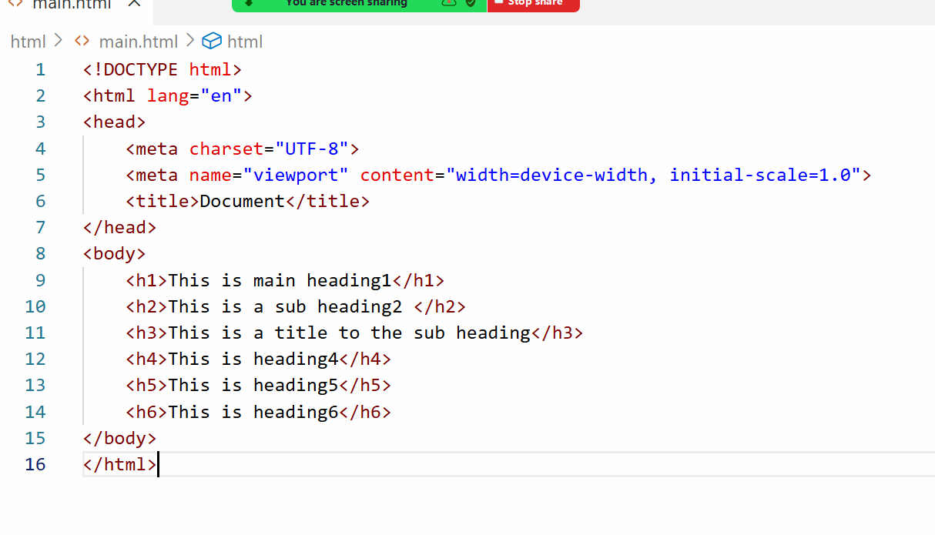
Output:
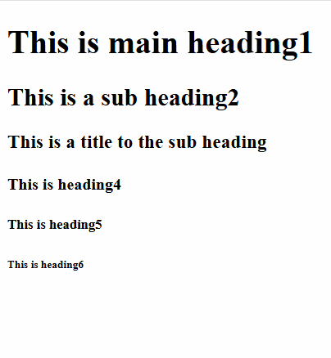
Lorem Ipsum: A short cut key to generate some random words
ex: lorem15 generates 15 random words
bold, italic, underline, strike tags
<b>, <i>, <u>, <stroke>
image tag
<img src = “URL” width = “200” height = “200” alt = “describe if image is not loaded”>

Subscript & Superscript tags
H<sub>2</sub>SO<sub>4</sub>
(a + b)<sup>2</sup>
HTML Entities: these display special characters
&pound; 10,000
www.company.com &copy; 2025
&#8377; 10,000

List tags
When you want to list some items you can use list tags, there are 2 types
- ordered list <ol>
- un-ordered list <ul>
Both the tags can have child tags like <li> which means list item or list index
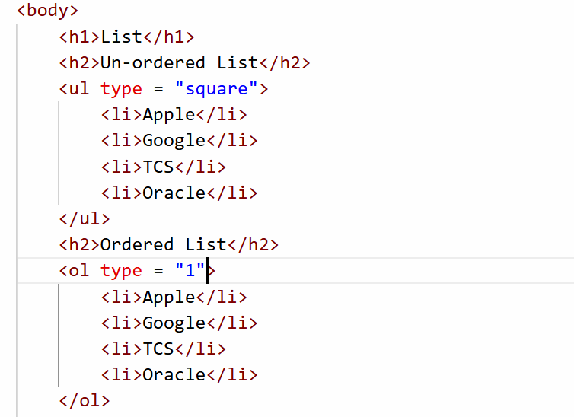

Activity:
Try to create a nested list which will have following output
- Operation Systems
  - Windows
  - Linux
  - MacOS
- Programming Languages
  - Java
  - Python
  - C++
Media tags
<video> and <audio>
<audio controls>
<source src = “file.mp3” type = “audio/mp3”></source>
</audio>
<video width = “300” height = “300” controls muted>
<source src = “file.mp4” type = “video/mp4”></source>
</video>
List of attributes you can use in audio and video
muted: starts with sound off
autoplay: automatically starts the media
loop: repeats media automatically

Table tag
<table> to create a table, it has 2 tags for head of the table for heading & for body for the content of the table, you can use <thead> & <tbody> for heading & body, however to create row you must use <tr> and for columns you can use <th> or <td>
<table> supports attributes like border, cellpadding and cellspacing
cellpadding: it gives space between content and the border
cellspacing: it gives space between the cells
anchor tag
<a> an anchor tag is used to create an hyperlink that opens another page
<a href = “url”> opens another page
<a href = “url” target = “_blank”> opens a page in a new tab
HTML Forms
HTML forms help user to enter data, using forms you can create text box, password field, radio buttons, check box, drop down, file upload field, buttons
<form> inside this form tag you can use many elements that accept the input.
form tag accepts 2 attributes
- action: This takes the url of the server program usually Java, ASP.NET kind of programs
- method: This is optional, there are two types of method you can use either GET or POST, by default method will be GET
GET vs POST
GET | POST
The data will be sent via URL | The data will be send via Request body
The data will be visible to the end user in the browser address bar | The data will not be visible
This is insecure | This is secured
Limited characters | Unlimited characters

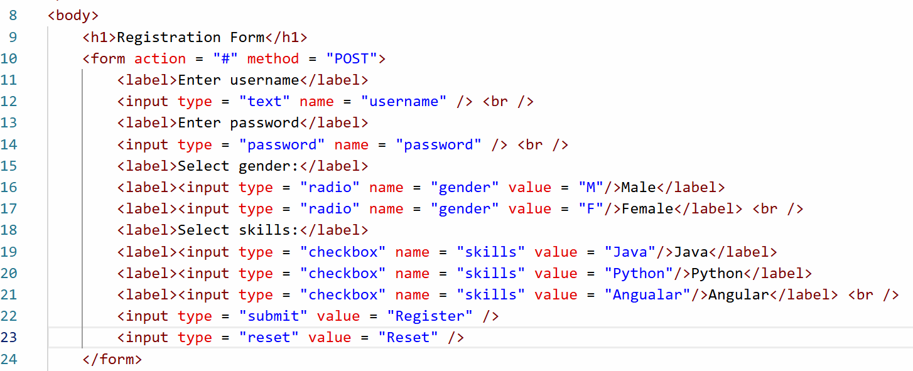
Output:
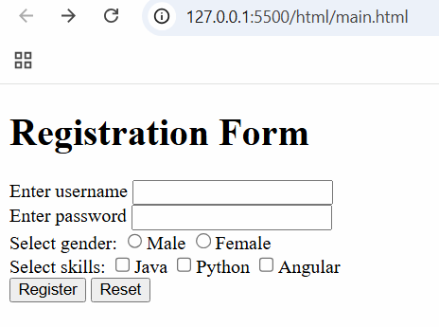
Other form controls are like date, file, email, range and so on
You can also create drop downs using <select> and <option> element
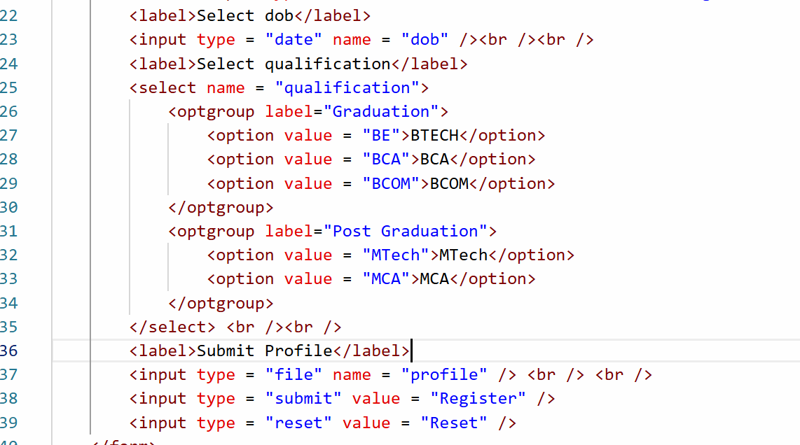
Output:
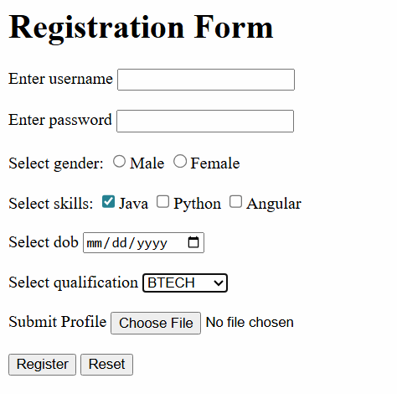
CSS
CSS stands for Cascading Style Sheet, it adds styles to the HTML elements, CSS has following selectors
- element selector: selects the element by the name
- class selector: selects the class associated with the element, multiple elements can have same class
- id selector: selects the id associated with the element, id must be unique
Types of CSS
- Inline CSS - You apply style to a particular element using style attribute
<h1 style = “color: blue”>Heading</h1>
- Internal CSS - You can apply style to an entire HTML document
<style>
h1 { color : red; background-color : yellow }
</style>
- External CSS - You can apply styles to multiple HTML documents
You will create an external css file i.e, global-styles.css
h1 { color : blue; background-color: yellow }
h2 { color : green; background-color: yellow }
Note: HTML document must use <link> tag to refer the external css file
css/global-styles.css
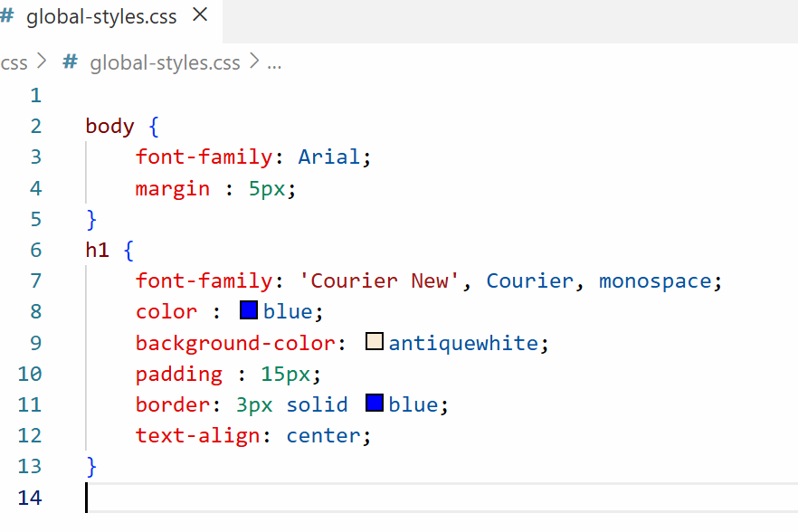
main.html
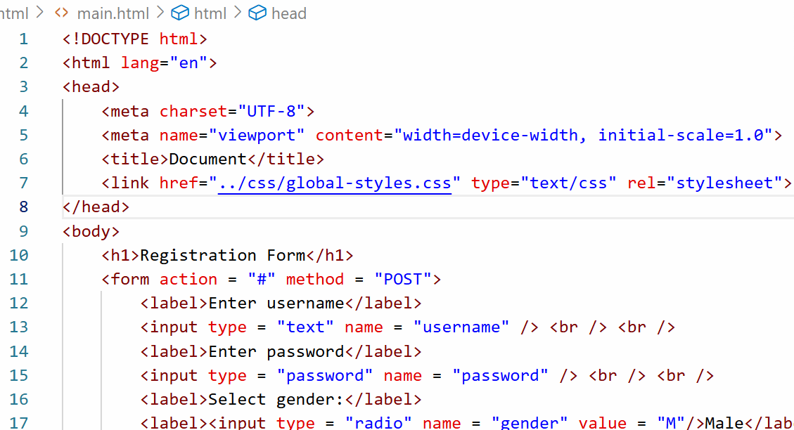
Output:
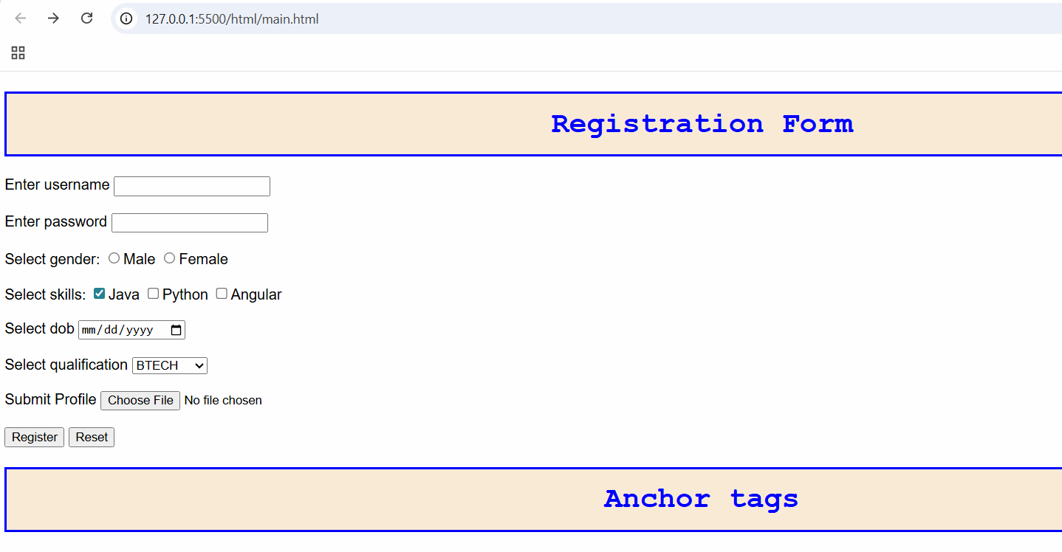

What happens when style is applied in externa, internal and inline
Inline overrides internal style and internal style overrides external style.
Activity:
Create a table, an ordered list element and a form element, apply CSS styles for all of them.
class & id
These are the selectors which you can use to apply styles to the element
class: You can have multiple elements using the same class, so that they all will have common styles
id: you need to have unique id for any element
<p class = “text-danger”>Some content</p>
<h1 class = “text-danger”>Some content</h1>
To apply CSS for class you must use dot followed by the class name
.text-danger { color : red }
<p id = “p1” >Some content</p>
To apply CSS for id you must use # followed by the id name
#p1 { background-color : yellow }
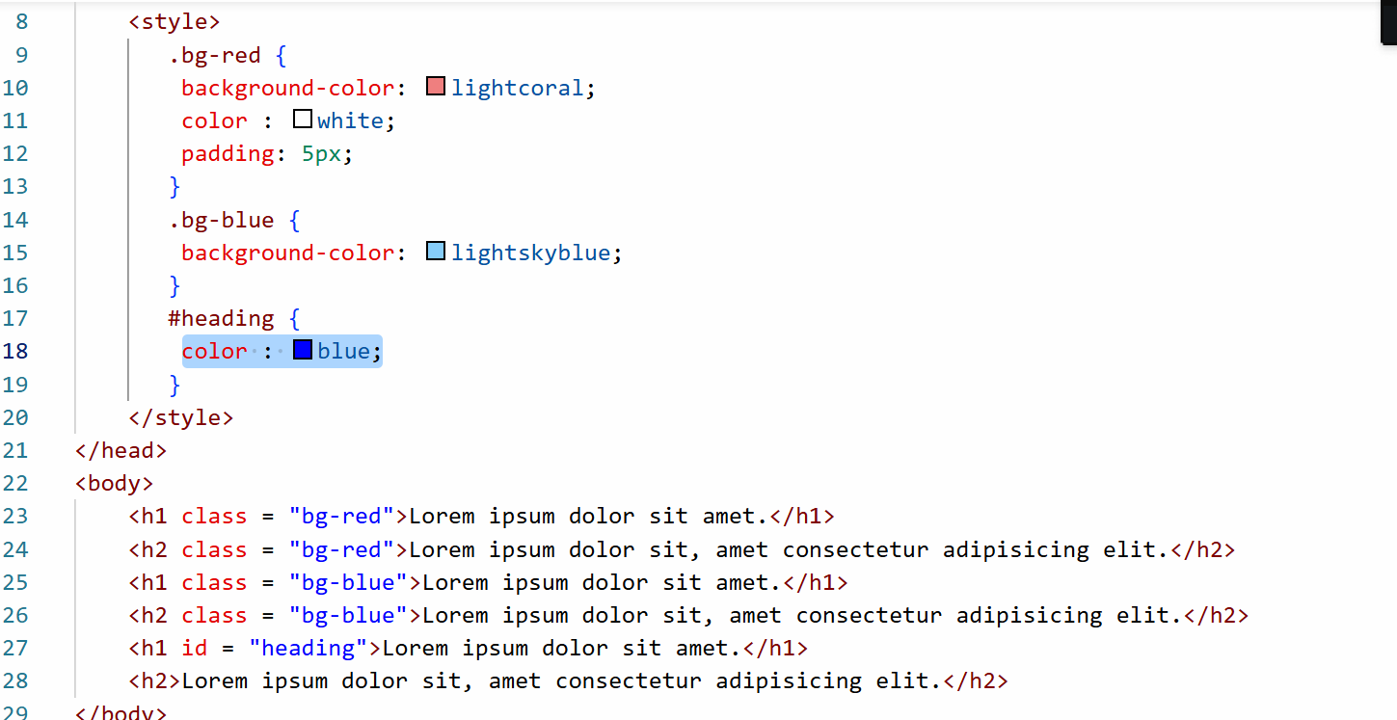
Output:
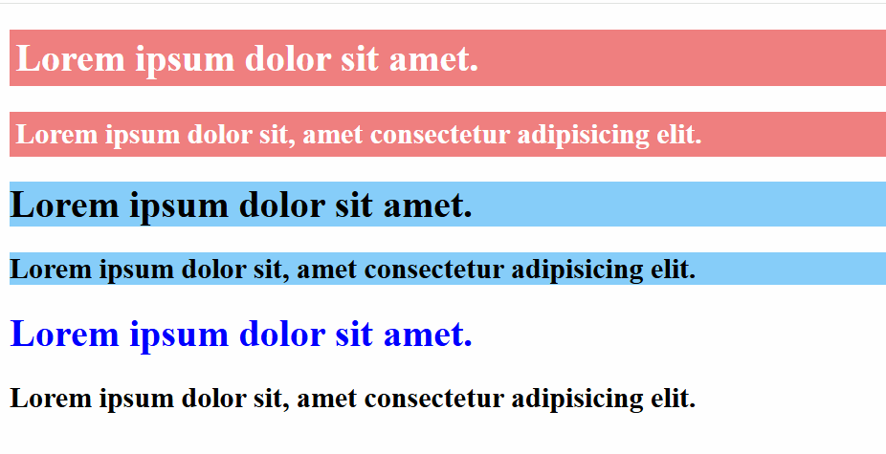
Bootstrap.js
It is a free library which you can use to apply CSS styles to your HTML elements, it gives lot of built-in classes that make your website to have a very good look and feel.
You need to just add the bootstrap.js library link in your HTML and go through the bootstrap.js website to see the built-class and how they appear on your page
Some common classes we can use from bootstrap
- alert alert-primary
- alert alert-danger
- btn btn-primary
- btn btn-secondary
- btn btn-danger
- btn btn-primary btn-lg
- table
- table table-striped
- form-control
- form-control form-control-lg
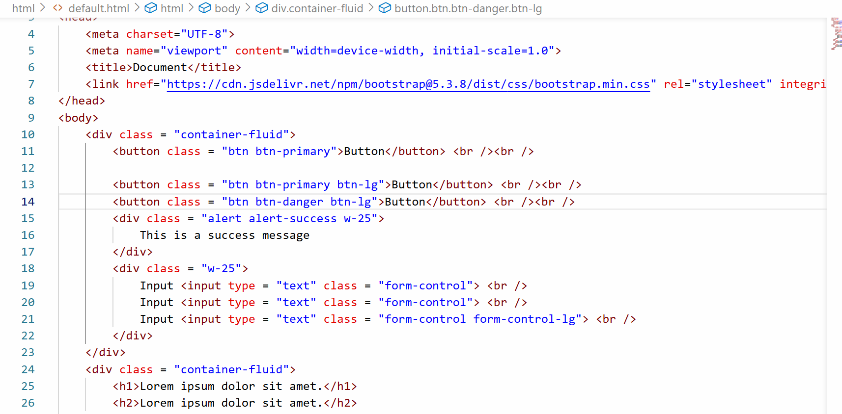
Output:
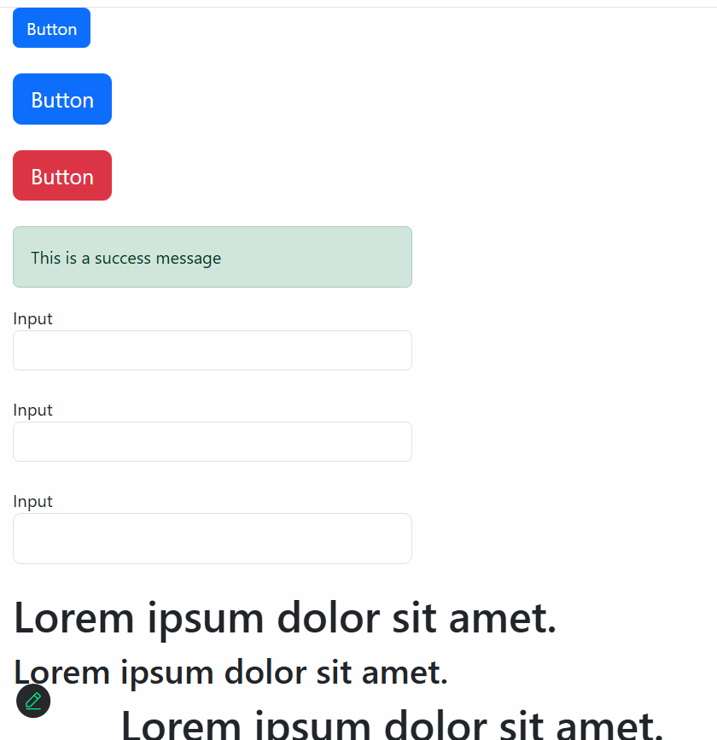

Javascript
It is a programming language which make website interactive, it runs in the browser (client-side) and it is also evolved to run on servers through node.js
To add javascript in your web page, you must include it in the <script> tag, you can write javascript inside HTML document or outside HTML document and refer it using <script> tag.
Software requirements
- VS Code
- Browser
index.html
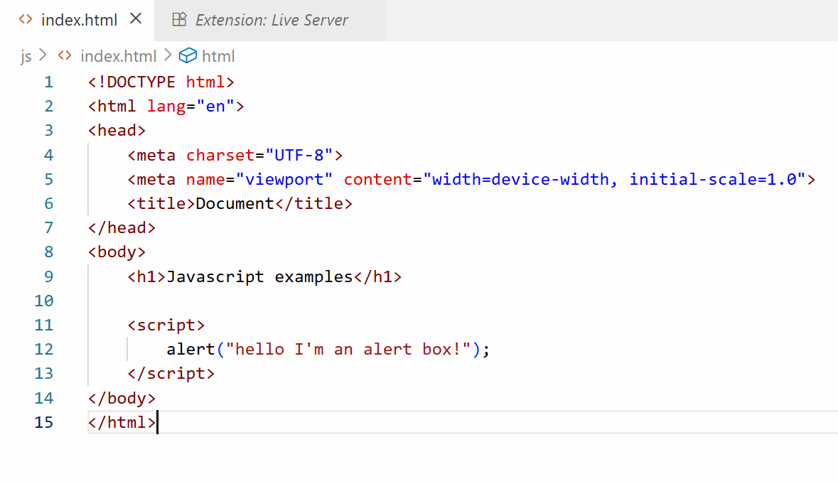
Output:
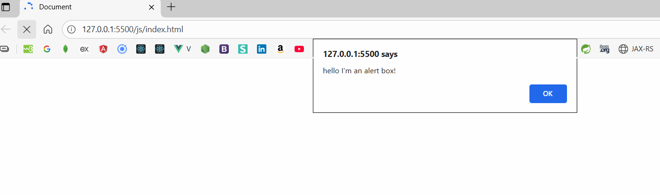
Various ways to display the messages
- alert
- document.write
- console.log
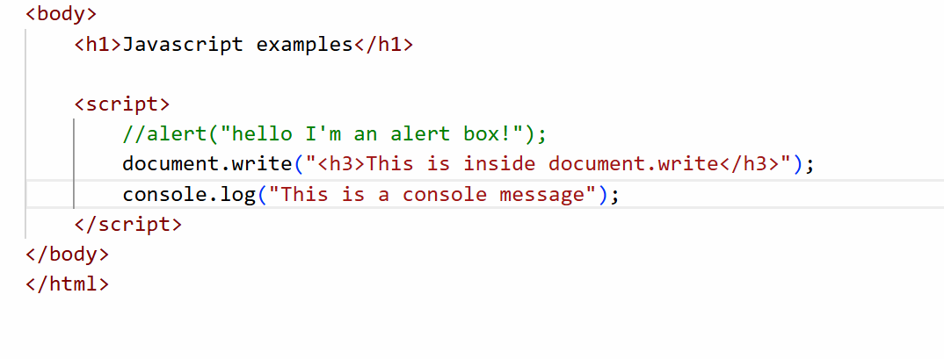
Output:
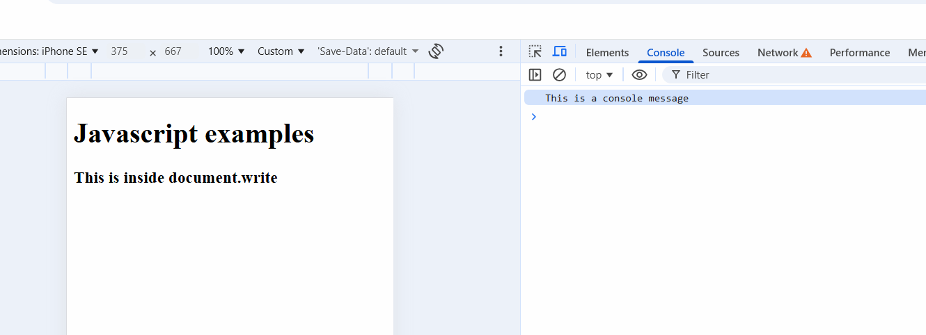
Javascript Fundamentals
- Variables & Functions
- Operators
- Conditional Statements
- Loops
- Arrays
- Objects
- Event Handling
Variables and Functions
Variables are placeholders or memory that can store data, it could be a simple data or a complex data, in Javascript you can declare variables using var, let, const keywords
Note: var is discouraged because it is an older approach and it’s not safe
Simple data
var username = “Kishor”;
var phone = 892892383;
var gender = ‘M’;
Functions: These are named blocks that will have set of instructions which you can reuse.
Function with a single argument
function greet(username) {
// this is a function that accepts an argument
}
Function with multiple arguments
function add(x, y) {
// add x and y
}
Function without any arguments
function test() {
// no argument
}
greet(“Kishor”);
add(20, 30);
test();

Variables Demo
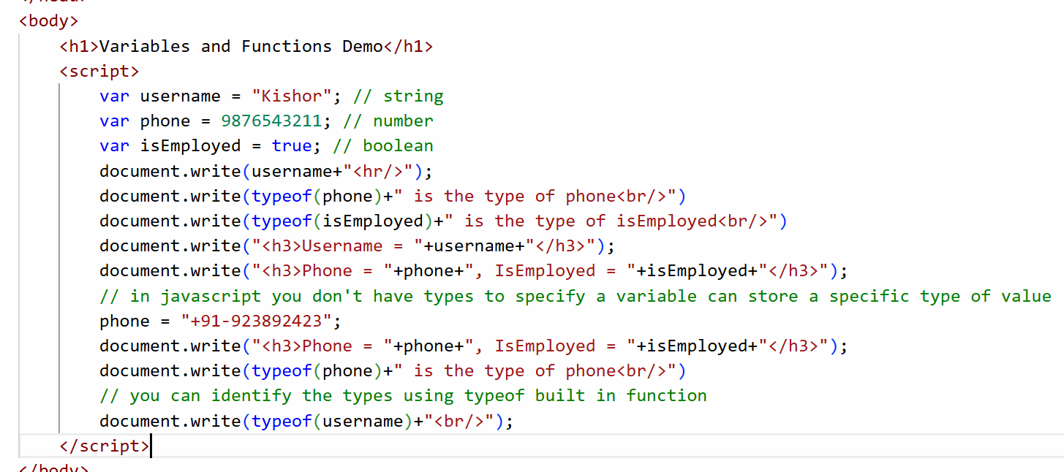
Output:
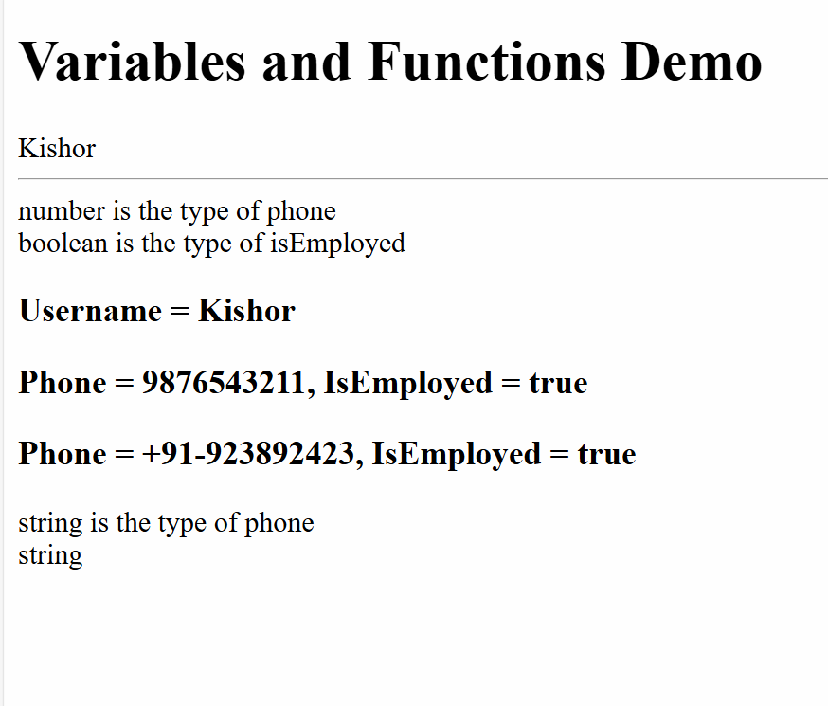
Function Demo
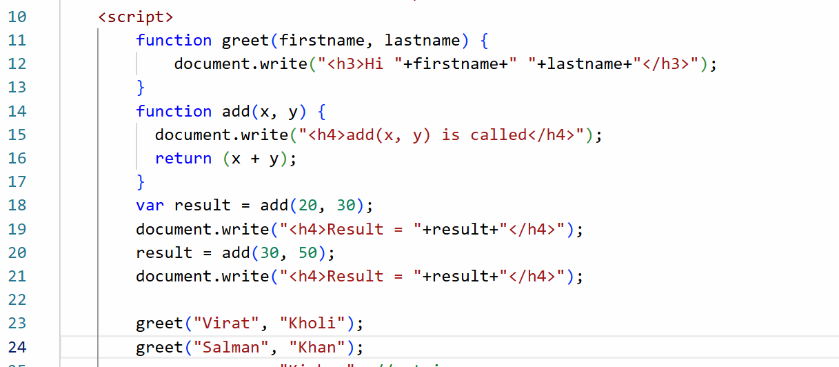
Output:
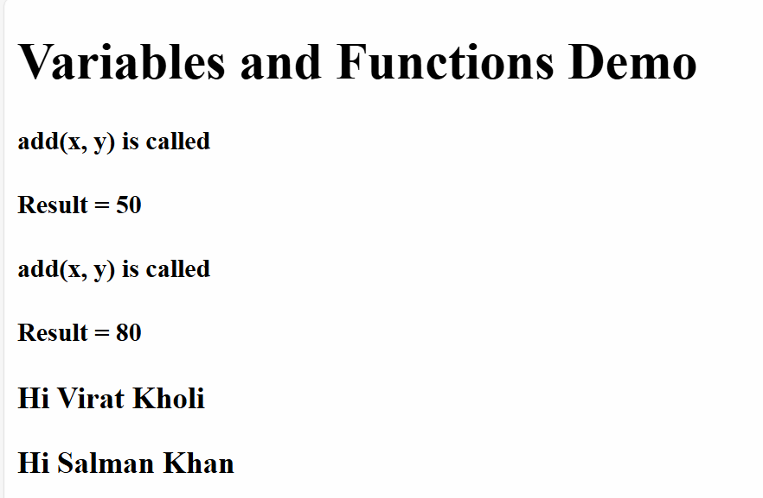

Operators
They perform operations on the variables or data, in Javascript there are many operations which are
+, -, /, *, =, %, ==, ===, <, >, <=, >=, !=, ++, --, &&, ||

Operators Demo
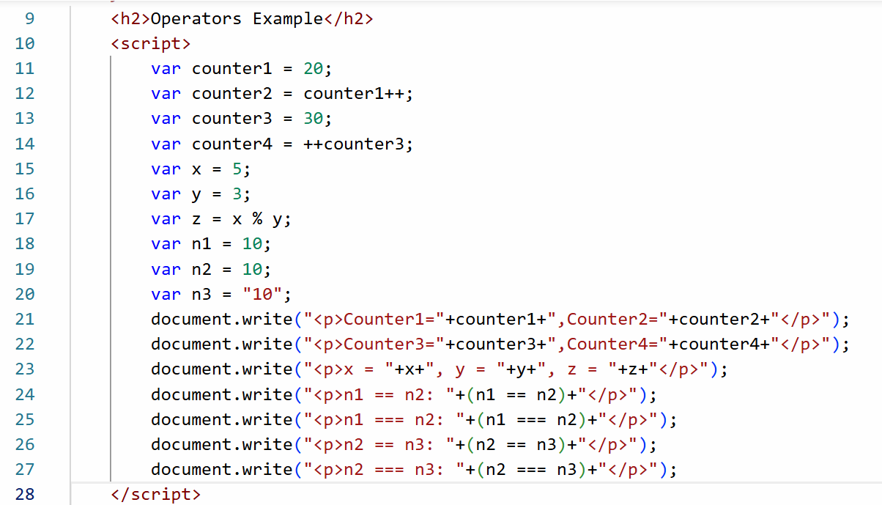

Output:
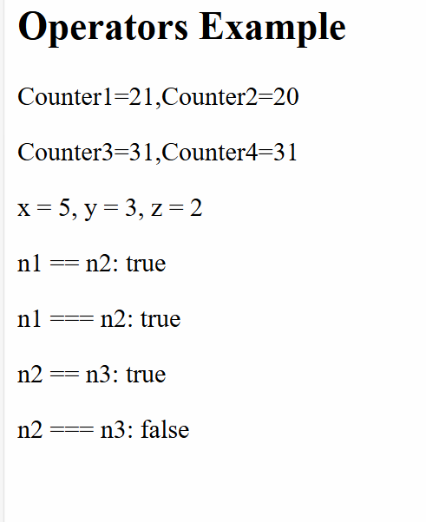
Conditional statements
Sometimes you want some code to be executed only when certain condition is met, there are following conditional statements in Javascript
- if
- if else
- if else if else if .. else
- switch
If Demo
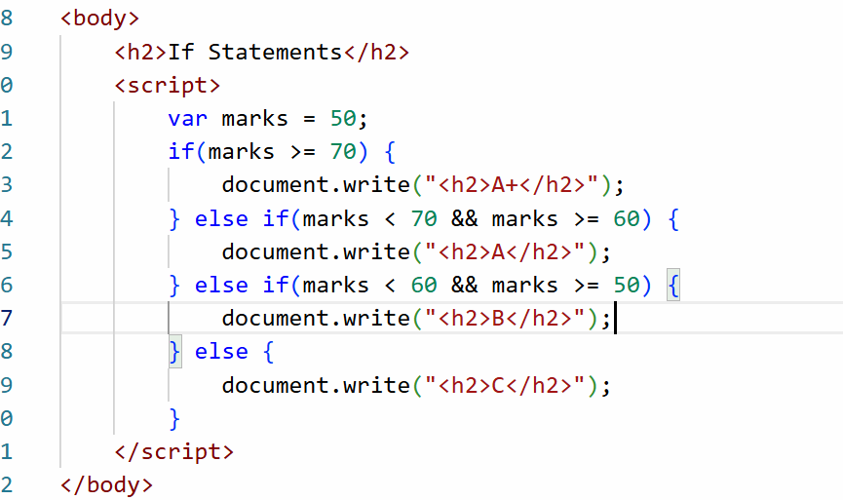
Output:
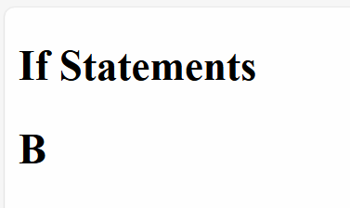
Switch Demo
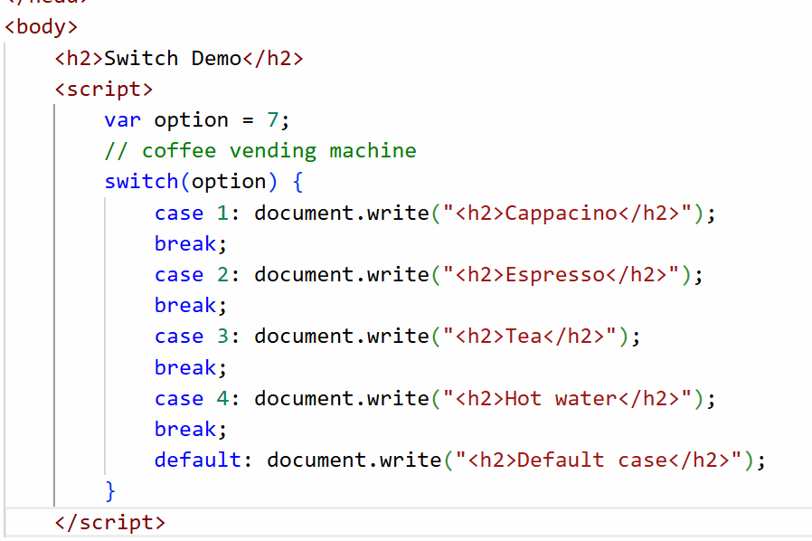
Output:
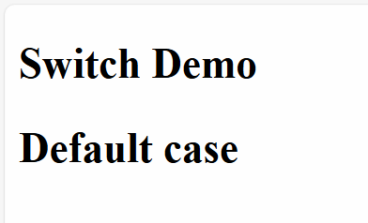
Complex types
These can store multiple values
- arrays - can store multiple values
- objects - they store properties and functions
Arrays:
let fruits = [ “apple”, “grapes”, “orange”, “mango”] ;
let items = [20, 10, 50, 30];
let items2 = [20, “apple”, true];
Objects
let employee = {id: 200, name : “Kishor”, gender: “Male”} ;
Object Array
let profiles = [ {id: 200, name: “Atharva”}, {id : 300, name: “Siddharth” }] ;
Array and for
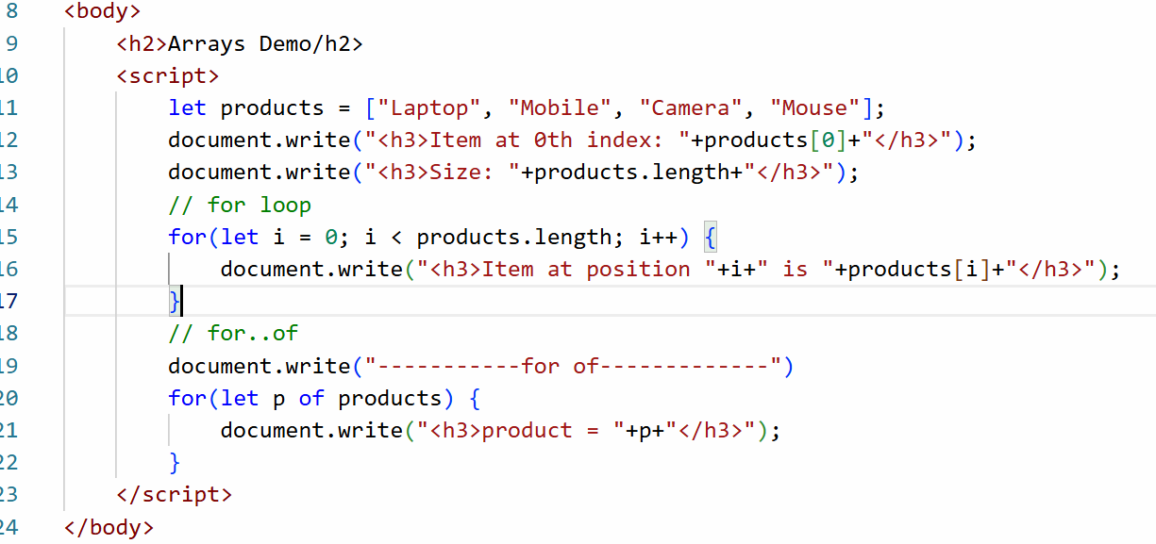
Output:
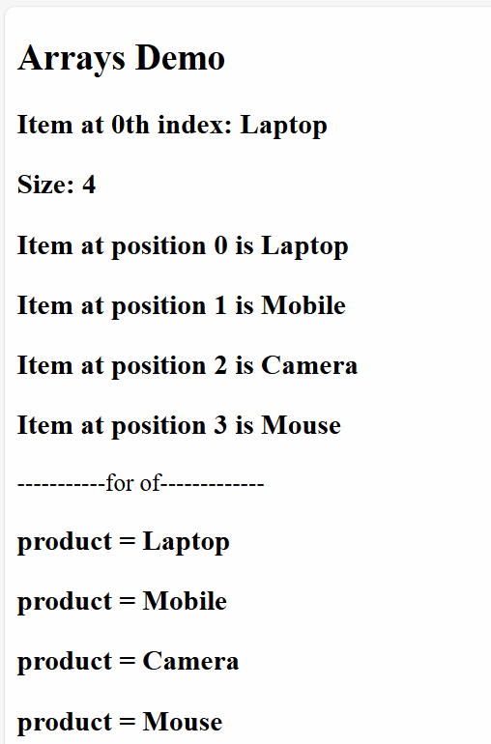
Loops:
When you want to run the same statement repeatedly you use loops, there are 3 types of loops
- for loop: When you know how many times to iterate
ex: iterating an array or printing a counter from 1 to 10
- while loop: Run the statement as long as the condition is true, it checks the condition first and then runs the loop
ex: print ticket until its available
- do while loop: It runs atleast once and then checks the condition
ex: Asking for ATM pin and then proceeding to withdraw, if pin is wrong again you will ask user to enter pin
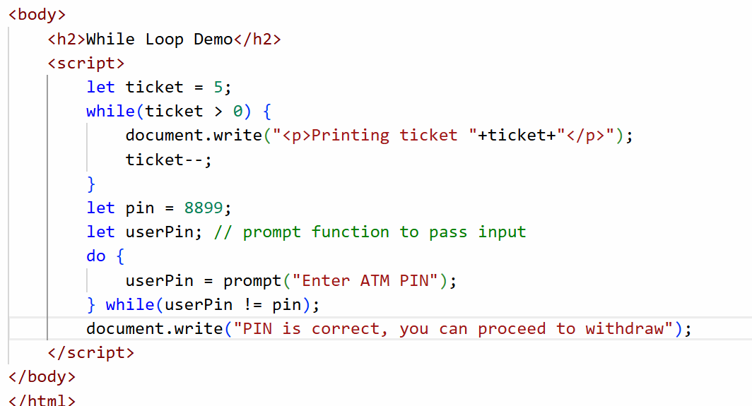
Output:
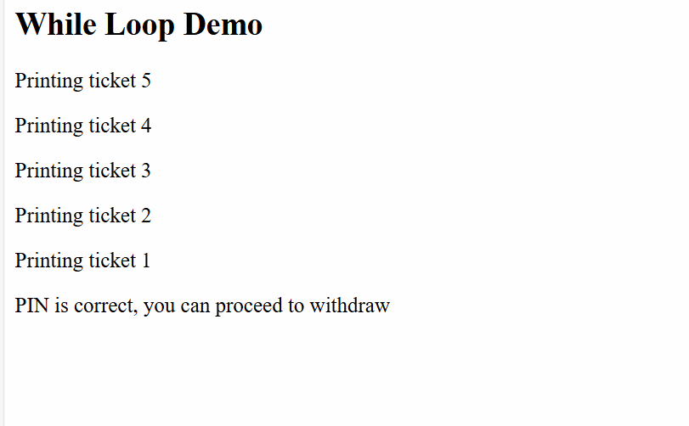
Activity:
In the following array 75, -5, 8, 20, -8, 5, 15 print the sum, max and min values
Expected output:
Max : 75
Min: -8
Sum: 110

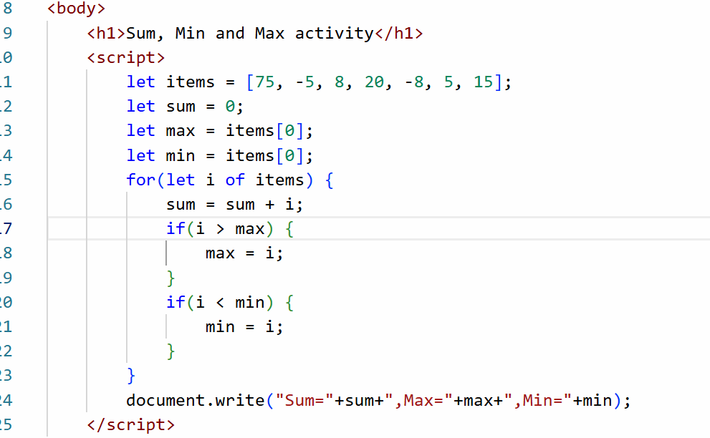

Javascript objects
Objects are real world entities they will have properties and behaviour
properties - what object has like name, phone, gender, email, dob
behaviors - what object does like login, withdraw(), deposit(), these are functions of objects
In Javascript you can create objects in following ways
- literal style
let emp = { id : 100, name: “Raj”, salary : 30000 }
- class based
class Employee { … }
let emp = new Employee(100, “Raj”, 30000);
- function based
function Employee(id, name, salary) { … }
let emp = new Employee(100, “Raj”, 30000);
Javascript Object Demo
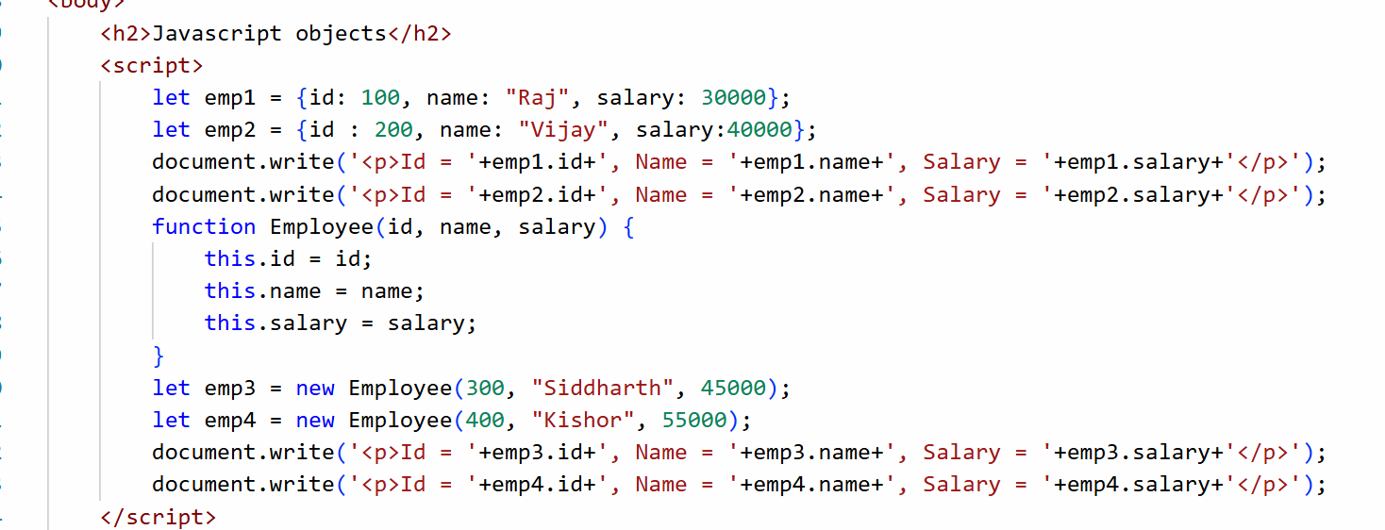
Output:
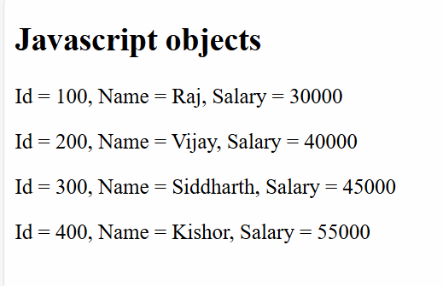
Literal style objects:
Best when you want a single object, because it is quicker to create, usually for configurations we use literal style objects
Here you can’t create similar objects without duplicating i.e., you need to copy-paste the same object and change their names
Function style objects
It uses a constructor function that specifies the structure of the object, you can create multiple objects with the same structure easily, you can use this approach when you want multiple objects with same structure.
How to add functions in an object
In literal style
let emp = { id : 100, name : “Raj” , salary : 45000, display : function() { /*code here*/ } }
emp.display();
In Function style
function Employee(id, name, salary) {
this.id = id;
this.name = name;
this.salary = salary;
this.display = function() {
/*code here */
}
}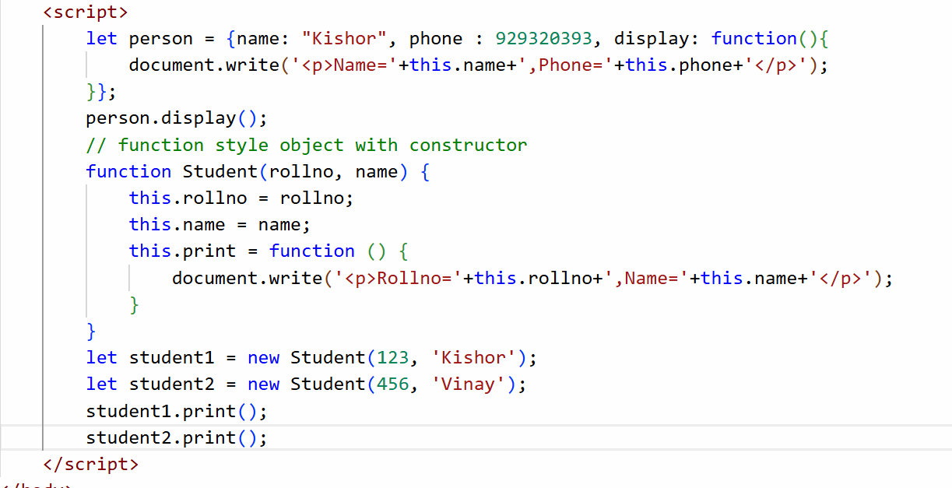
Output:
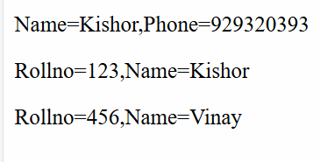

Event handling
Events are the things that occur when user interacts with HTML element like clicking, mouseover, keyup, keydown, form submission and etc.
Event handlers: These are javascript functions that are executed when a particular event occurs
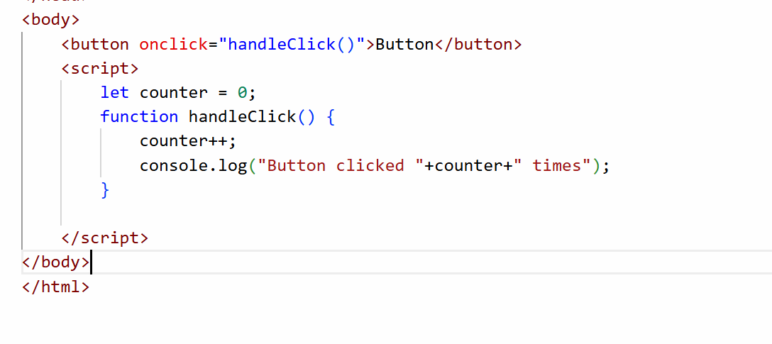
Output:
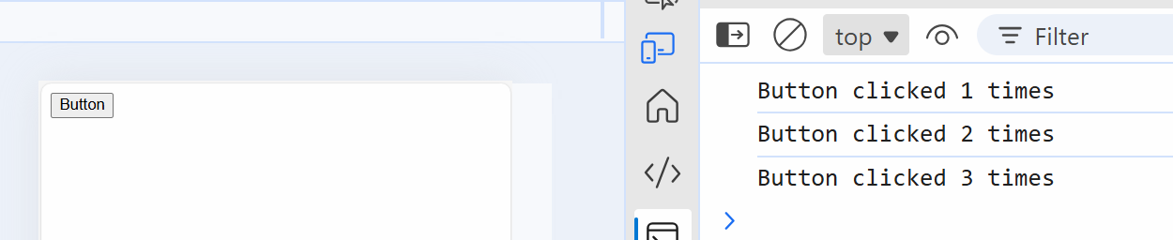
document.write(): erases the existing content if a content is written later.
We must access an element based on some selectors like tag name, id or class, in the document object we have methods to access the elements
document.getElementById(“id”): This returns the element having an id
document.getElementsByClassName(“class”): This returns array of elements
document.getElementsByTagName(“tag”): This returns array of elements
document.querySelector(“selector”): This returns the element based on the selector which could be id, class or tag names
document.getElementById(“id”): This returns an HTMLElement
HTMLElement: It is an object that has properties like innerHTML, textContent, style and so on
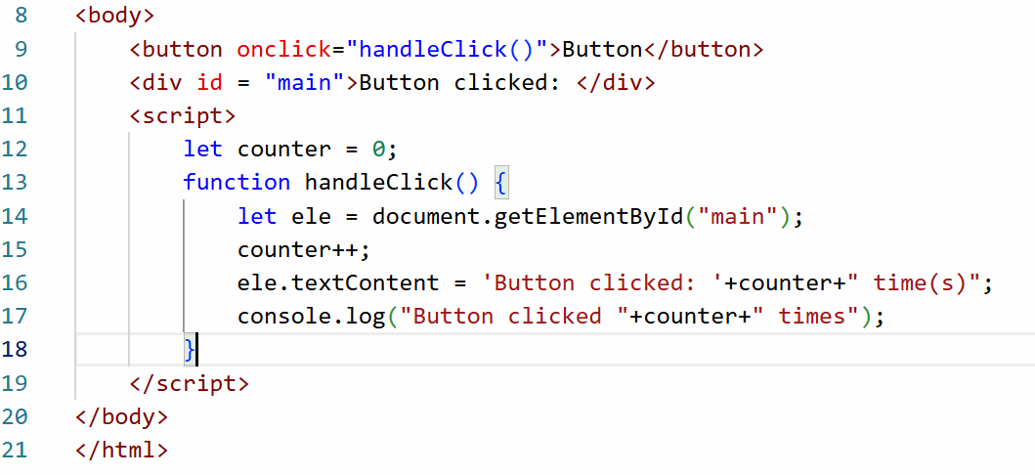
Output:
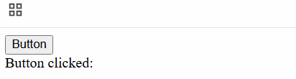

document.querySelector(“selector”): This is used to access an HTML element based on id, class or tag names, but it returns only one element if you use class or tag names
<p id = “x”>
<p class = “y”>
<div class = “y”>
<p class = “y”>
document.querySelector(“#x”): #x means id = x, it selects <p id = “x”>
document.querySelector(“p”): it selects there very first <p> i.e., <p id = “x”>
document.querySelector(“.y”): It selects the class which has the class = y, here the very first element is selected i.e., <p class = “y”>

using document.querySelector
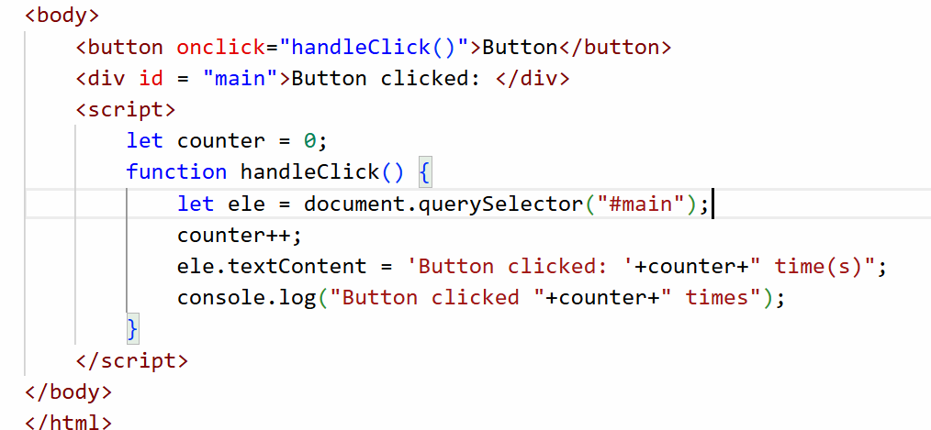
Output:
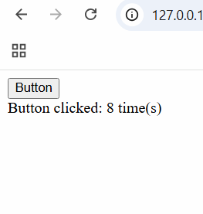
How to dynamically add styles to the element
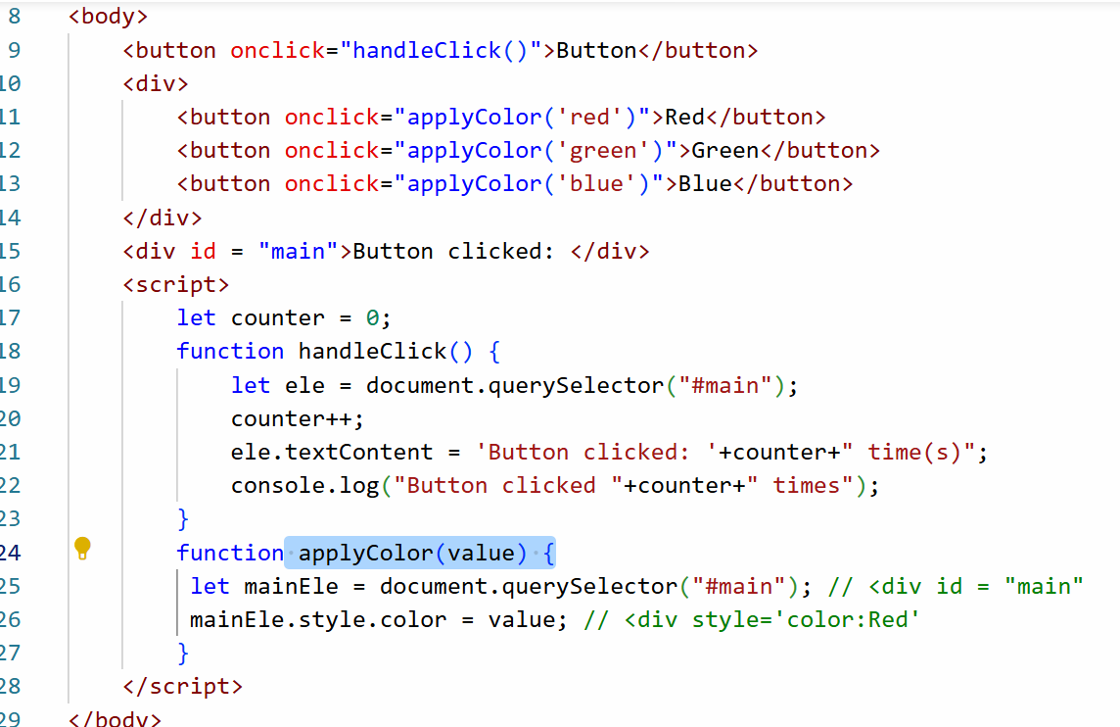
Output:
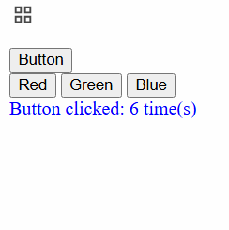

In Javascript you have an object called event that refers to the target element that generated the event, this helps you to dynamically access HTML element
<div onclick=”apply(event)”>
<h1>..</h1>
<h2>..</h2>
</div>
event.target that refers to the element that generated the event, this is another way of getting the element without using getElementById() or querySelector()
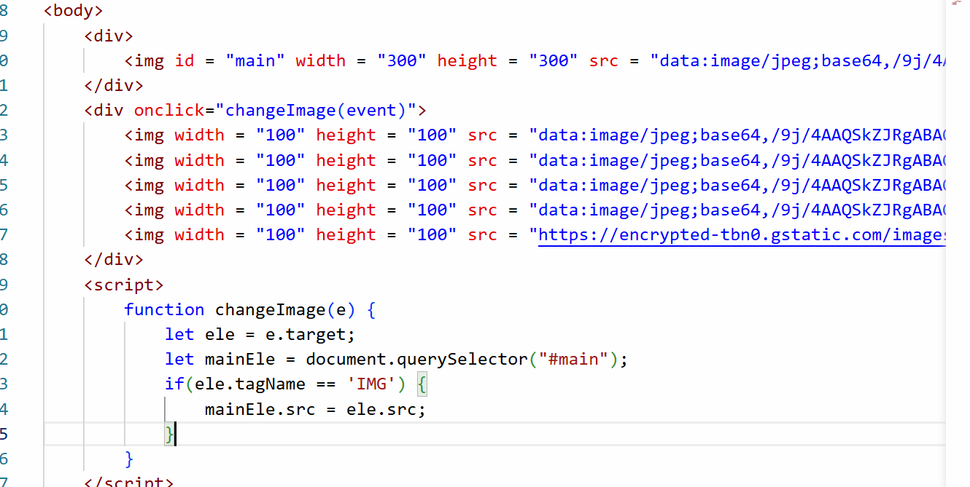
Output:


Activity: Enter inputs in Input1 and Input2 text box and Result must show the operation based on the buttons you click.
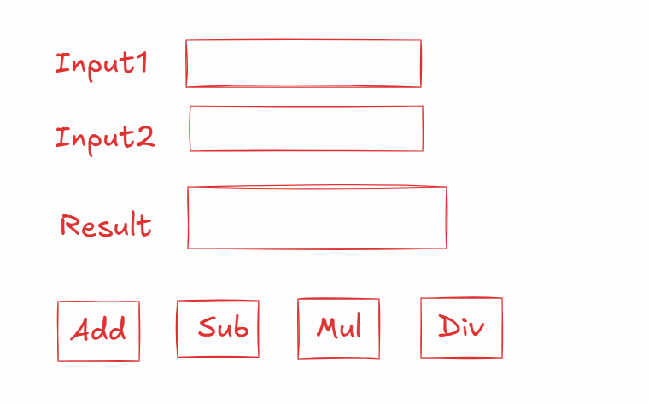
Validating form inputs
Javascript can perform client side validations as well like stopping user to send some invalid data to the server
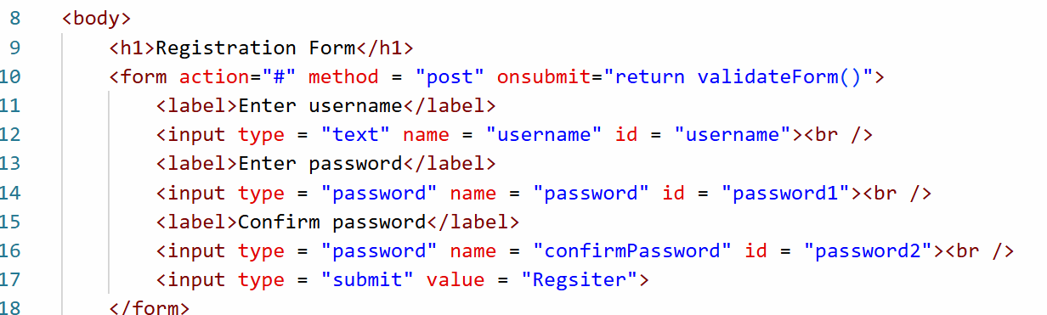
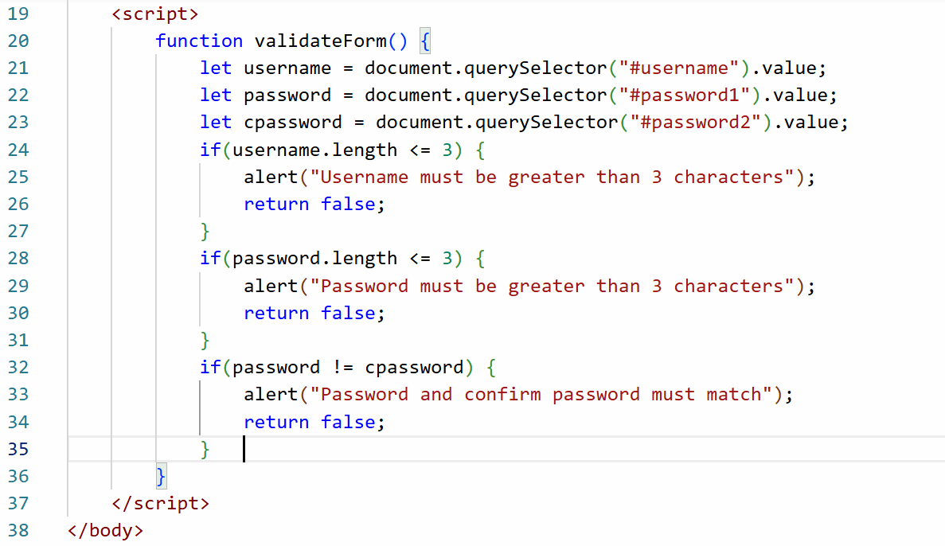
Output:
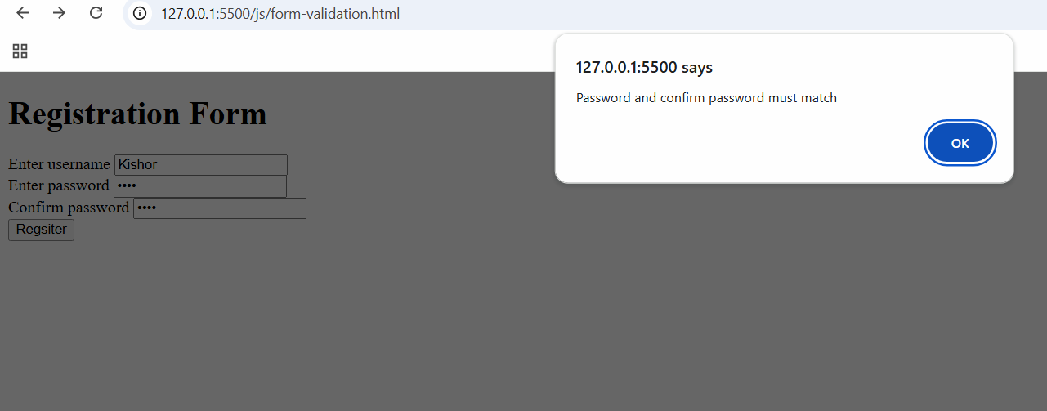
22-11-2025
Summary of JS
- Fundamentals - operators, variables, functions, objects, arrays
- Event handling
- document.querySelector(“..”)
- document.getElementById(“..”)
- event.target
- Form validation
- var vs let vs const
Modern features of JS
- let & const for variables
- class, constructor - for objects
- rest and spread operators
- Template Strings
- array and object Destructuring
- arrow functions
- Promises
- async/await
class & constructor: It is used to create objects with a modern syntax instead of using function keyword
Old approach:
function Employee(name, age) {
this.name = name;
this.age = age;
this.display = function() { console.log(this.name, this.age) ; }
}
New approach:
class Employee {
constructor(name, age) {
this.name = name;
this.age = age;
}
display() { … }
}
let emp = new Employee(“Raj”, 35);
emp.display();
Rest & Spread operators
Earlier you couldn’t write functions to take varying arguments
Old approach:
function sum(x, y) { .. }
You must pass 2 parameters to the sum() function, but what if at runtime you want to pass 3 or more parameters
Rest operator/parameter: It is a parameter to the function that can accept 0 or more parameters
Note: In a function you can have maximum one Rest parameter & it must appear as a last parameter
New approach: Rest parameters which can accept 0 or more parameters
function sum(a, …b) { …………. }
Now sum has …b which can accept 0 or more parameters
sum(20, 30); // a = 20, b = 30;
sum(20), // a = 20, b =
sum(20, 30, 40) // a = 20, b = [30, 40]
sum(40, 50, 60, 70) // a = 40, b = [50, 60, 70]
Template Strings: It uses back tick(`) character to easily concatenate string and javascript expression
Note: Single quote ‘ is different and back tick ` is different
`<p>Name = ${name}, Age = ${age}</p>`

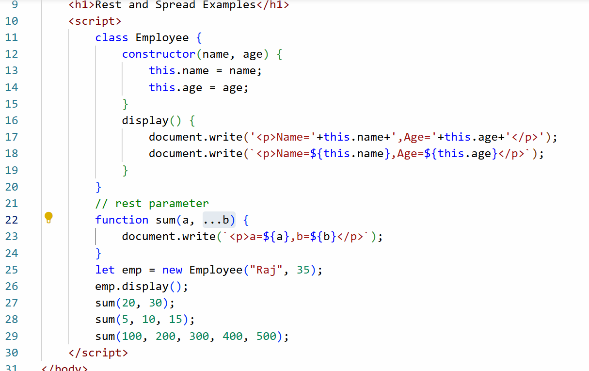
Output:
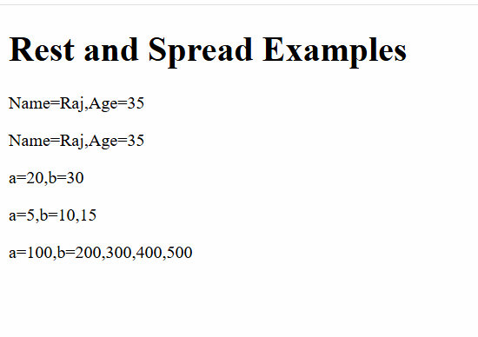

Spread operator: It is used to spread multiple values of an array to multiple parameters of the function
Old approach
let items = [20, 30, 40]
function test(x, y, z) { … }
test(items[0], items[1], items[2]);
New approach
test(…items); // x = 20, y = 30, z = 40
the items value would spread across the parameters, if there are 3 elements in the array and 3 parameters in the function then it spreads properly
If there’s a mismatch in the array elements or parameters of the function
items1 = [3, 1, 6]
items2 = [10, 20, 30, 40, 50]
function test(a, b, c, d) { }
test(…items1); // a = 3, b = 1, c = 6, d = undefined
test(…items2); // a = 10, b = 20, c = 30, d = 40 and value 50 will be lost
So to avoid losing the values you need to combine rest & spread
function test(a, b, c, …d) { … }
test(…items2); // a = 10, b = 20, c = 30, d = 40, 50
rest vs spread
Rest parameter is used while creating the function parameter
Spread operator is used when you want to assign values to the variable i.e, while calling the function you can use spread operator
Destructuring
It is a feature that helps to easily assign values to the variables in a single line without declaring them in separate lines
Array Destructuring:
let items = [10, 20, 30];
old approach
let x = items[0];
let y = items[1];
let z = items[2];
new approach
let [x, y, z] = items;
Object Destructuring
let emp = {id : 100, name : “Raj”, salary : 55000}
old approach
let id = emp.id;
let name = emp.name;
let salary = emp.salary;
new approach
let { id, name, salary } = emp;
Note: variable names must match to the object properties, if you don’t give the same name then that variable will be undefined
let {x, y, z} = emp;
x = undefined, y = undefined, z = undefined
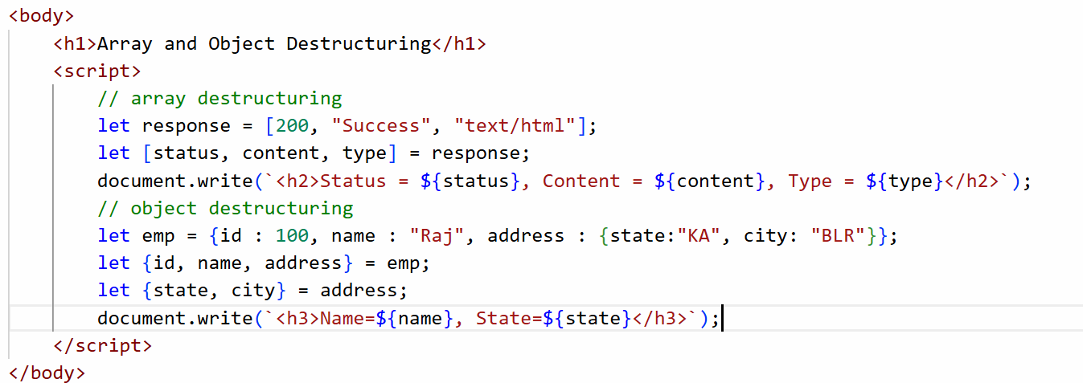
Output:
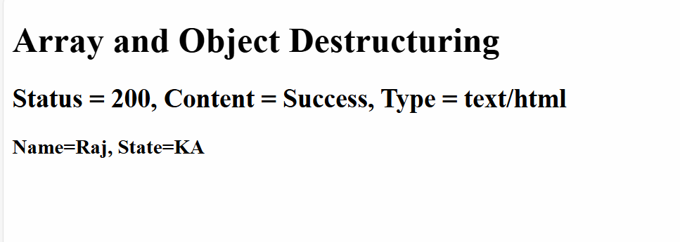
Arrow functions:
These are simplified form of an anonymous functions / callback functions in javascript
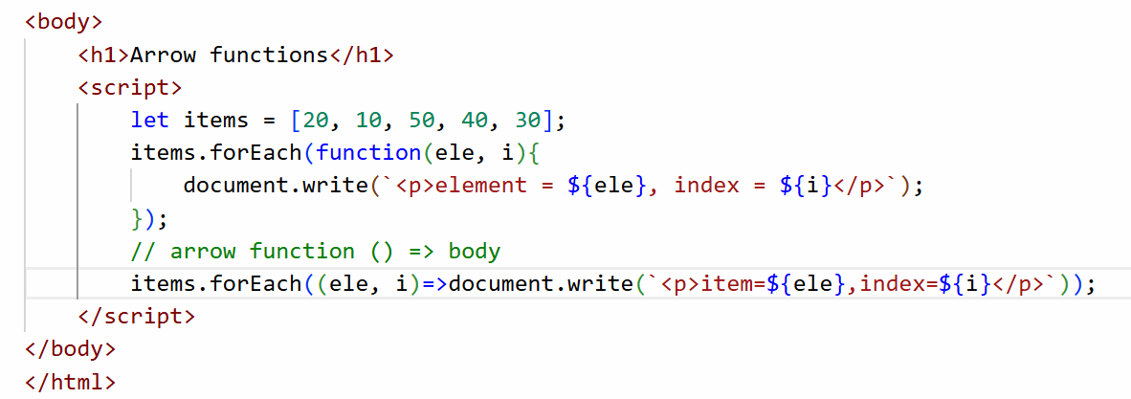
Promises in Javascript
These are objects which can perform asynchronous operations like handling the requests or any other background process which waiting for the response
Promise can return either with success or failed response, to handle these two status you have .then() and .catch() functions, these two functions take callbacks that are executed when the response is ready
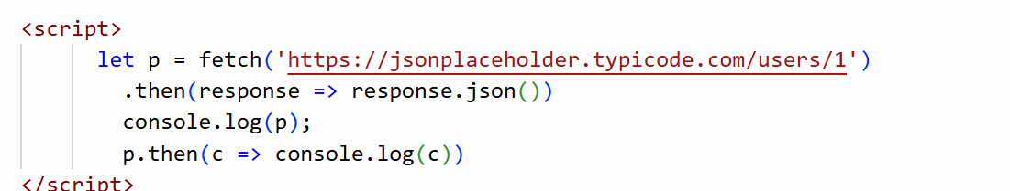

23-11-2025
Async/Await: It is a simplest way of dealing with promise objects, it will wait for the promise to settle and then only it goes to execute the next statement
Difference between async/await and promise
Promise | Async/await
Use it when you are not depending on the previous promise result | Use this when you are depending on the previous promise
Uses .then() or .catch() to settle the promise | Uses await to settle promise, and also you can use await only inside async function

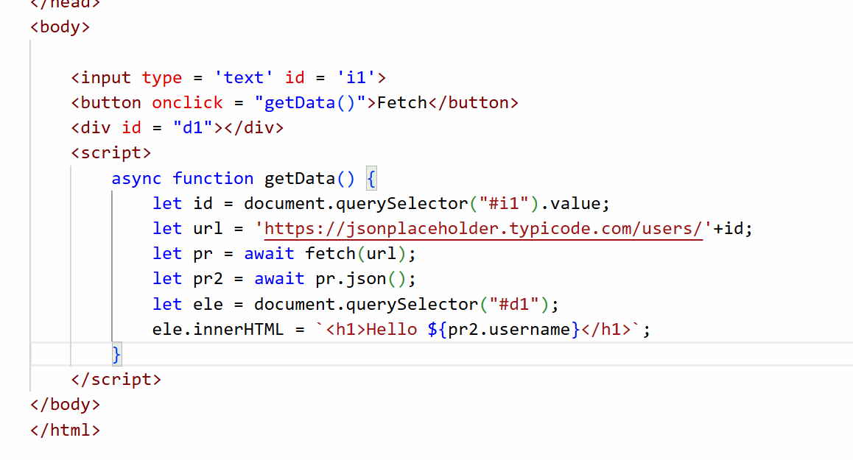
Output:
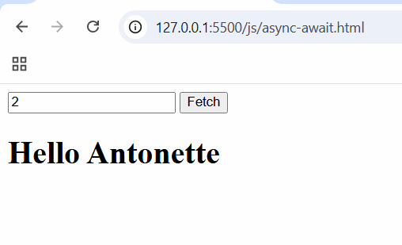
Summary
- Fundamentals of JS
- Event handling
- Access HTML elements
- Modern JS features - arrow, template strings, Destructuring
- Promises and async/await
Angular Framework
It is used to develop Single Page Applications using Typescript and HTML technologies, it helps you to create mobile and web based applications
Typescript - It is a super set of Javascript, it adds types to the Javascript
Ex: In JS a function or a variable can be written without types, they are not type safe
let name = “Kishor”;
name = 10;
name = true;
name = new Date();
function sum(x, y) { }
sum(“hello”, “world”);
sum(2, 3);
The data wouldn’t be reliable in JS, because the data are not typed
Typescript: It adds types to the variables, functions, parameters, return types
It gives types like string, number, boolean, any, undefined
let name : string = “Kishor”
name = 25; // typescript compiler throws an error
Typescript -> compiled -> Javascript
Software’s required
- Node.js - LTS: node and npm tools
- VS Code
- Angular CLI - Provided by Google to create and manage angular projects

How to install Angular cli
npm install -g @angular/cli [or] npm i -g @angular/cli
Verify the angular cli
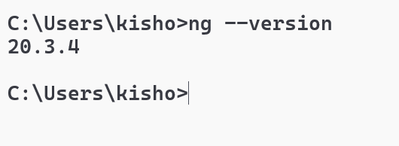

Angular CLI features
- It helps you create and manage angular projects
- It provides built-in commands to quickly setup angular features like components, services, pipes and etc.
- It provides built-in development server which automatically reloads the application when you make changes in it
- It provides commands to run, test and build angular applications
How to create an angular project
ng new project-name --no-standalone
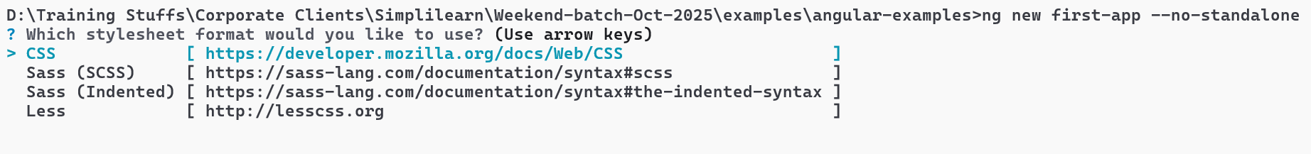
You can use arrow keys to select the stylesheet -> we will select CSS
Next it asks for server side rendering - type N
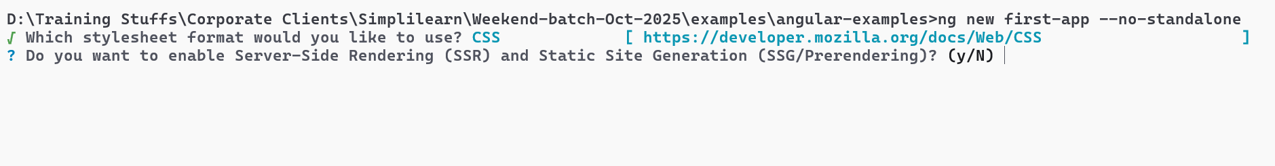
Next it asks for zoneless - type N
Next it asks you to select AI tools select None
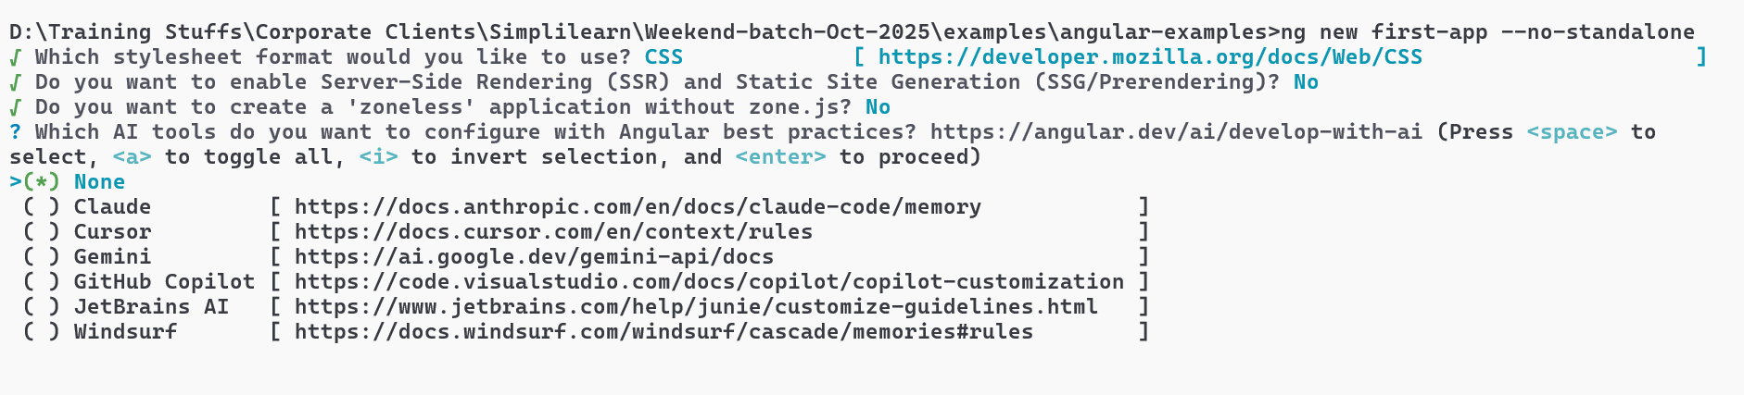
Now you see the project getting created
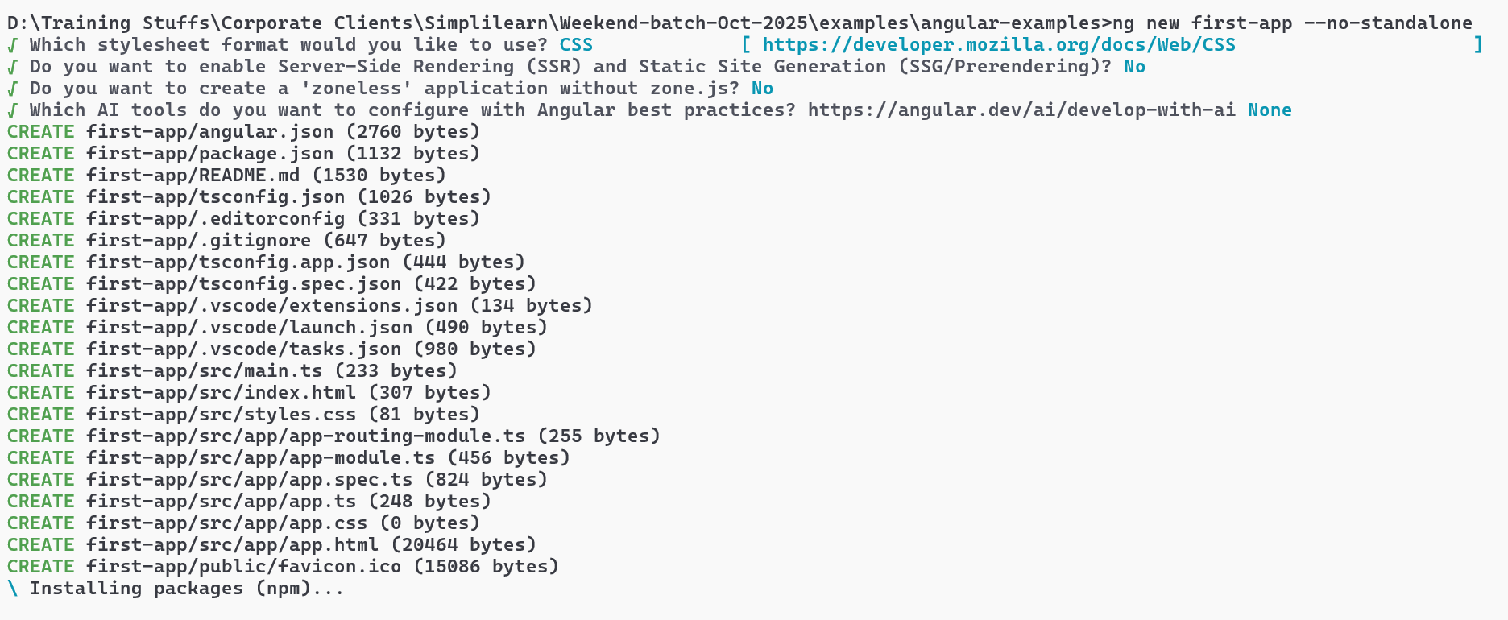
How to run the project
You must navigate to the project folder & run the command `ng serve` or `npm start`
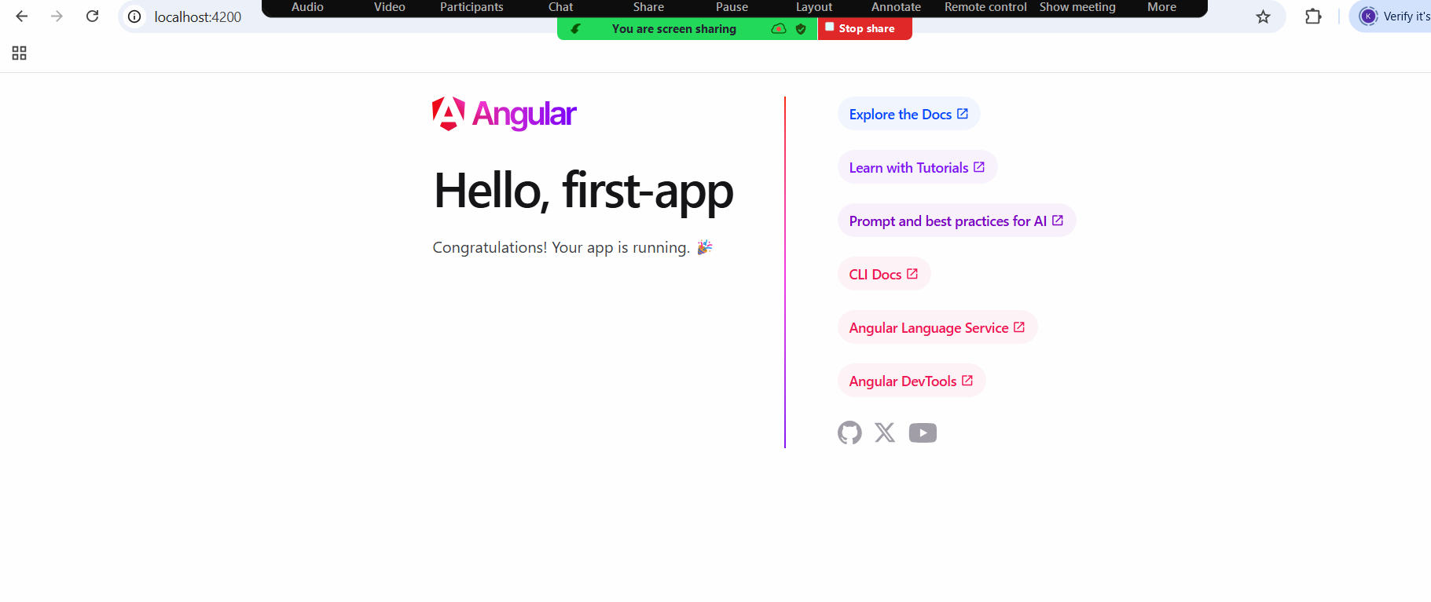
Note: This is the default output you get in every new project

Project structure
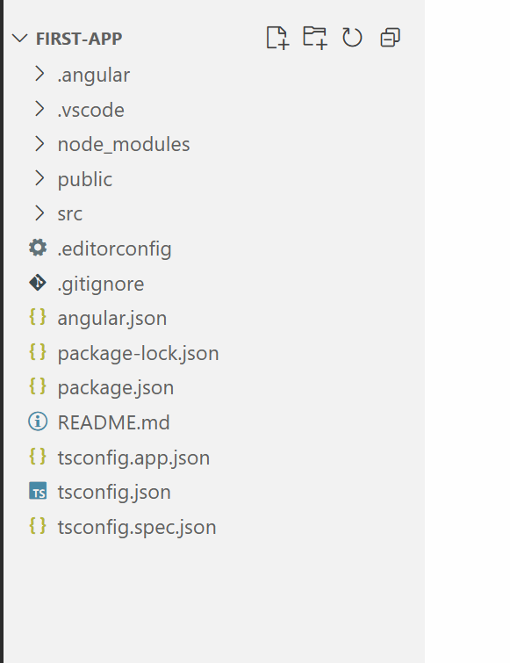
Component: It is a reusable UI which you can develop independently and use in other components
A component will have mainly 4 parts
- selector - tag name
- template - html content
- css - styling of the template
- class - logics and data
A component is created with a @Component({ }) decorator and written on top of the class
@Component({
selector : ‘app-root’, templateUrl : ‘app.html’, styleUrls: [‘app.css’]
})
export class App {
}

app.ts
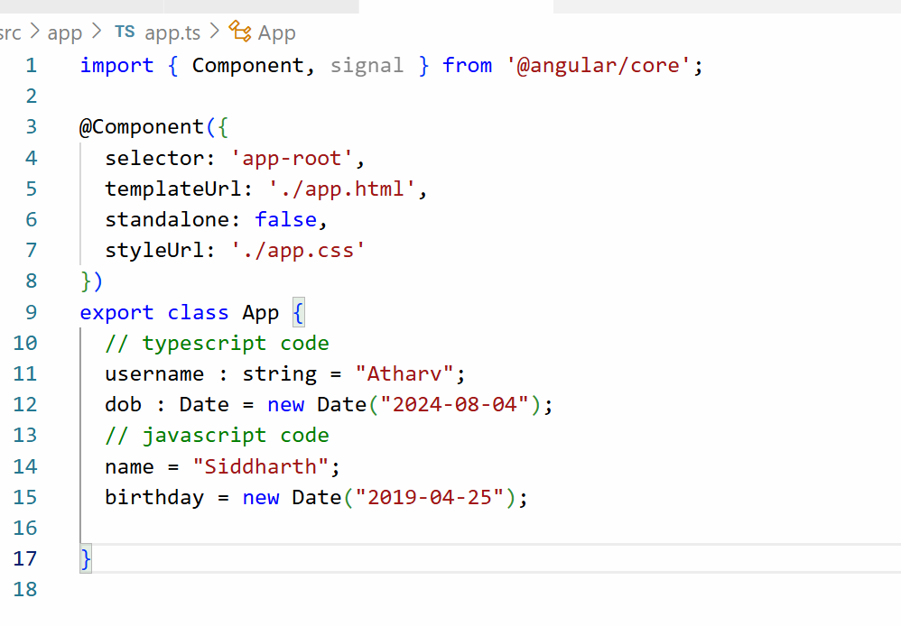
These variables are storing some data which can be hardcoded or you can get those data from the backend programs, to display these data you can use html template and wrap these data using {{ variable-name }}
app.html
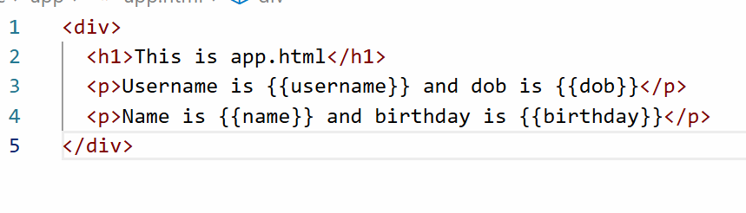
Output:
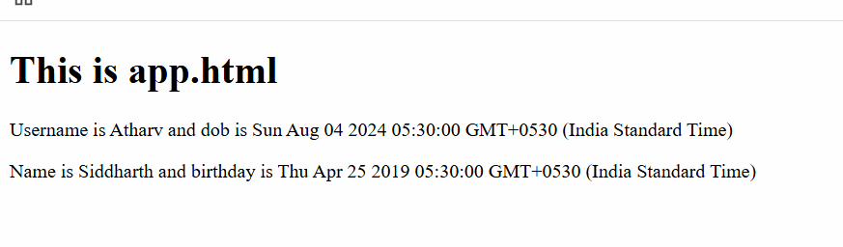
How to create our own components
- Manually you can create but, you need to create
  - folder to organize the components and other files
  - ts file
  - css file
  - html file
  - class with @Component decorator
  - declare the component in the app.module.ts file
- You can use the command to create a component, that takes care of automatically doing all the above steps which you manually do
Manually configuring the components
src/app/hello/hello.ts
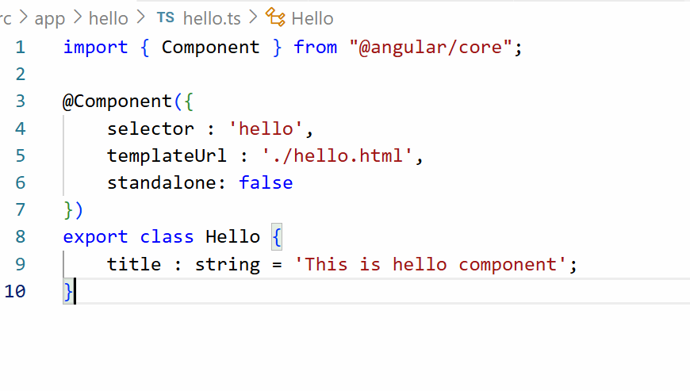
src/app/hello/hello.html
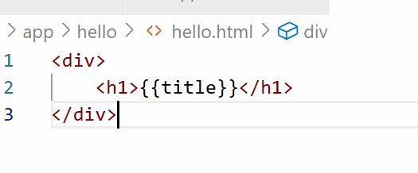
Add the Hello component in the @NgModule.declarations so that you can use
the <hello> tag in any other components
app-module.ts
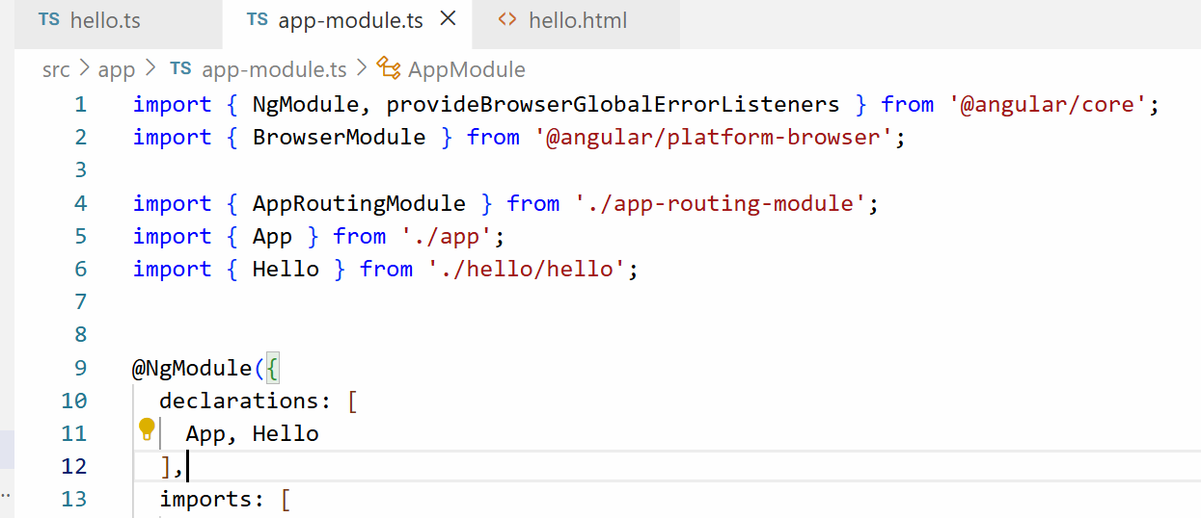
app.html
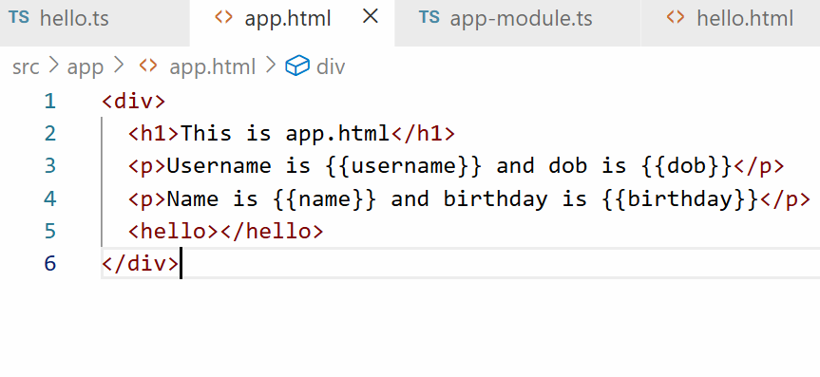
Output:

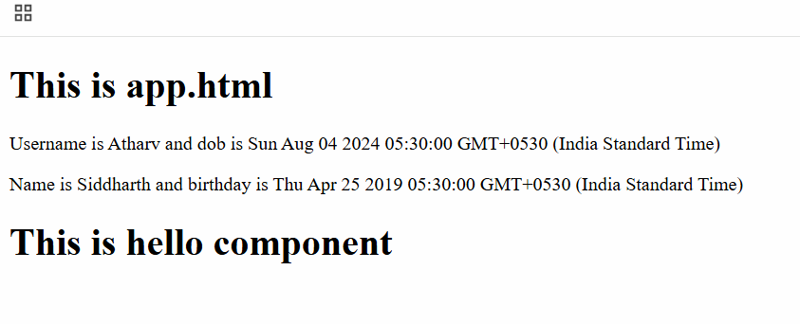
29-11-2025
Creating components using command
ng generate component component-name [or] ng g c component-name
Note: All the angular related commands must be entered in the parent directory of the project, i.e., project folder.
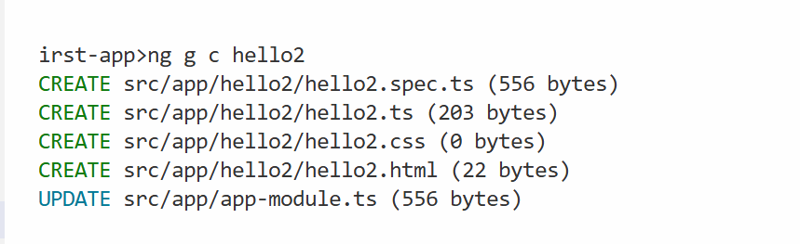
Regardless of what components you create, we must understand that only the root component is part of the index.html, so all the components we created must be part of root component or its child component.
app.html
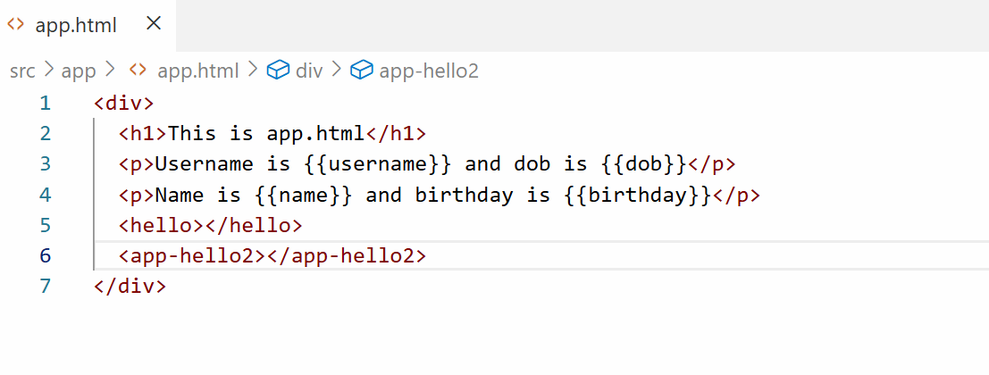
Now you can see the hello2 component result in the web page
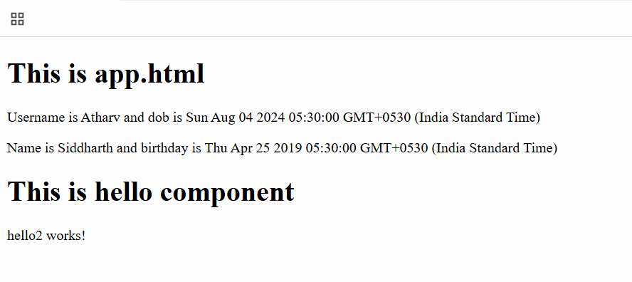
Activity:
- Create a component with the name employee, inside the employee component create a Javascript object called emp that will have properties like id, name, salary and dob, in it’s HTML display those id, name, salary and dob and add the employee component in the root component

Angular data-binding
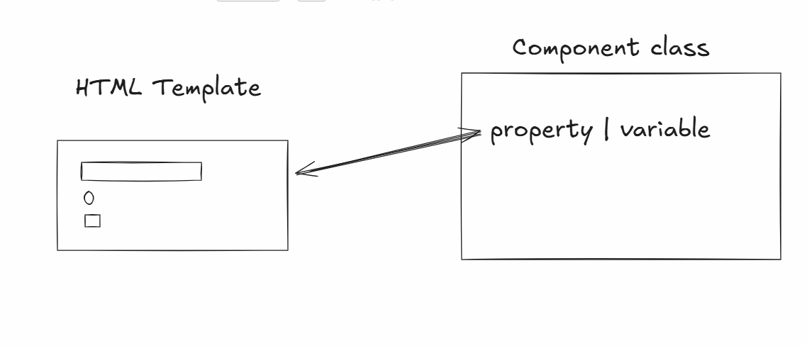
Data-binding is a way where angular helps HTML template and Component class to share the data, in Angular there are mainly 4 types of Data-binding
- Interpolation {{ }} : Here component class shares the data to the HTML template, this is mainly used to display the data
- Event binding ( ) : Here HTML template shares the data to the Component class, here you can send form data or update the component property through events
ex: <button (eventName) = “functionName()”>Button</button>
The eventName can be ngSubmit, click, input, change, blur and so on
- Property binding [ ] : Here component class shares the data to the HTML template, this is mainly used to modify the HTML DOM properties
<button [disabled] = “propertyName”>Button</button>
Here propertyName can have true | false value based on that the disabled property will be enabled | disabled

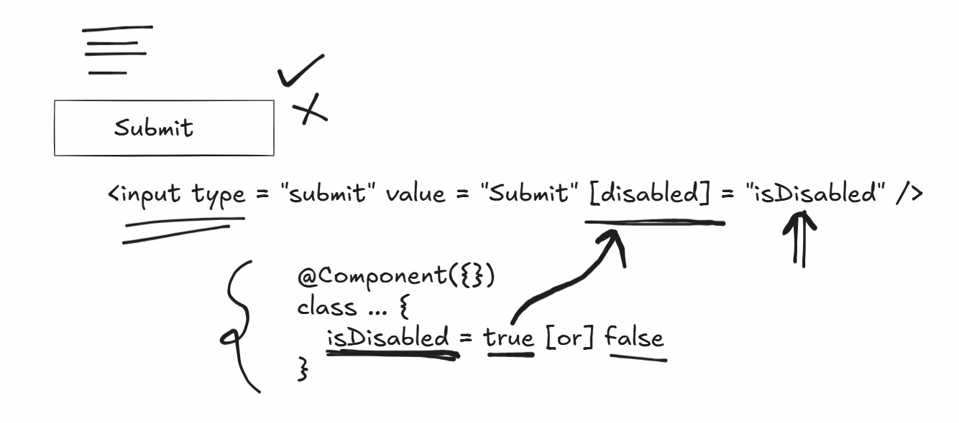
- Two-way data-binding [(ngModel)] : This shares the data in both the ways i.e, from component class to html template and from html template to component class, this makes the data in sync

Event Binding Demo
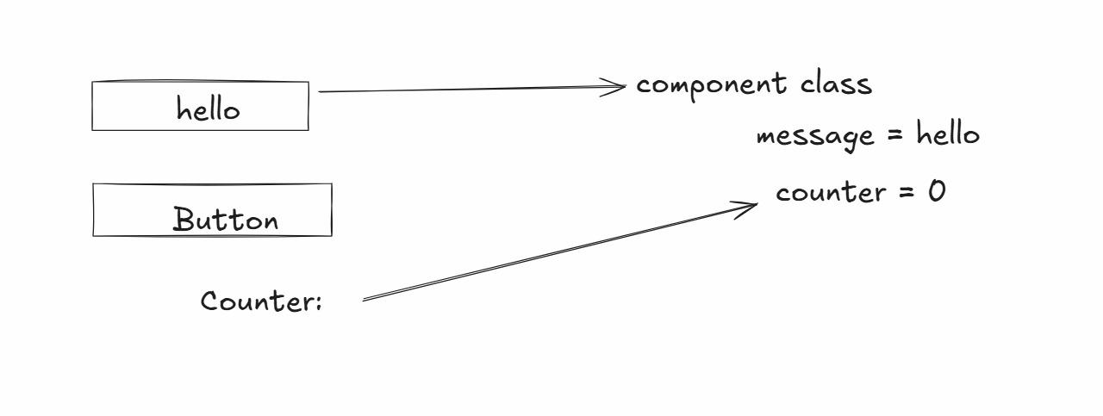
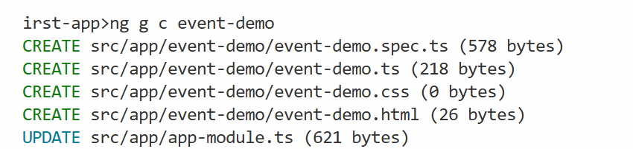
Add this component to the root component
app.html
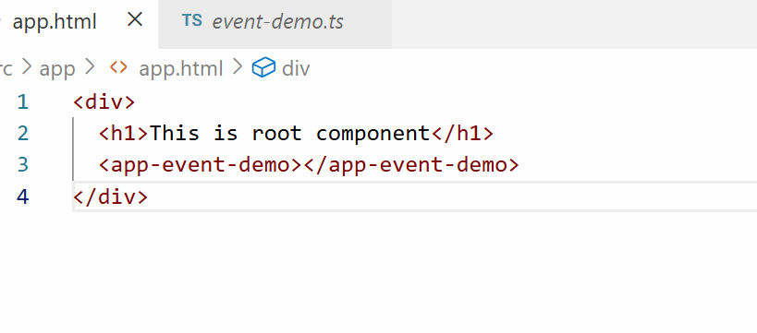
event-demo.ts
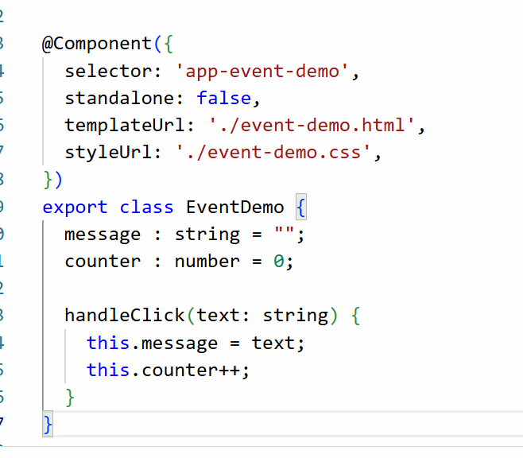
event-demo.html
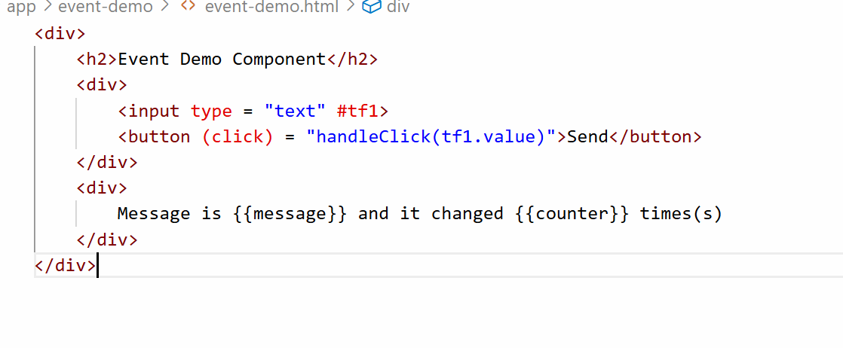
Output:
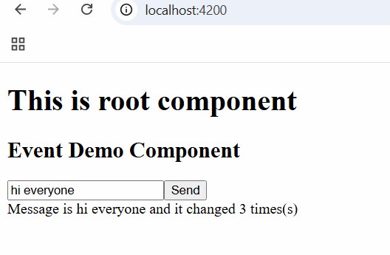
Property Binding Demo
It helps to bind the HTML DOM objects like disabled, hidden, this shares the data from component class to html template.
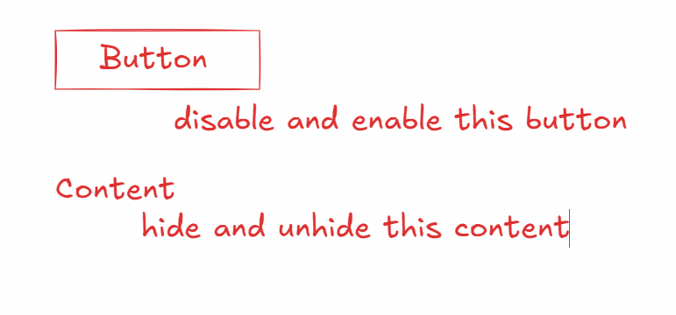
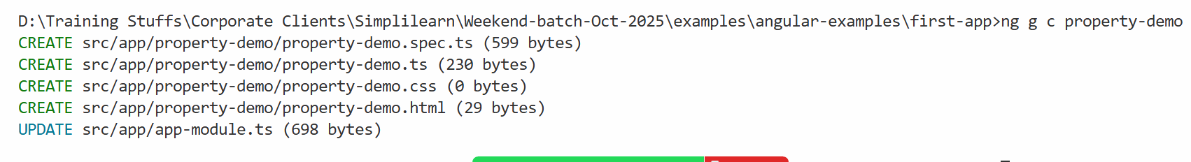
Add the component to the root component
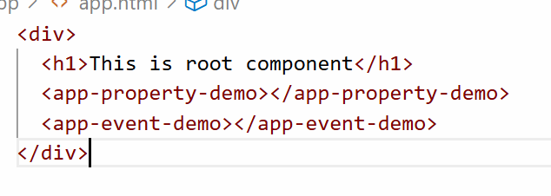
property-demo.ts
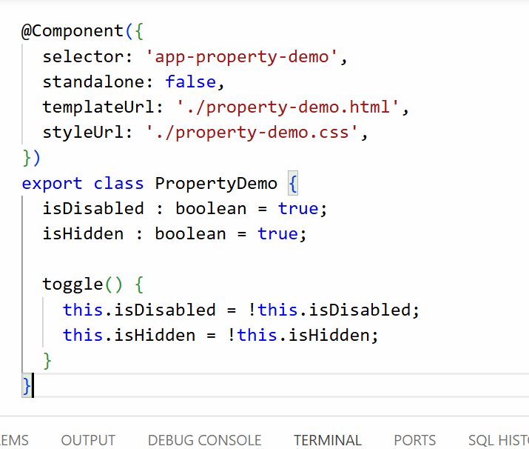
property-demo.html
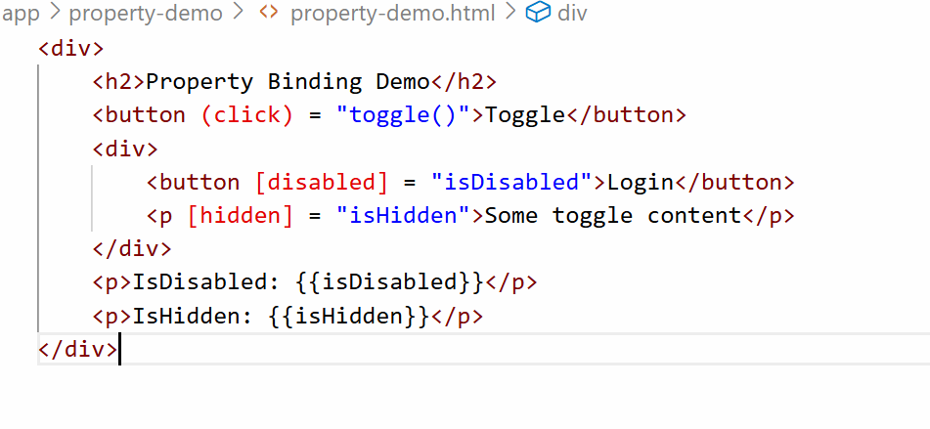
Output:
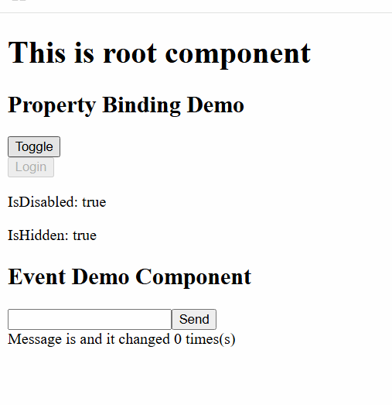
Two way data binding
Here angular helps component class and html template to share the data in both the directions so that the data will be in sync, it is a combination of event and property binding.
By default Two way databinding doesn’t work because it uses [(ngModel)] directive, this directive is part of a built-in module called FormsModule, angular recognizes [(ngModel)] only if you add FormsModule in the application.
How to add FormsModule in the application
You just need to add FormsModule in the @NgModule.imports of your AppModule class which is present inside app.module.ts

app.module.ts

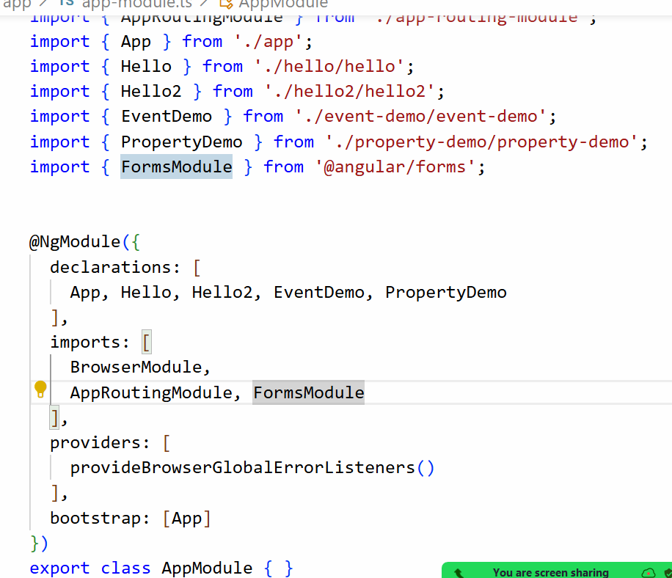
Generate two-way-demo
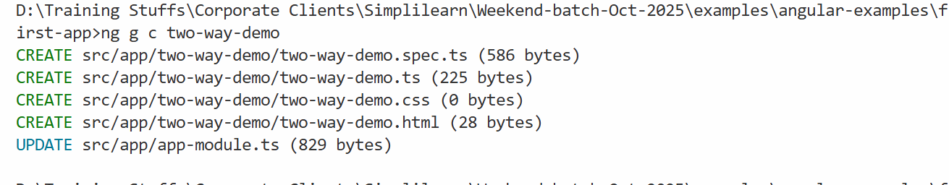
Add the two-demo component to the root component
app.html
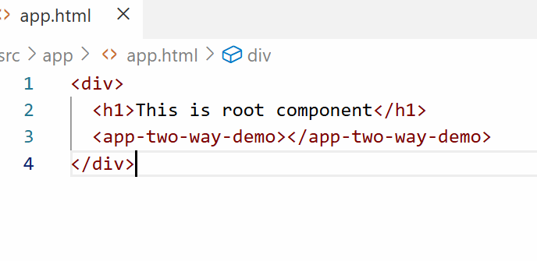
two-way-demo.ts
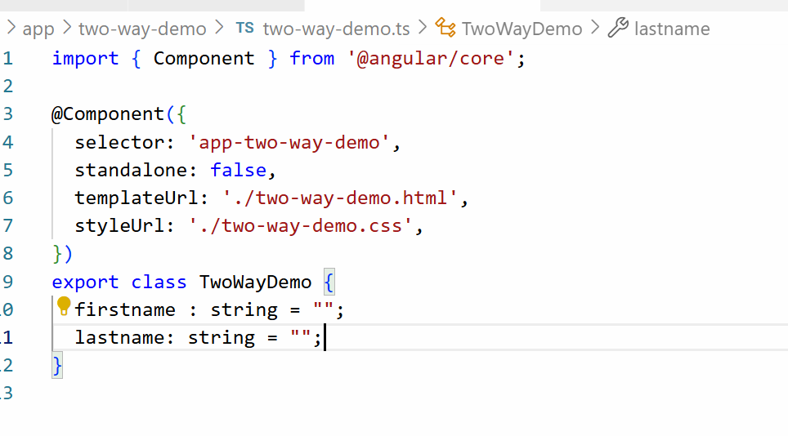
two-way-demo.html
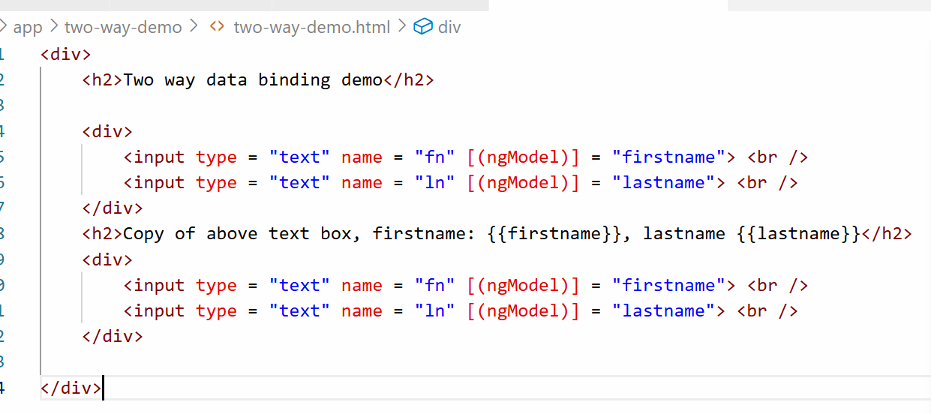
Output:
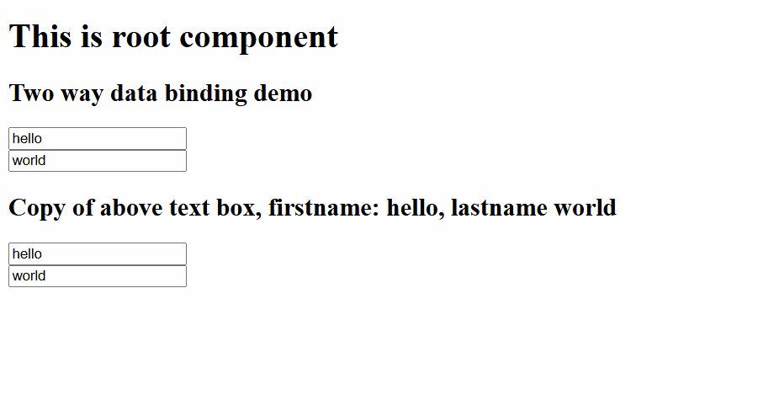
Where exactly two way databinding is useful
- Live preview
- When server wants to update the form when user types some value in another input box
- In shopping cart if you change the quantity automatically the prices should update

30-11-2025
Directives
They allow you to work with DOM elements, there are following directives
There are 3 types of directives
- Component directive
- Structural directive
- Attribute directive
Component directive: a class with @Component is a component directive, most of the UI is built with component directive
Structural directive: These change DOM structure like add/remove elements, there are 3 types
- *ngFor: It helps to create DOM elements at runtime while iterating the arrays
- *ngIf: It helps to add/remove DOM elements based on some condition
- *ngSwitch: It helps to add/remove DOM elements based on multiple conditions
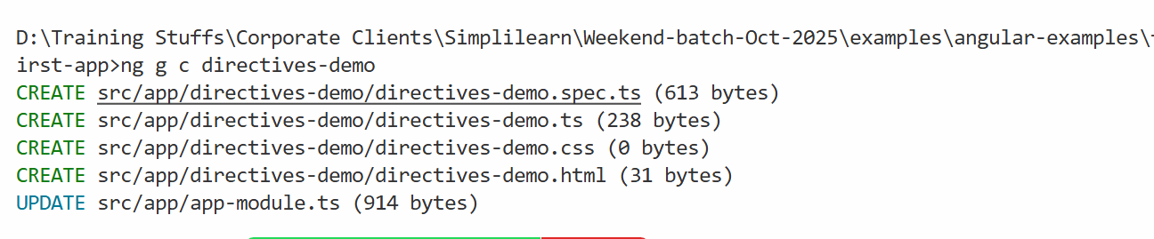

Add the component to the root component
app.html
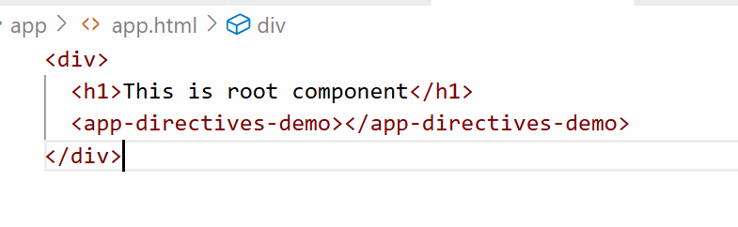
directives-demo.ts
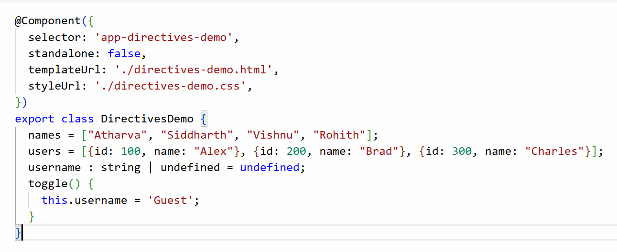
directive-demo.html
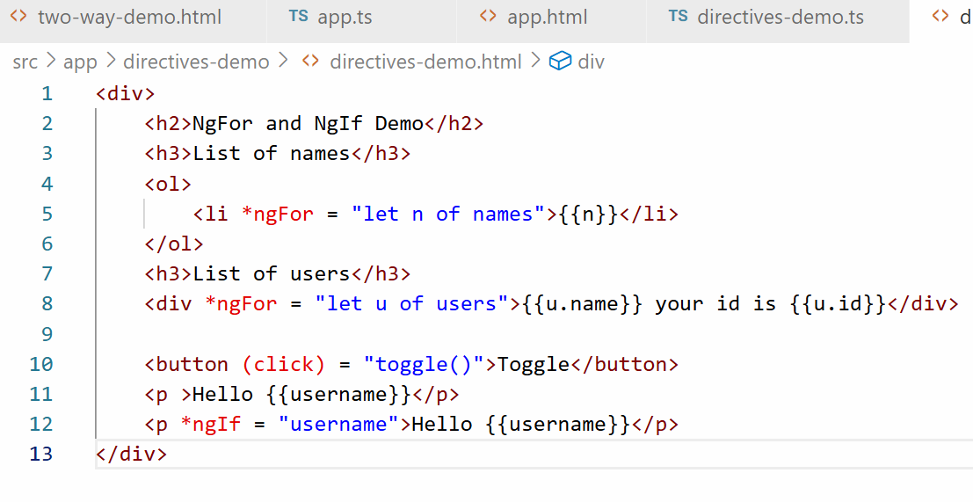
Output:
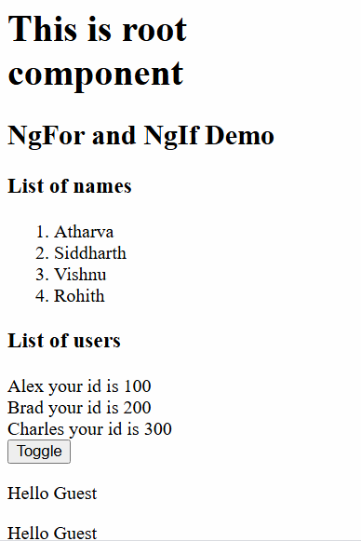

*ngSwitch: it helps you to show only one HTML block depending on the value of an expression
You can use *ngSwitchCase to match the value and if none of the value matches you can use *ngSwitchDefault which is executed when the none of the condition match.
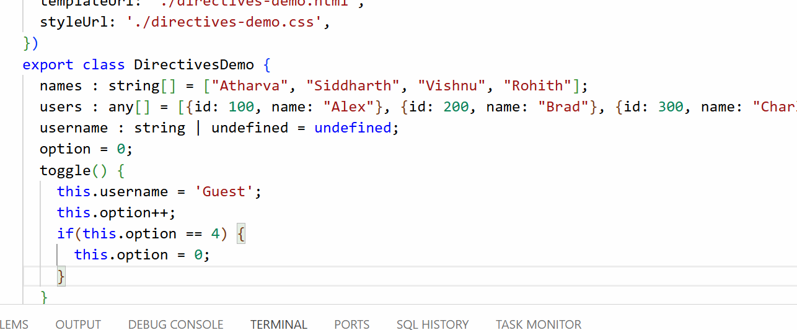
directive-demo.html
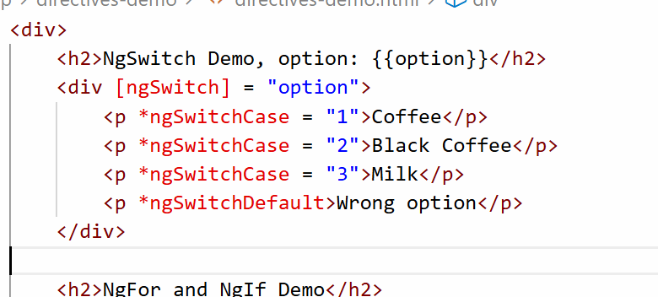
Output:
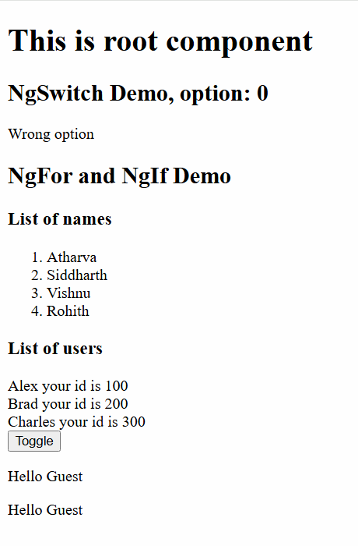
Angular Pipes
It is used to transform the output like showing the names in uppercase, lowercase, or amount in different currencies, date in different formats
actual data is 2025-11-30 but you want to show as 11-Nov-2025 or 11-10-2025
actual data is 10000, but you will show $10,000

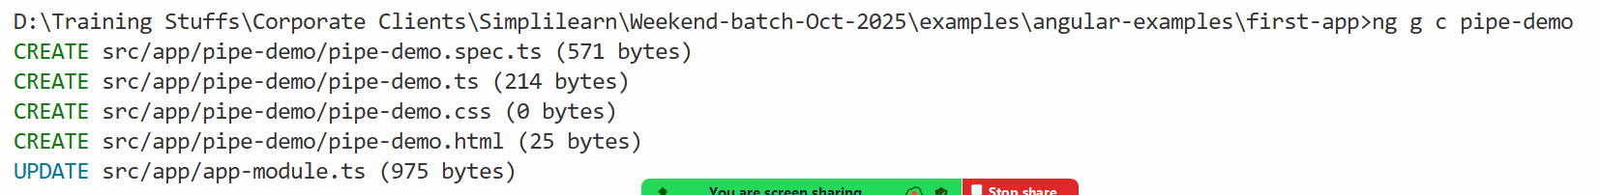
Add this component to the root component]
app.html
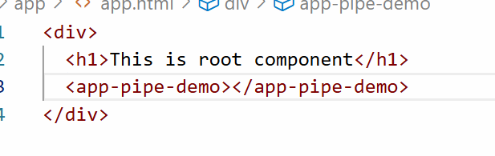
Angular has built-in pipes
- currency
- date
- uppercase
- lowercase
- json
{{ salary | currency }}
{{ name | uppercase }}
{{ birthday | date }}
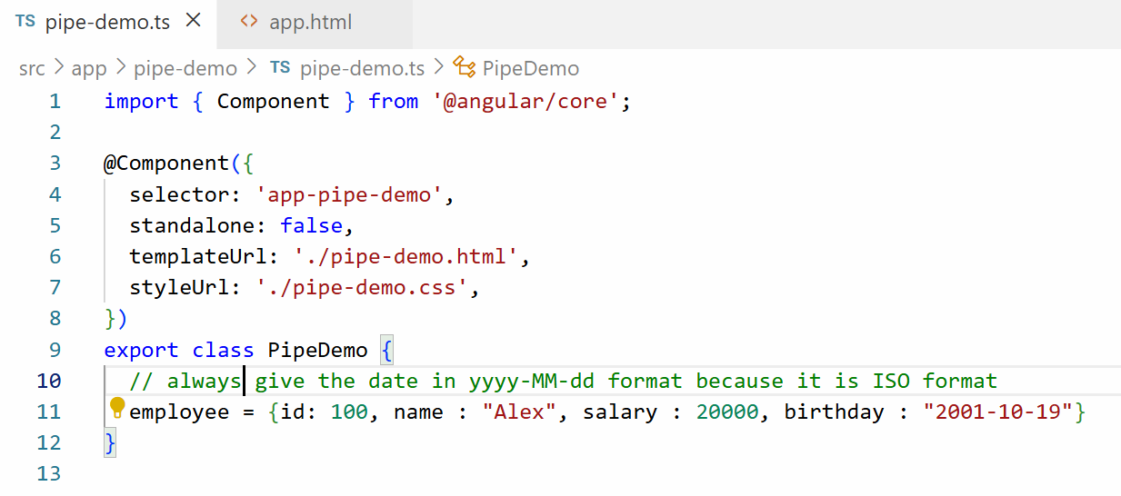
pipe-demo.html
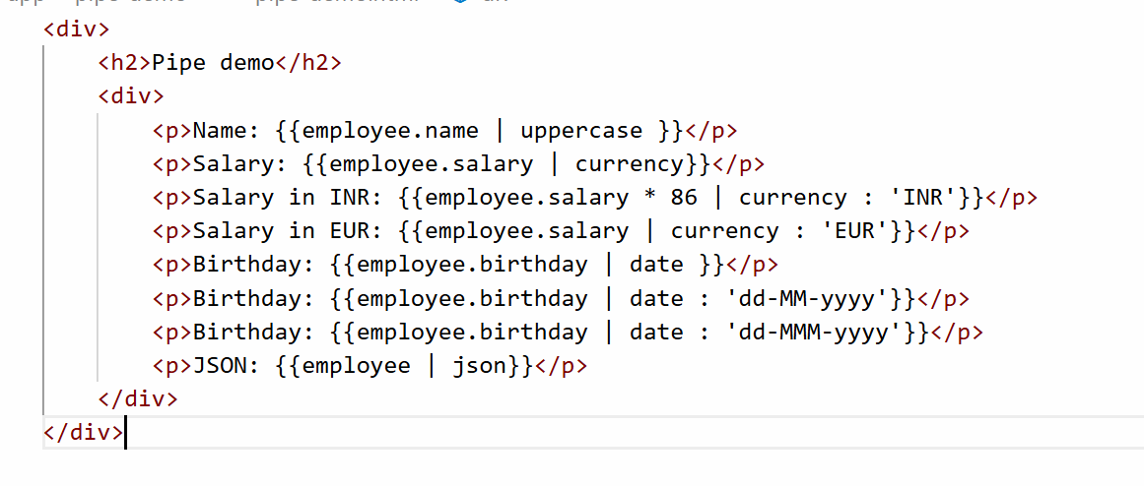
Output:

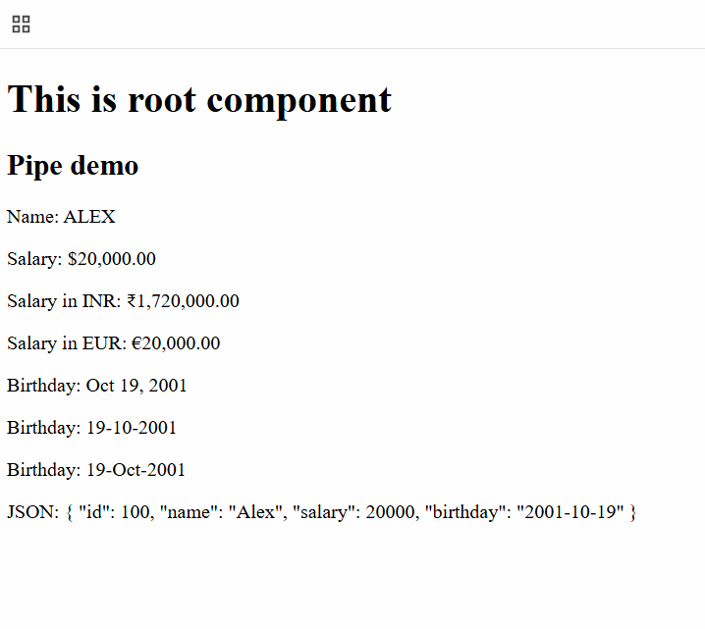
Activity
Create 3 to 4 employees in an array that will have id, name, salary, birthday, address, but address is a nested object with state, city and pin, display these employee data in a table format.
expected output
id | name | salary | birthday | state | city | pin
100 | Alex | $20,000 | 10-Nov-2000 | KA | BLR | 50393
200 | Brad | $40,000 | 11-Oct-1999 | MH | PUN | 60293

Custom pipes
You can create your own pipes that would transform the data based on your requirement, to create a custom pipe you must use a following command
ng generate pipe pipe-name [or] ng g p pipe-name
This creates a class with @Pipe({}) decorator and a function called transform inside it, this function is called whenever the pipe is used in the template
user = { username : “Sachin”, gender: “Male“ }
Output: Mr. Sachin
user = { username : “Preeti”, gender : “Female” }
Output: Ms. Preeti

pipe-demo.ts
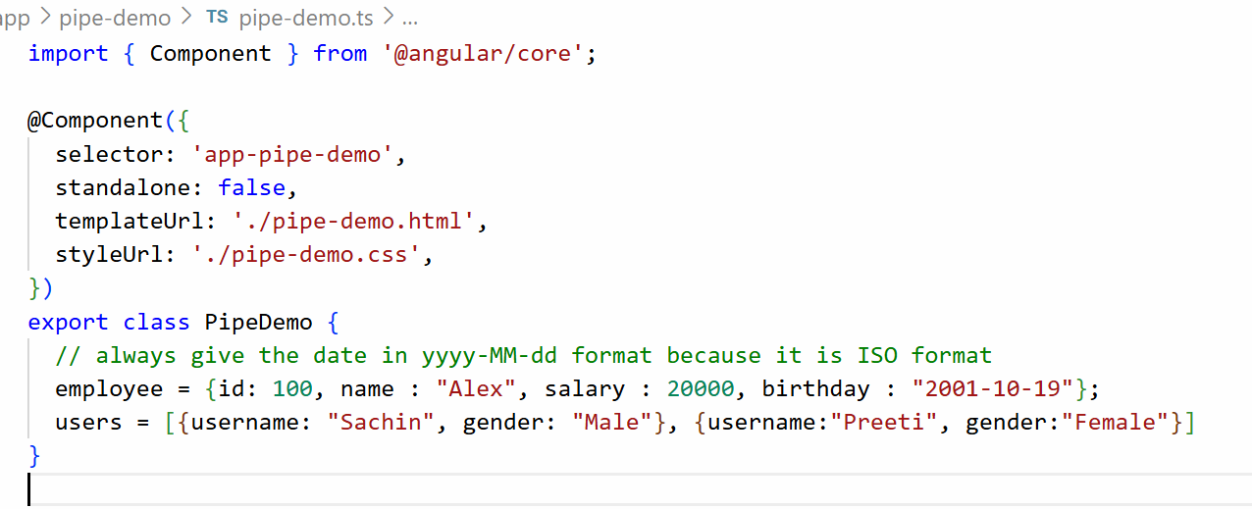
Create a pipe name-format
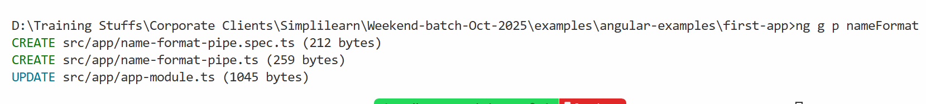
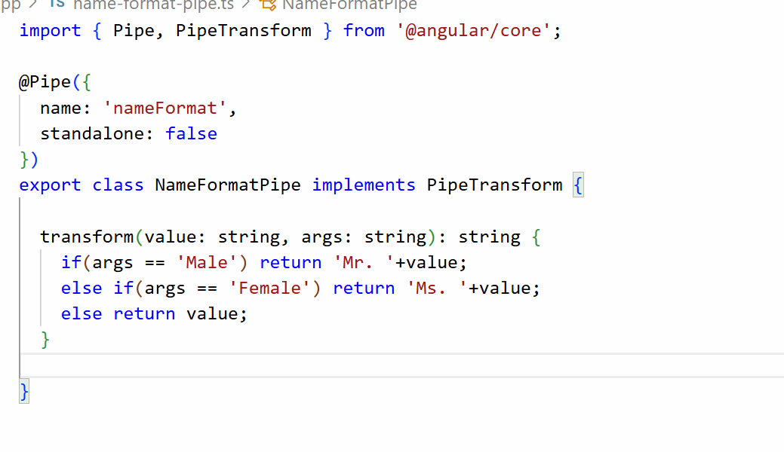
HTML
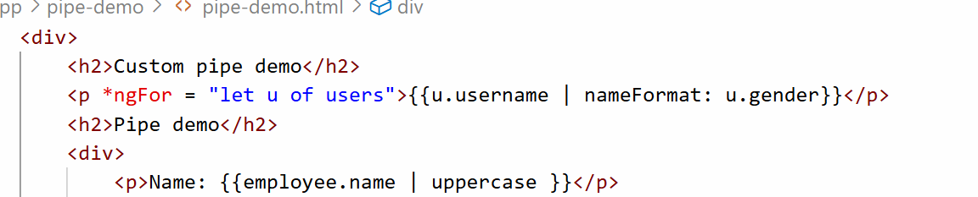
Output:
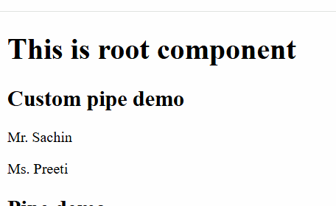

Session 13
06-Dec-2025
Let us create a new project with a name second-app
Command: ng new second-app --no-standalone

Class & Style binding
These are property style binding which helps to add CSS classes or remove CSS classes and add style attribute to the HTML template.
NgStyle: It is used to add style to the HTML element, here you create a variable that will have the style properties and in the HTML you will use that variable using [ngStyle] binding
Example
TS code
myStyle = {“color” : “blue”; “border”:”2px solid black”, “padding”:”5px”}
HTML code
<div [ngStyle] = “myStyle”>Some content</div>
The above code adds style attribute to the div
i.e, <div style = “color : blue; border: 2px solid black; padding: 50px”>content<div>
Class Binding: This adds or removes the class, it uses [ngClass] and a CSS class name in the HTML template
Example
CSS file
.blueColor { color : blue }
TS file
status = true;
HTML
<div [ngClass] = {‘blueColor’ : status }>Some content</div>
If status is true then <div class = “blueColor”>Some content</div>
If status if false then <div class>Some content</div>
Create a component
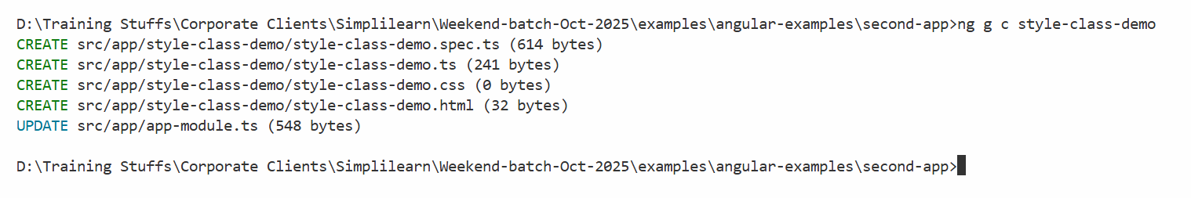
app.html
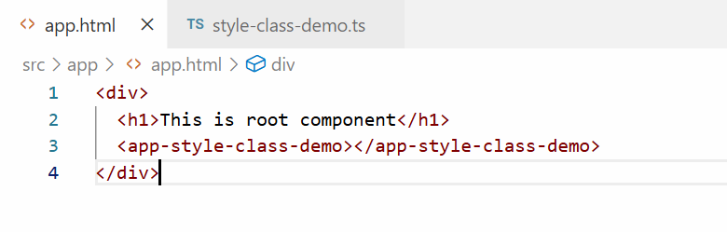
style-class-demo.ts
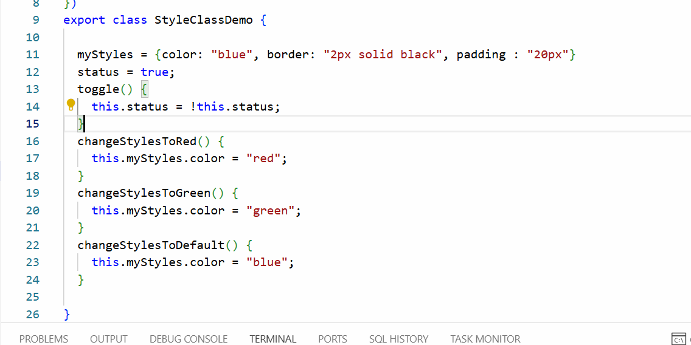
We are changing the values of the color in myStyles using 3 different functions like changeStylesToRed(), changeStylesToGreen() and changeStylesToDefault(), then we have status and toggle() that will add/remove CSS class
style-class-demo.css
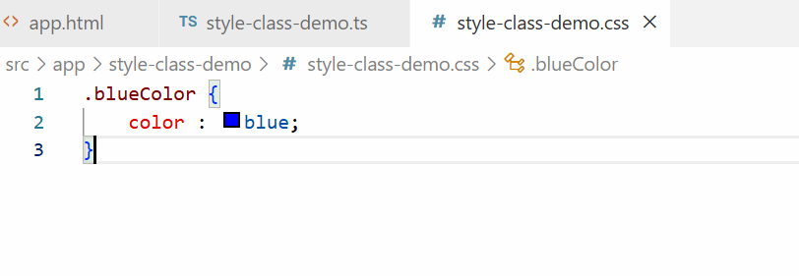
style-class-demo.html
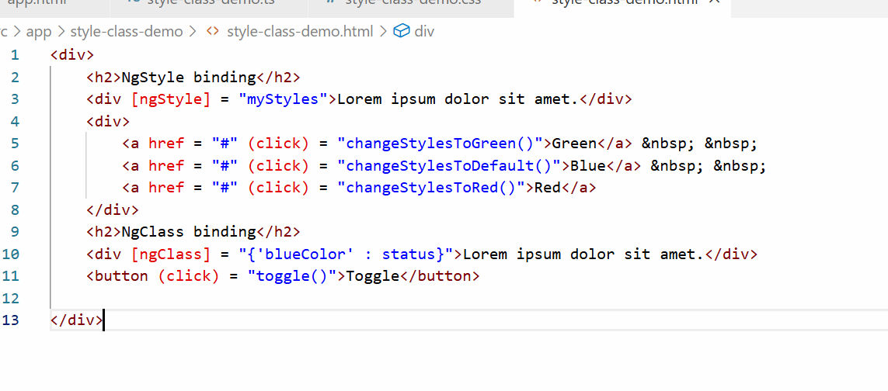
Output:
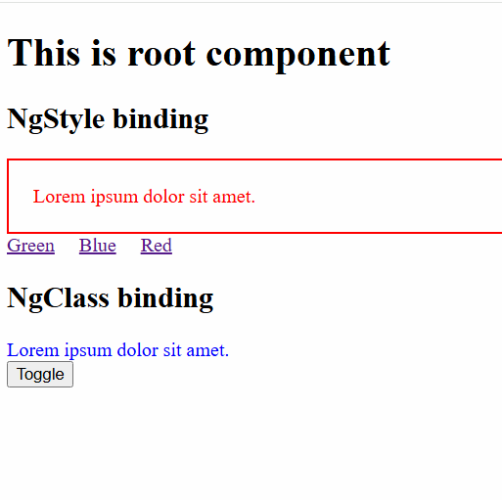
Adding bootstrap css to the angular project
You need to install bootstrap library in the project and add the location of the library in styles.css
styles.css: It is a global style sheet whose style can be used in any components you create
Note: Don’t use the CDN link of bootstrap in your project, because CDN link is not reliable
How to download bootstrap
npm install bootstrap --save or npm i bootstrap --save
This downloads bootstrap in node_modules/ folder

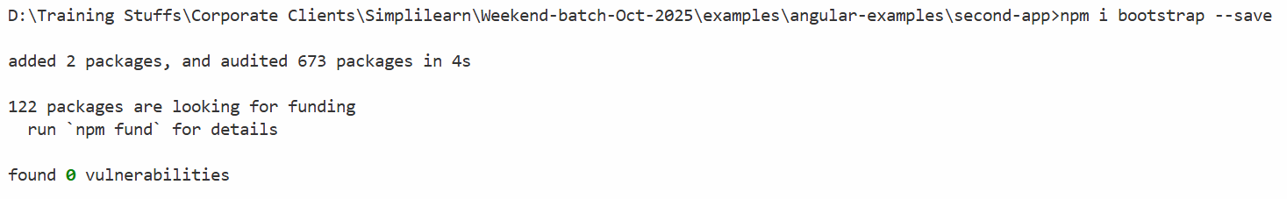
Component to Component interaction/communication
A component can share data to another component, especially parent to child or child to parent interaction
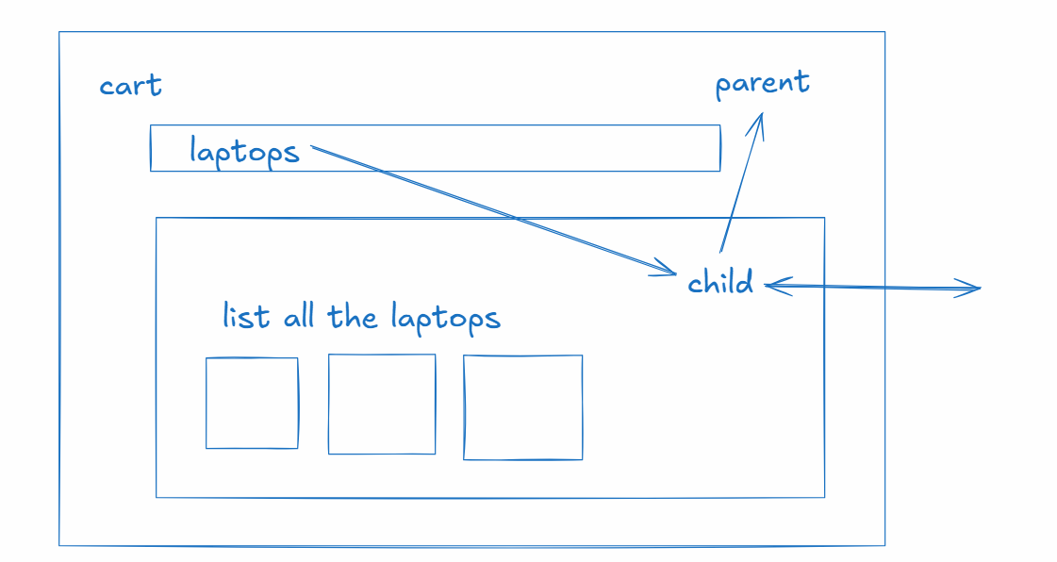
There are two decorators you can use to share the data between parent and child
- @Input()
- @Output()
@Input() It helps parent to share the data to the child component
@Output() It helps child to share the data to the parent component

Parent to child communication
parent.ts
item = “laptops”; // assume item value is dynamic
child.ts
@Input()
product = “”; // this receives the data from the parent component
child.html
<p> {{ product }} </p>
parent.html
<child-component [product] = “item”></child-component>
Child to parent communication
child.ts
@Output()
message = new EventEmitter<string>();
@Output()
product = new EventEmitter<any>();
// child component can share the data using emit function present in the EventEmitter
message.emit(“some message”) // $event
product.emit({id: 100, name : “HP” });
parent.ts
data1 = “”;
parent.html
<child-component (message) = “data1=$event” ></child-component>
Create 2 components
parent
child
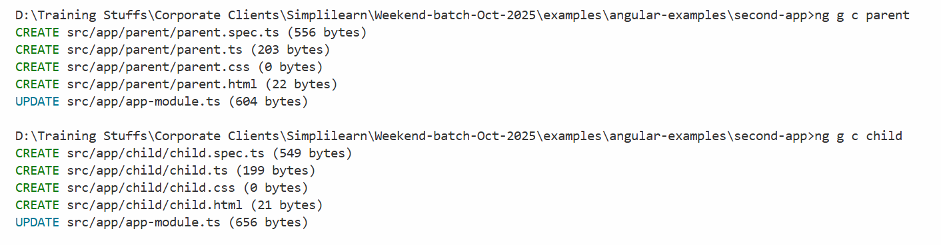
We need to add child component to parent component & parent component to root component.
app.html
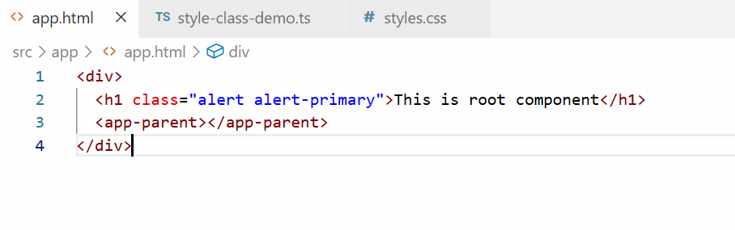
We have added parent component to the root component
Now we will add child component to parent component
parent.html
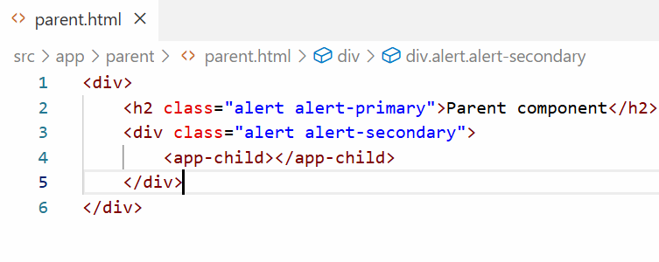
Output:
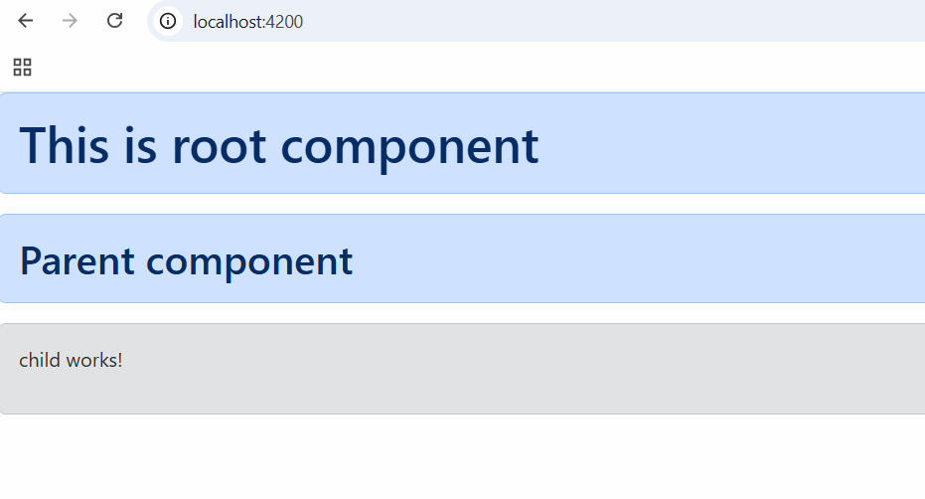
Now we will share a simple text message to the child component from the parent component, for that we need a text box in the parent and its value must be stored in the variable that will be share to child component.
Let us first create a property in child component that would have a default message
child.ts
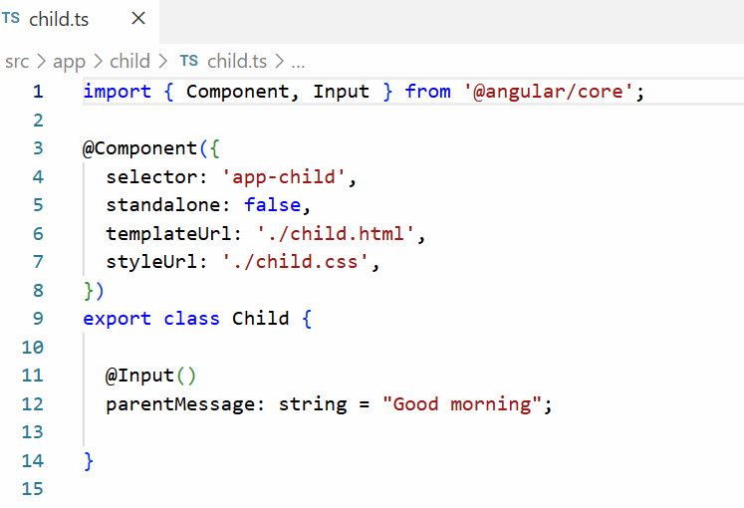
child.html
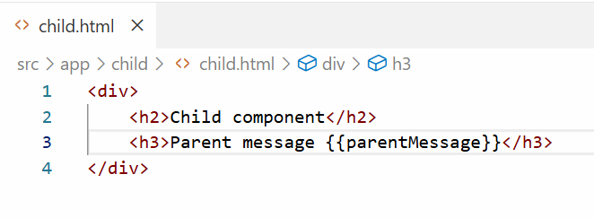
Current we will see default output
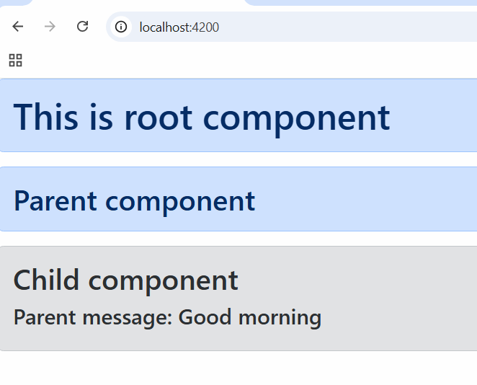
parent.ts
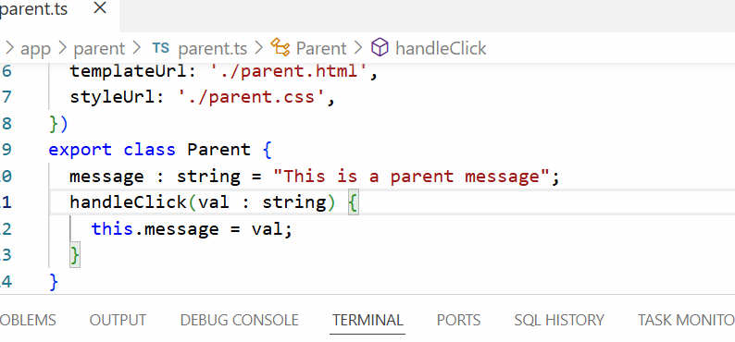
parent.html
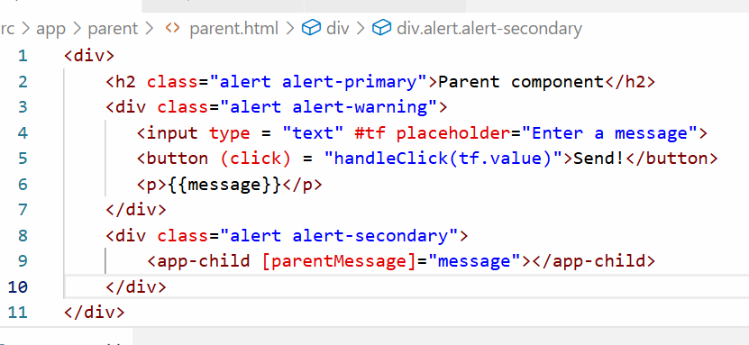
Output:
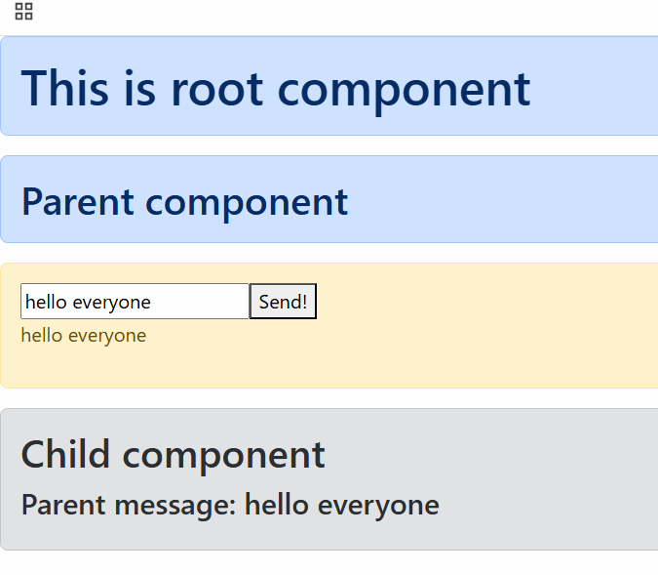
Sending the data from child to parent
child.ts
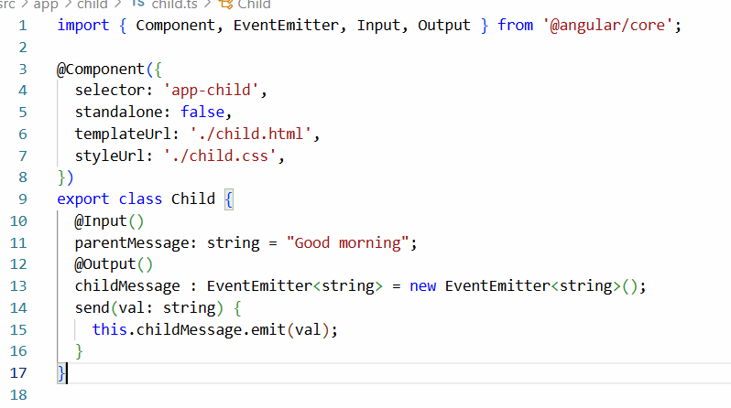
child.html
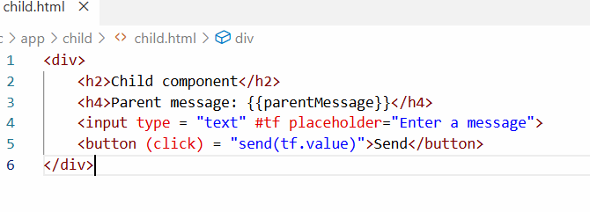
parent.ts
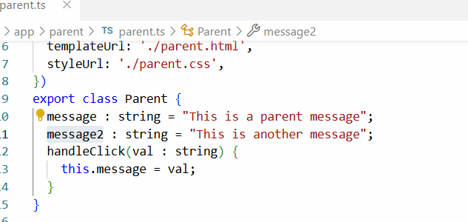
parent.html
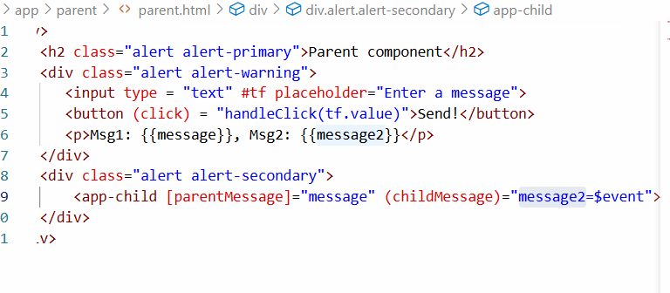
Output:
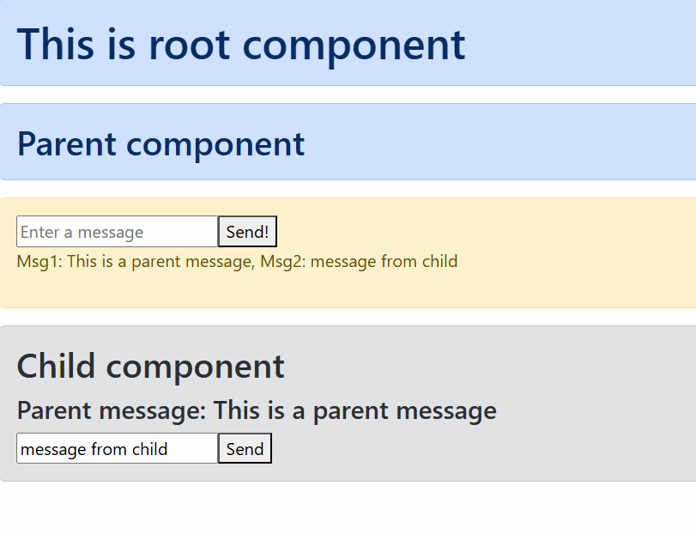

Session 14
07-12-2025
Angular Forms
They are just similar to HTML forms that helps you to enter user input, however they come with angular data binding features, angular forms can be created in 2 ways
- Template Driven Forms (TDF) - used for simple forms
- Model Driven Forms (MDF) or Reactive Forms - used complex forms
Template Driven Forms
It is a way to build forms where logic and validations are handled within the HTML template, it uses angular directives (ngForm) to track the forms state / data.
You must import a module called FormsModule to use the template driven forms, this must be imported in the @NgModule.imports property which is present in the app.module.ts
With the help of FormsModule you can use ngForm, ngModel.
Thing to do while using TDF
- Add FormsModule of @angular/forms in the @NgModule.imports
- Use two way databinding to bind the form data to the component property
- Use ngForm to track forms data so that it can collect all the form data in a single javascript object which will help you to manage with single object
<form #user = “ngForm” (ngSubmit) = “handleForm(user.value)”>
<input [(ngModel)] = “firstname” name = “fn”> -> binds to firstname
<input [(ngModel)] = “lastname” name = “ln”> -> binds to lastname
<input [(ngModel)] = “phone” name = “ph”> -> binds to phone
</form>
user = { fn : value, ln: value, ph : value}
In the component class you will three properties
@Component({})
class UserComponent {
firstname, lastname, phone;
// manually you will create an object, if you don’t use ngForm
userObj = {fn : firstname, ln : lastname, ph : phone }
}

Create a component named tdf
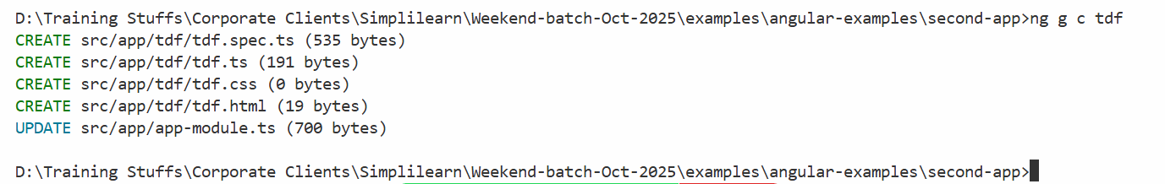
Add the component to the root component
app.html
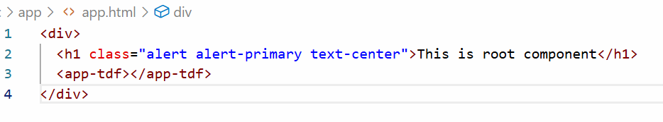
tdf.ts
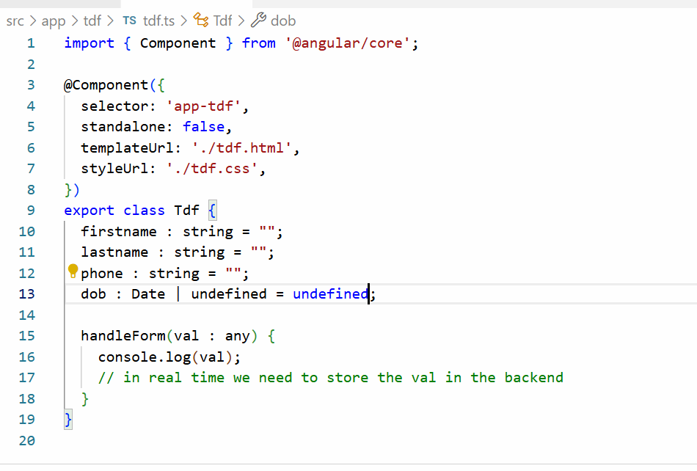

Add FormsModule of @angular/forms in the app-module.ts
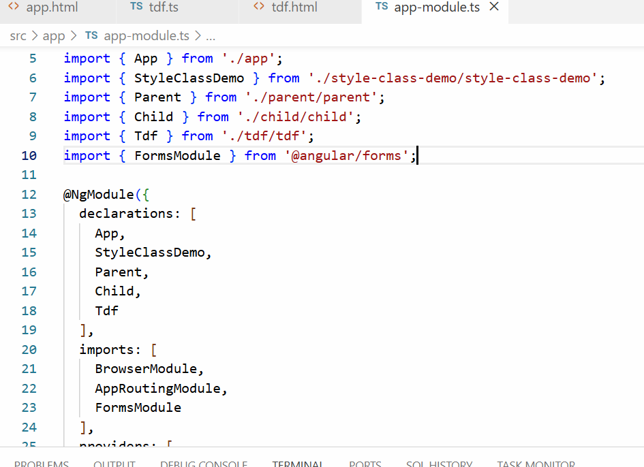
tdf.html
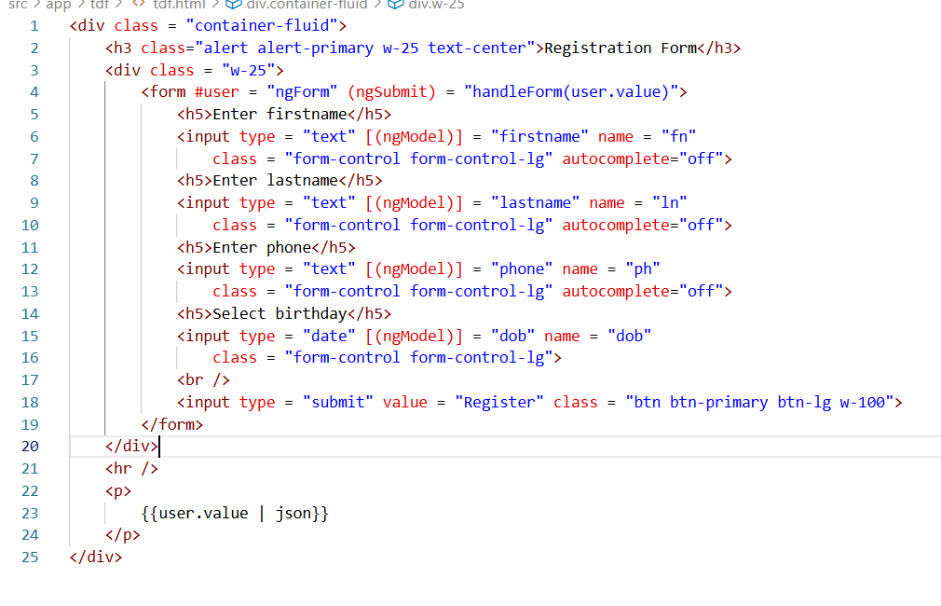
Output:
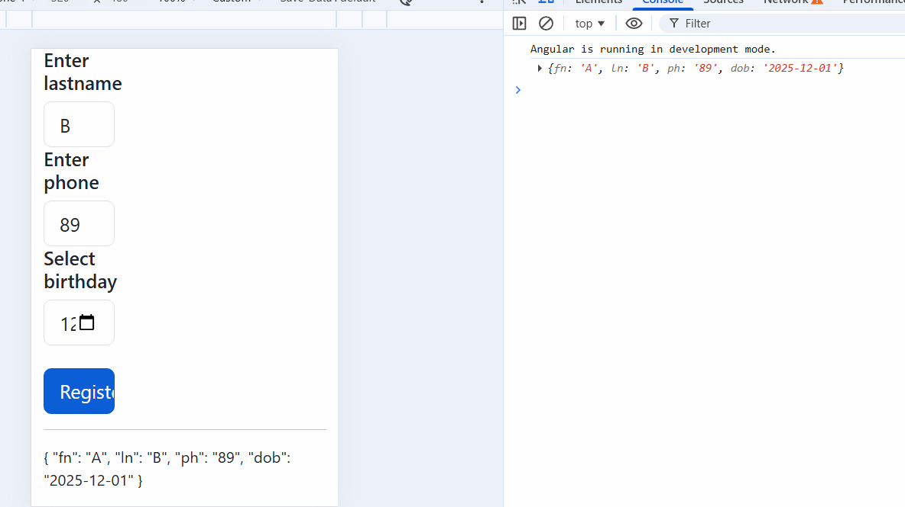
Template Driven Form Validation
In TDF validators like required, maxLength, minLength are specified in the HTML template itself, but you must use ngModel directive instance to validate the input element, because the NgModel directive instance provides inbuilt properties like valid, invalid, value, pristine, touched, dirty which you can get from the official angular document
The input element must use ngModel with a template reference so that you can use that name in other places ex: to display error messages
<input type = “text” [(ngModel)] = “firstname” name = “fn” #first=”ngModel” required maxLength = “15” minLength = “5”>
first.value
first.valid
first.invalid
first.pristine
tdf.html
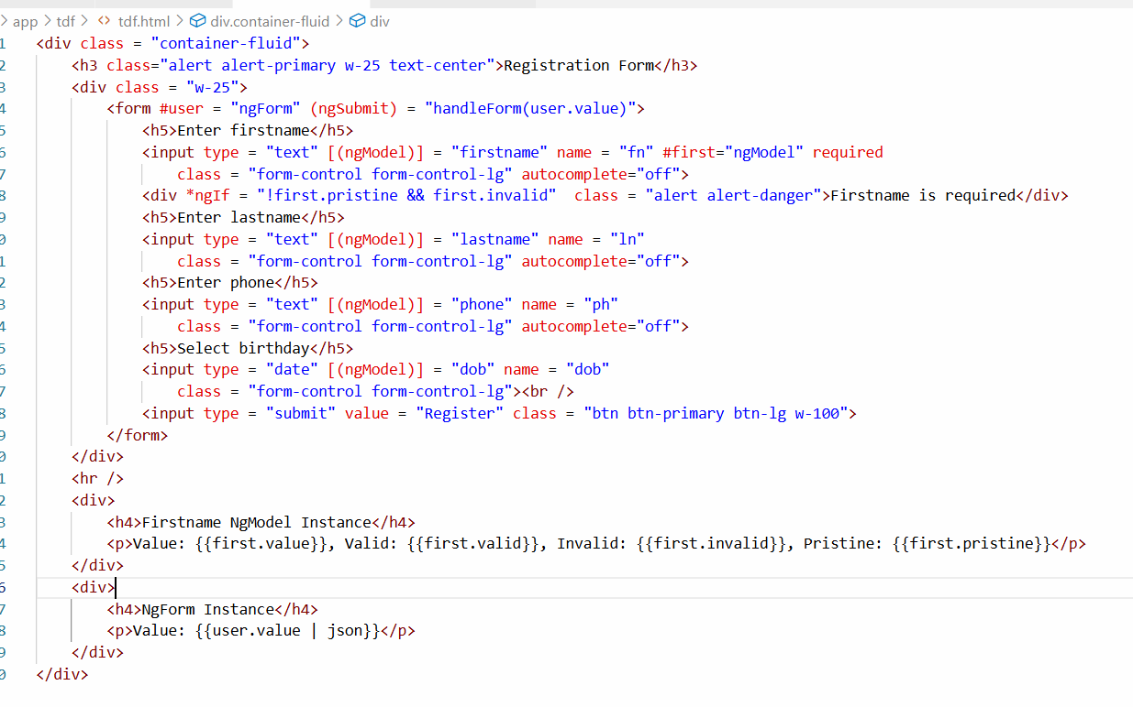
Output:
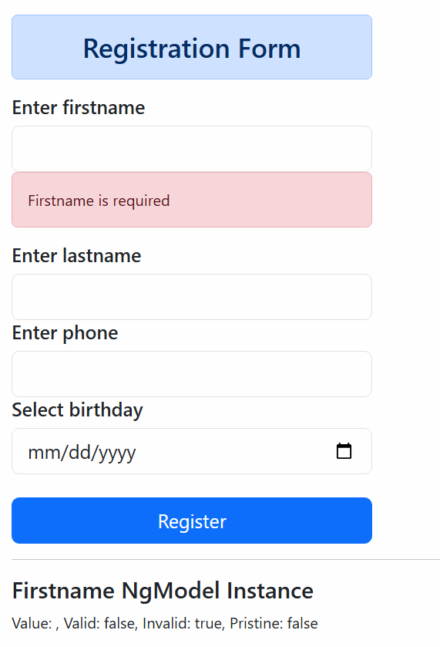
Try out displaying the validation errors for lastname, phone and dob, then disable the submit button when any one of the form input is invalid and enable the submit button only if all the inputs are valid.

How to disable the submit button
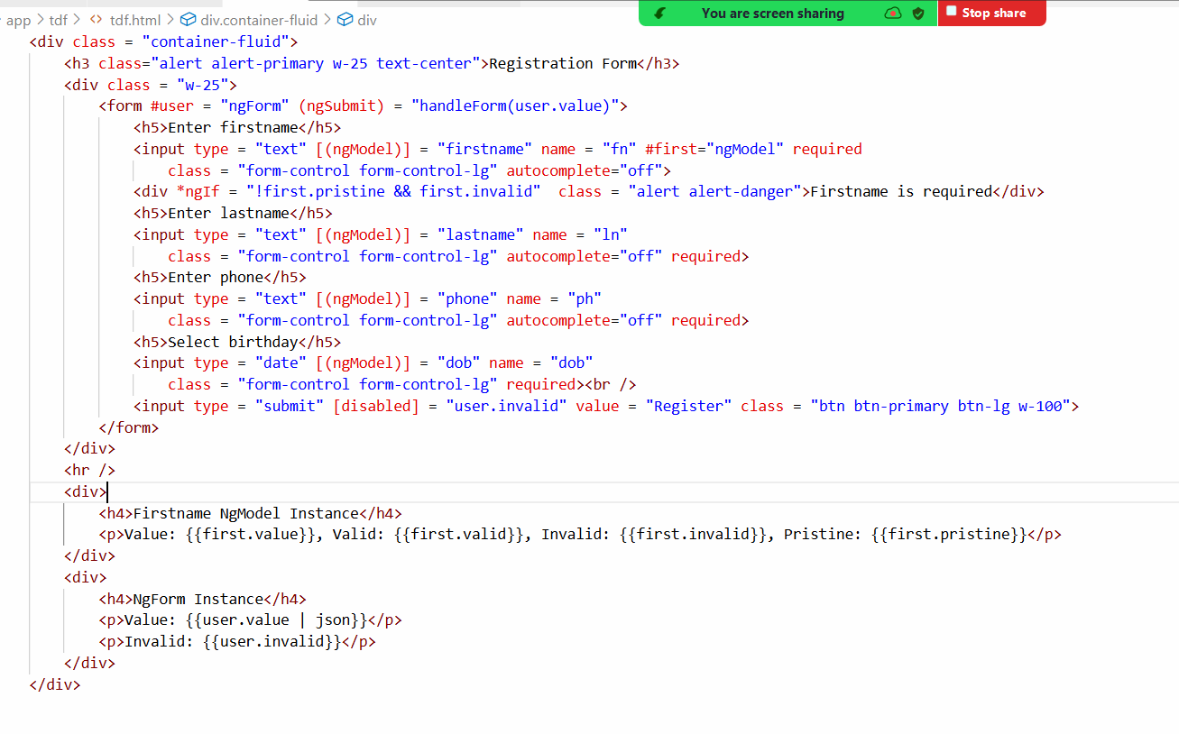
Output:
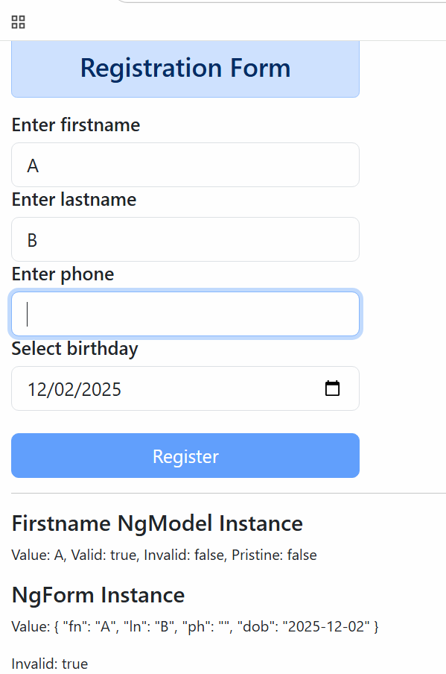
Model driven forms or Reactive forms
This helps to manages the forms programmatically i.e., you can manage in the typescript code instead of HTML code, you will have more control over the form when you use model driven forms hence it is used for complex forms, model driven form can handle form data, handle validators in the code itself.
To use Model Driven Form you need to use an Angular service called FormBuilder, this form build object is not available by default hence you must import in the NgModule using ReactiveFormsModule
i.e.,
NgModule.imports must use ReactiveFormsModule
app-module.ts
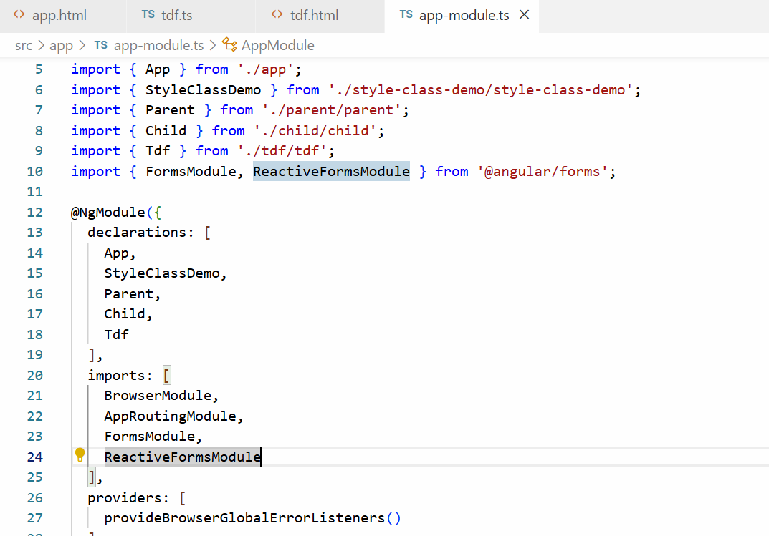

Generate the component
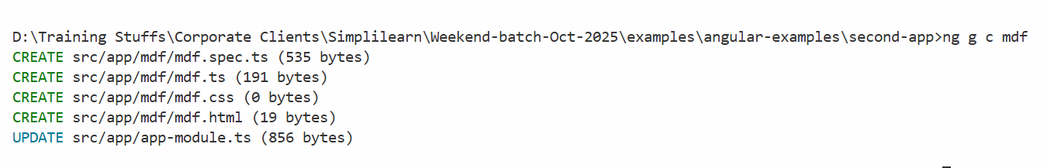
Add this component to the root component
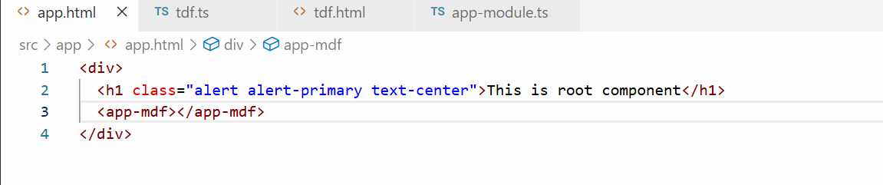
In Model Driven Form you create form controls in the code and HTML form in the HTML template, it makes HTML template look cleaner, because you can use Validators in the code itself, this you can achieve using one of the service called FormBuilder which you can use with the below code
builder = inject(FormBuilder);
Then you can group the form controls using group function that will take javascript properties
userForm = builider.group({
firstname : [],
lastname : [],
phone : [],
dob : []
});
You can also add Validators to the form controls using below code
userForm.group({
firstname: [‘’, Validators.required], lastname : [‘’, Validators.requried]
});
Now in the HTML template you can access the from group as below
<form [formGroup] = “userForm”>
<input type = “text” formControlName = “firstname”>
<input type = “text” formControlName = “lastname”>
</form>
mdf.ts
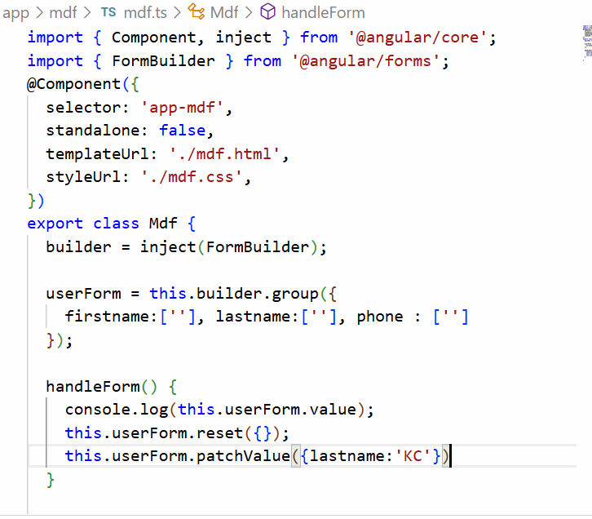
mdf.html
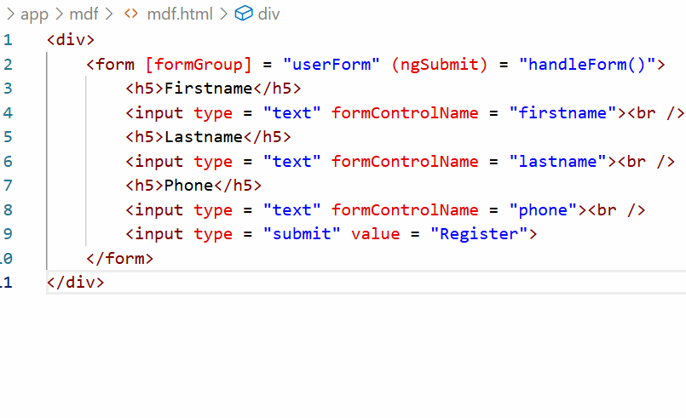
Output:
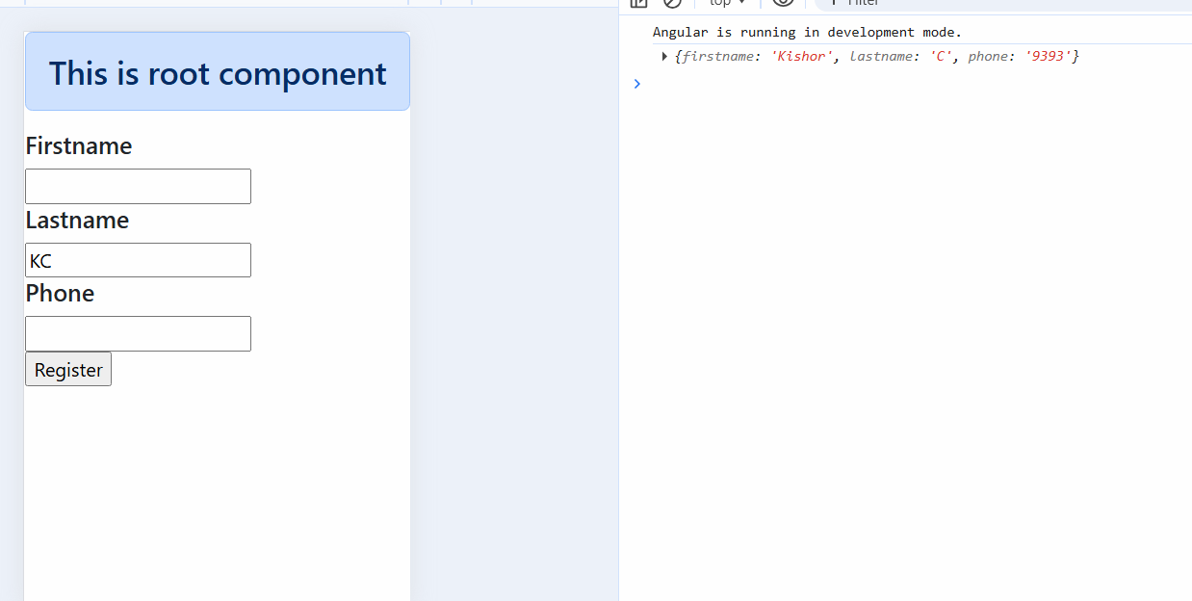

Session 15
13-12-2025
Validations on model driven form or reactive forms
The form control in the form builder can use Validators.compose([]) function which accepts array of validators
userForm = this.builder.group({
firstname:['', Validators.compose([Validators.required])], lastname:[''], phone : ['']
});
Now angular made it a little simpler to apply validators just by adding nested array inside the form control value
userForm = this.builder.group({
firstname:['', [Validators.required]], lastname:[''], phone : ['']
});
mdf.ts
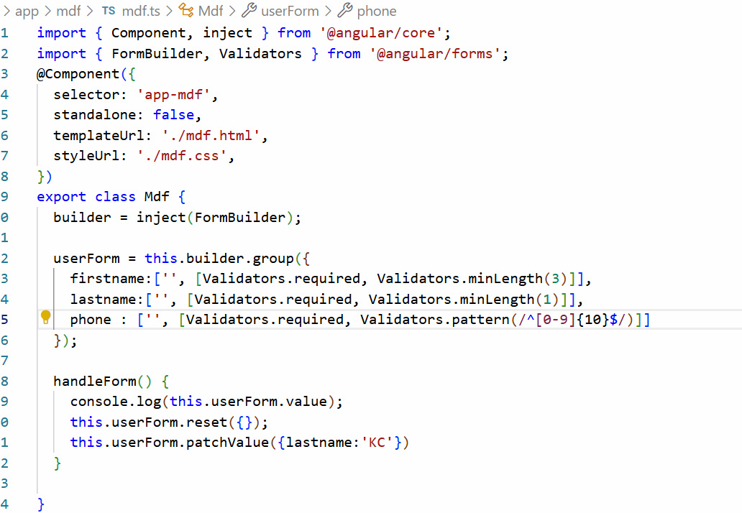
The pattern is a regular expression where ^ means start with a string and [0-9] means any digits between 0 to 9 and $ end of the string

mdf.html
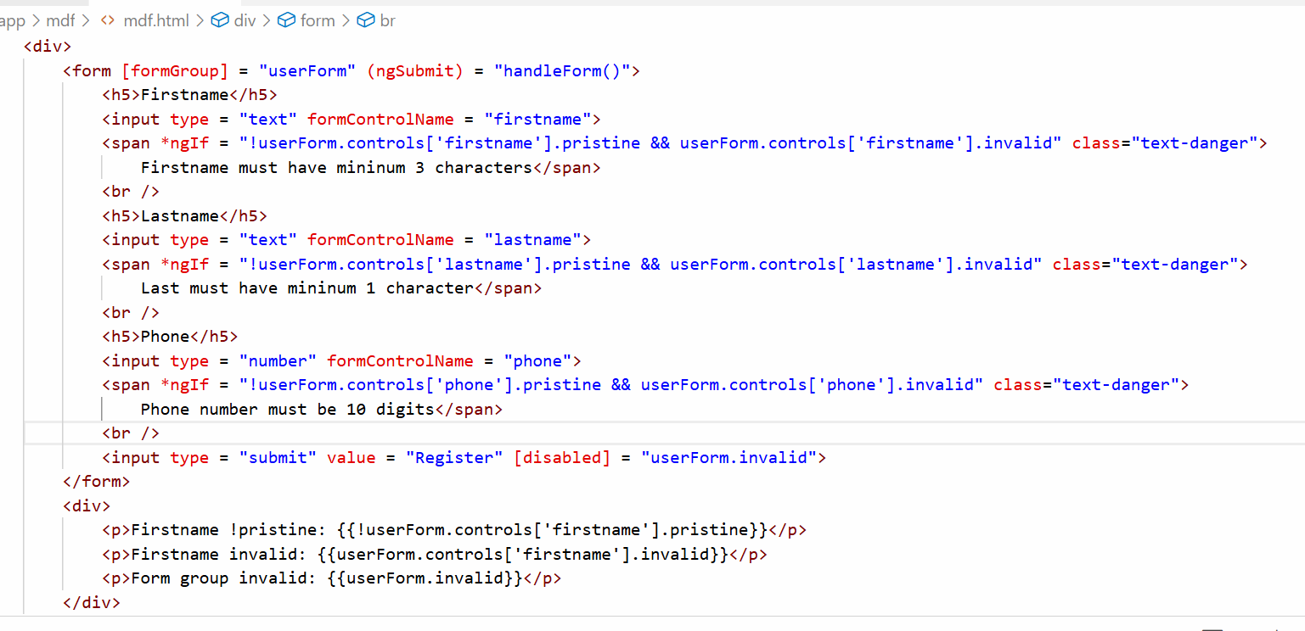
Output:
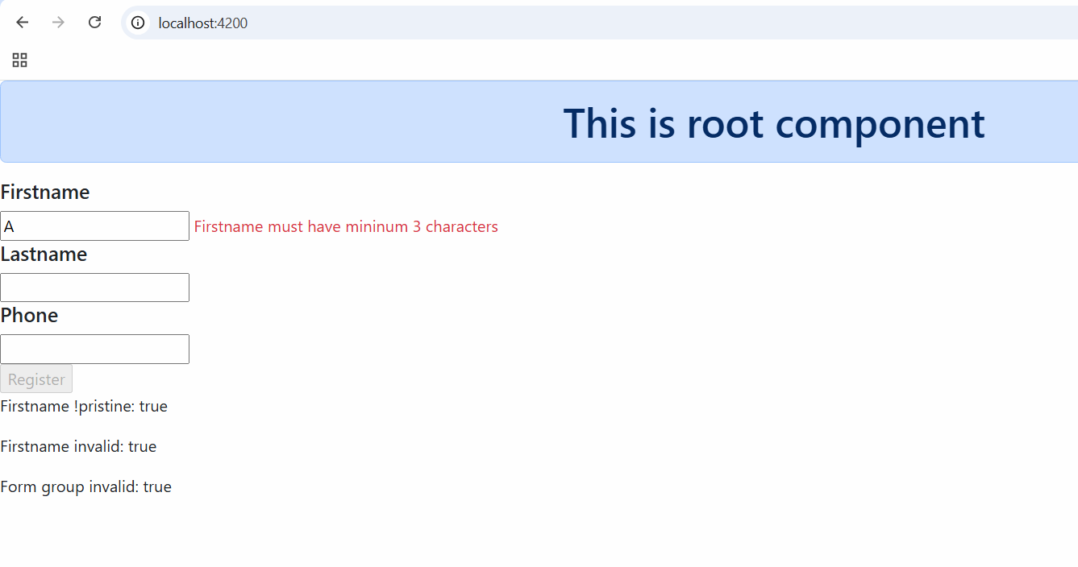
Angular Services
These are reusable logics that can be called by multiple components, you can use these to separate UI logics with business logics
Component class: It can have UI logics and the data the UI wants to maintain
Service class: It can have business logics that can be called by Component classes
Business logics are the logics that handle the data like invoking the backend services and performing some complex computation
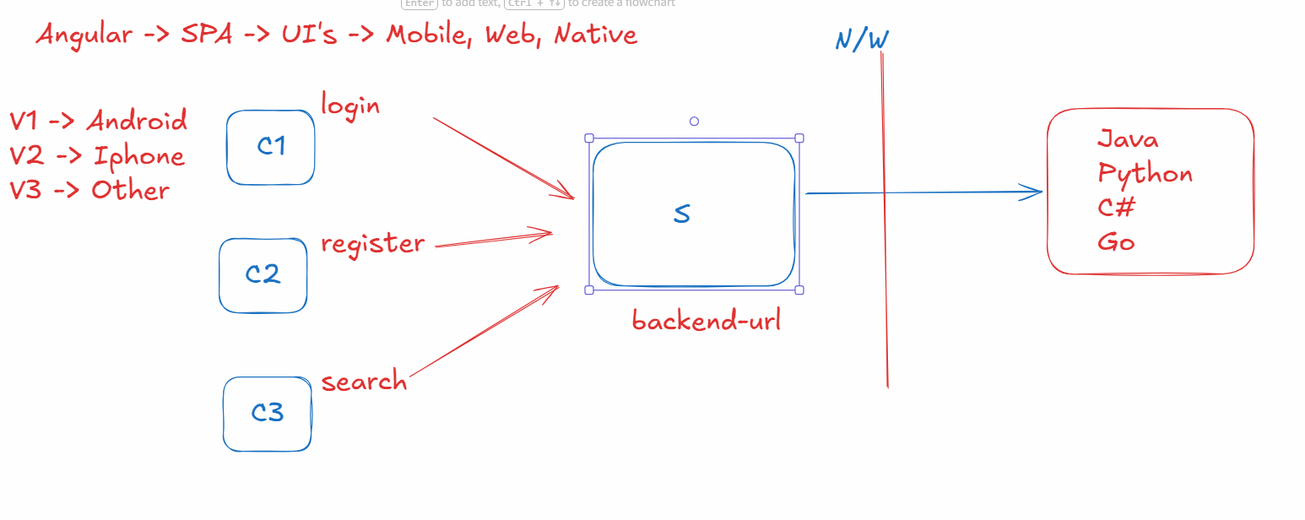
In angular you can create services using ng g s service-name, this creates a class with @Injectable() decorator
Why @Injectable() decorator: this creates an object of the class automatically and any component who wants to use this object can just use using the inject() function to get the object, they don’t have to create the object
ex:
builder = inject(FormBuilder): FormBuilder is an object which already available, instead of creating it we used the object
A service class looks like this
@Injectable()
class ProfileService { … some logics … }
A component class can tell angular to supply the dependency of ProfileService which is called as Dependency Injection
@Component({})
class ProfileComponent {
service = inject(ProfileService)
}
Dependency Injection: It is a process where we don’t create the object instead the framework creates the object & supplies the object
What inject() function does
It tells angular to supply the object
Creating a service with the name profile-service
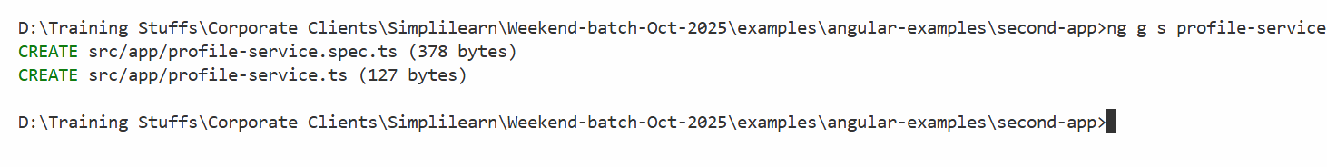
profile-service.ts
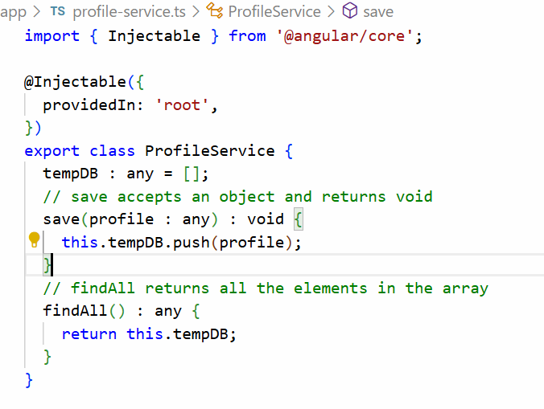
Let us have 2 components one invokes save() and the other invokes findAll()
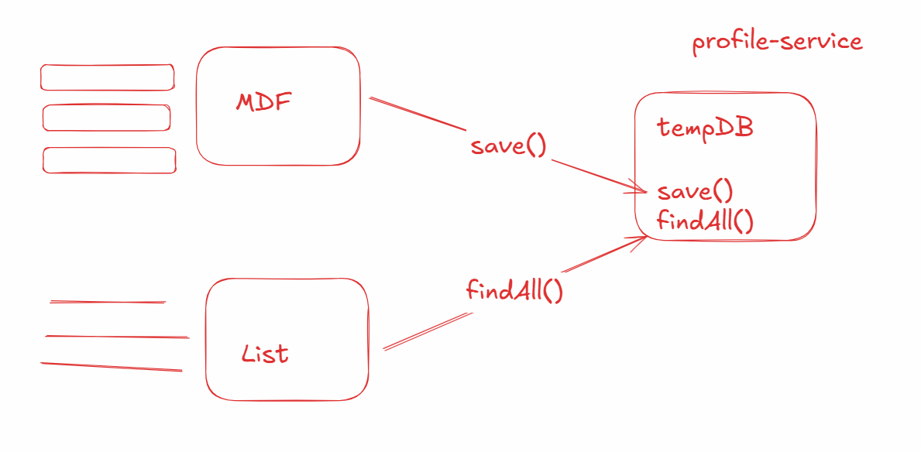
We will create list-profile component
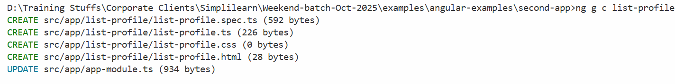
We will add mdf and list-profile in the app component
app.html
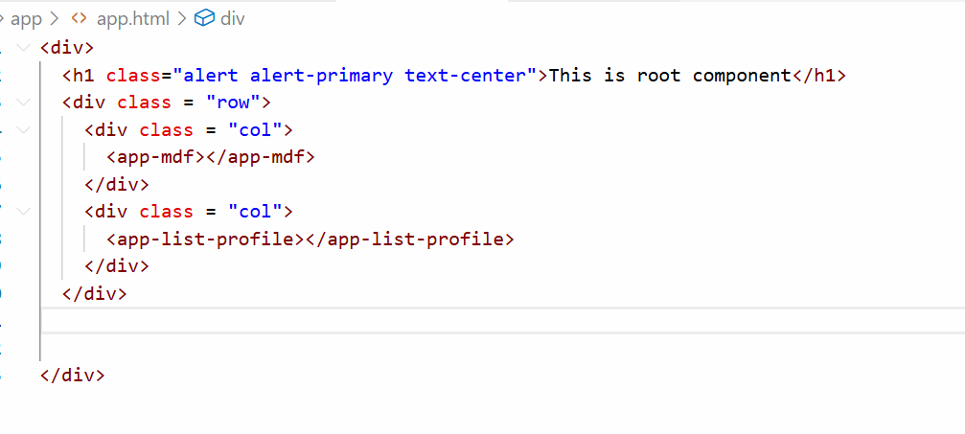
Invoke store in mdf and findAll in list-profiles
mdf.ts
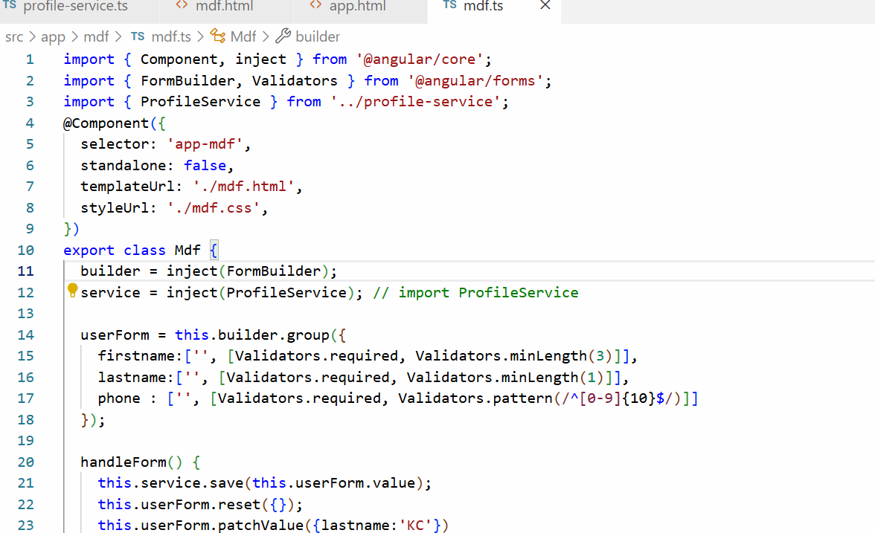
list-profiles.ts
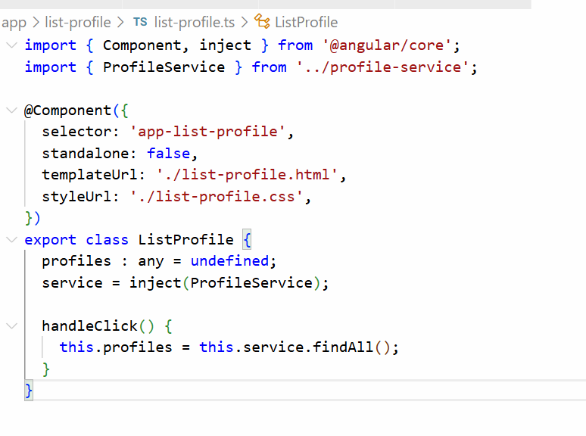
list-profile.html
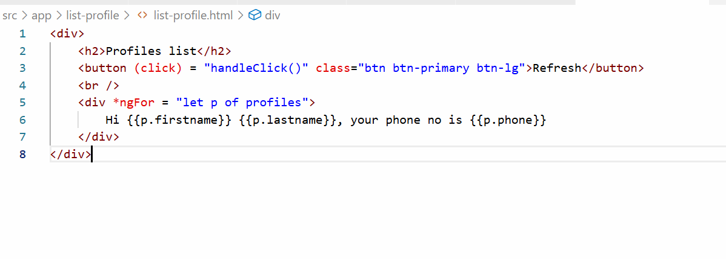
Output:
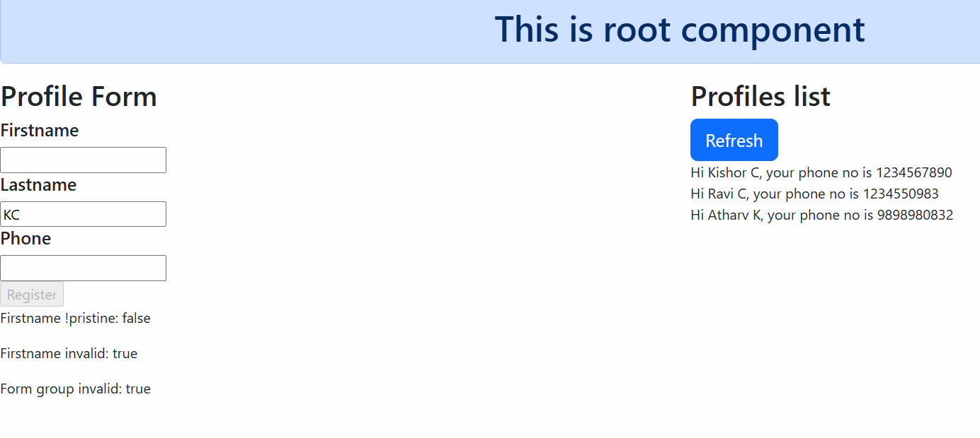
Backend services
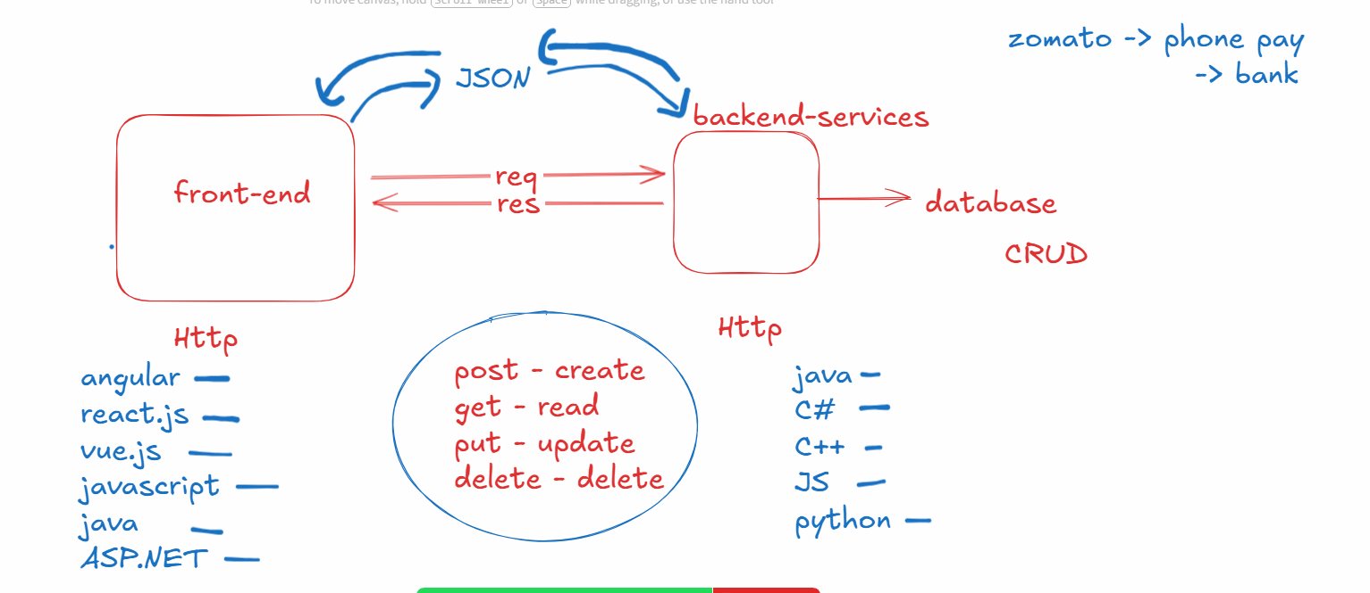
Backend services are the applications who accept the data from the front-end and share the data to the front-end, the common protocol both must use is HTTP and common structure the data must use is JSON
HttpClient: It is an object provided by angular to make HTTP calls and it provides methods like get(), post(), put() and delete()
All the HTTP methods of HttpClient returns an Observable
Observable: It is a container that will have response from the backend service, these will produce some response whenever the components subscribe to the observable
Note: Observable will not send request unless someone subscribes
When components subscribe to the observable they can receive success or error response
HttpClient object is created automatically by angular using a provider called provideHttpClient(), by default angular doesn’t create HttpClient object, hence you must use provideHttpClient() in the NgModule.providers property
Once angular creates HttpClient object you can use inject(HttpClient) to use the HttpClient object
Steps to access JSON Placeholder
- Mention provideHttpClient() in the @NgModule.providers
- In the Angular service use inject(HttpClient)
- Make HTTP requests in the Angular service that returns Observable
- Components can subscribe to the Observables to receive the data, observable object has a subscribe() method that initiates the request to the backend
Mentioning the provideHttpClient() in the @NgModule.providers
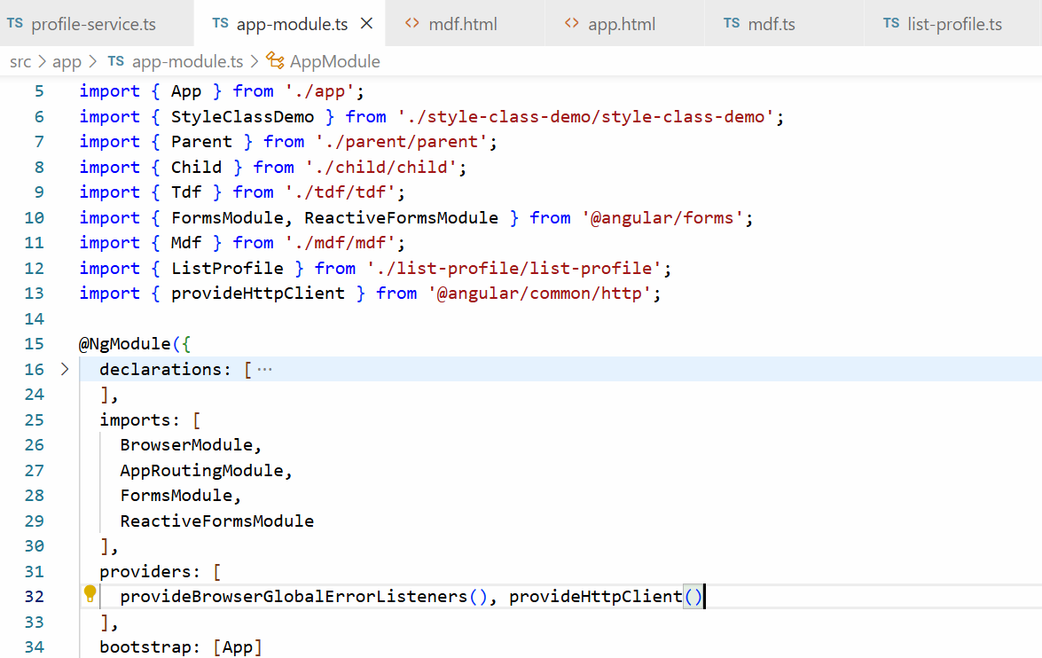
In the Angular Service use HttpClient object & Make HTTP calls
profile-service.ts
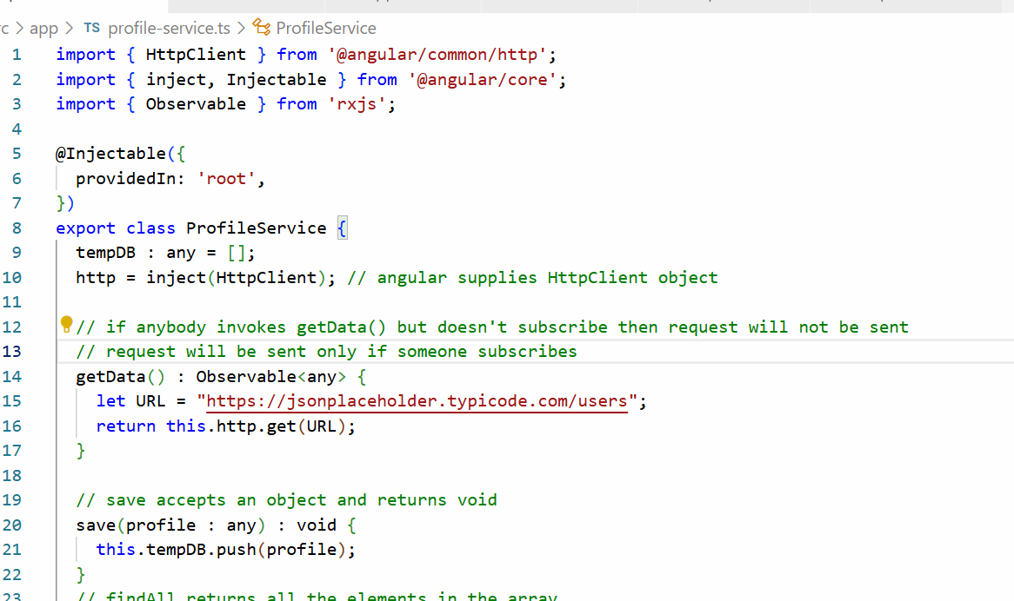
Subscribing to the Observable
subscribe(obj): subscribe sends a request to the resource and accepts an object with 3 properties
obj : { next : (v) => {}, error : (v) => {}, complete: () => {})
list-profiles.ts
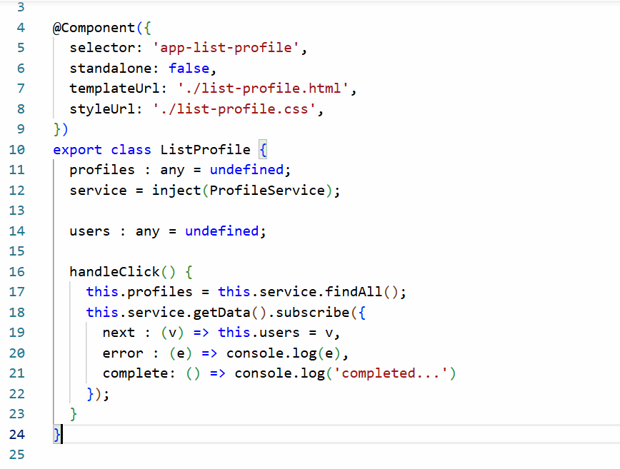
List all the users
list-profile.html
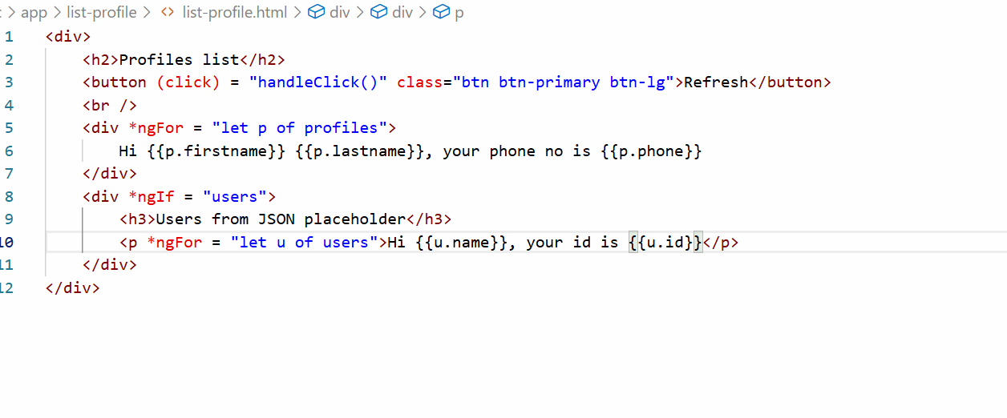
Output:
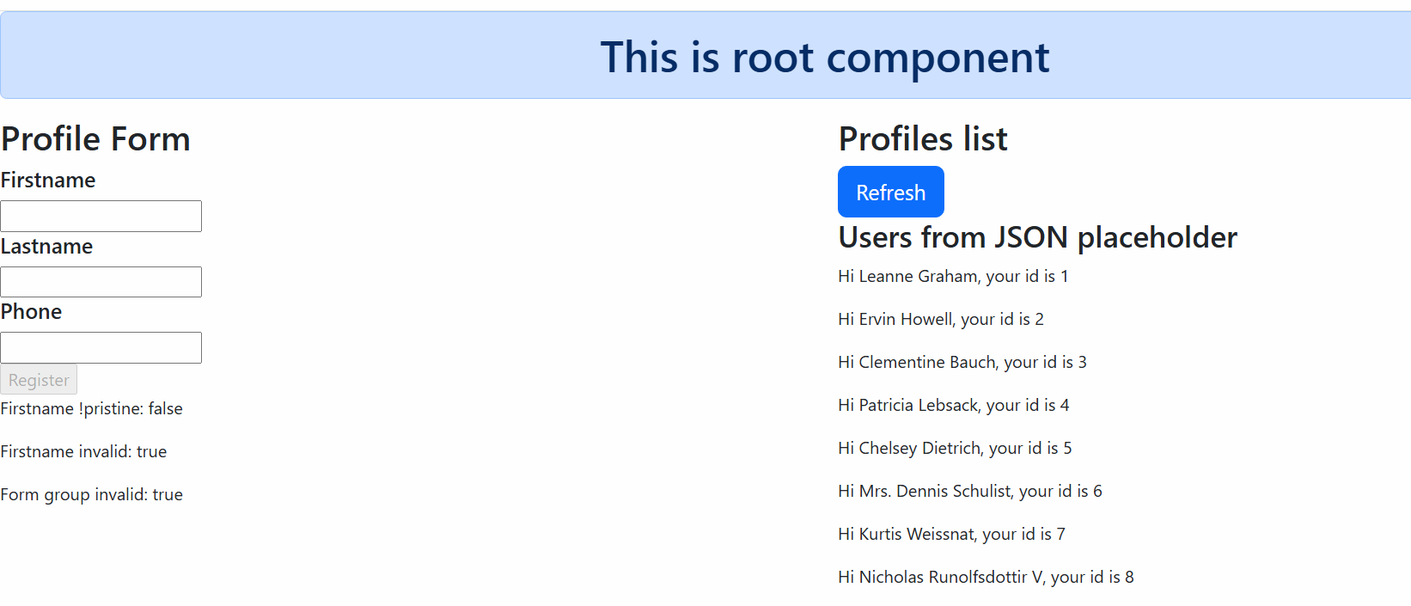
We have tried only get(URL) method from HttpClient but there are other methods in HttpClient like post(), put() and delete() they take more than one parameters but they all return Observable
- post(URL, data)
- put(URL, data)
- delete(URL, data)
Since get(URL) doesn’t accept request body it takes only one parameter

Session 16
14-12-2025

Flow of component to service to backend service
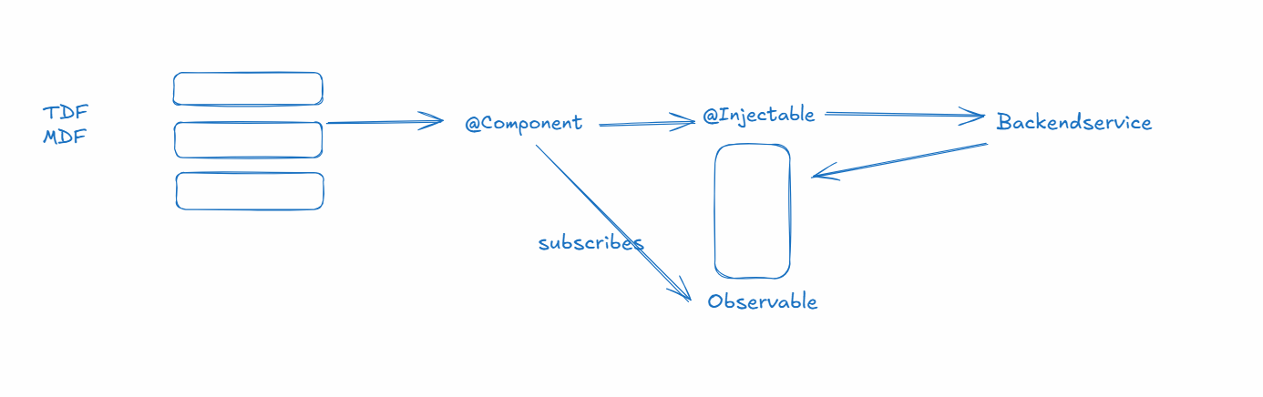

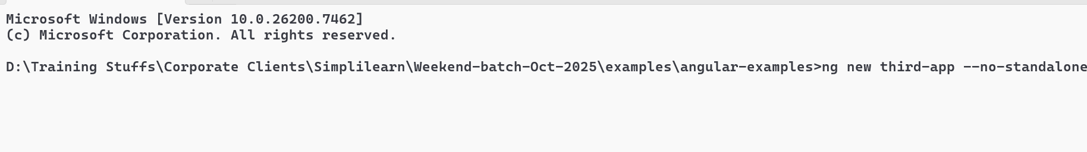

Angular Routers
It allows you to create a single page that can navigate from one component to another component without reloading the entire page, it uses a placeholder that can add components dynamically
router-outlet: It is a selector angular provides to load components dynamically.
Angular Router uses one of the file called app-routing-module.ts that has a routes variable which will have path & component configuration
routes : Routes = [
{ path = “login”, component : Login}, { path = “register”, component: Register},
{path = “search”, component : Search }
];
app.html
<a routerLink = “login”>Sign in</a>
<a routerLink = “register”>Create</a>
<a routerLink = “search”>Find</a>
<router-outlet></router-outlet>

Create 3 components
- login
- register
- search
configure the path for the components in app-routing-module.ts
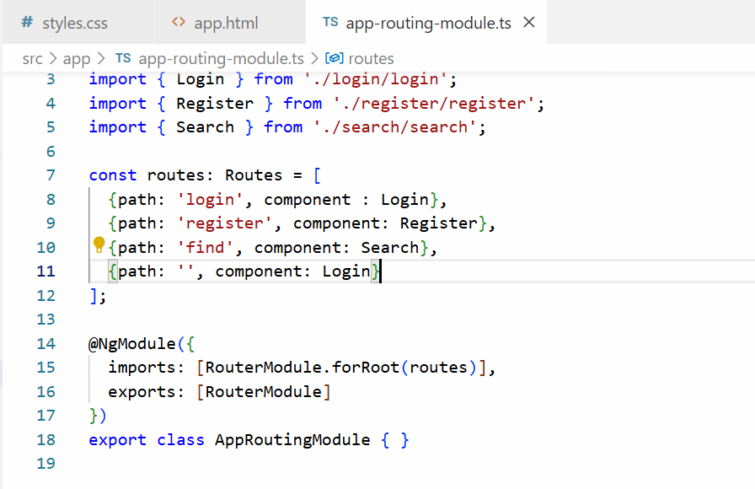
Use <router-outlet> and routerLink in the component to add in-app navigation in the root component
app.html
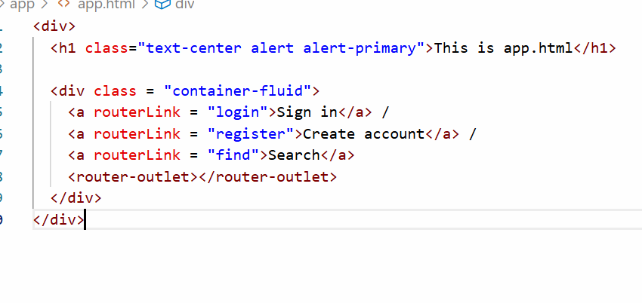
Output:
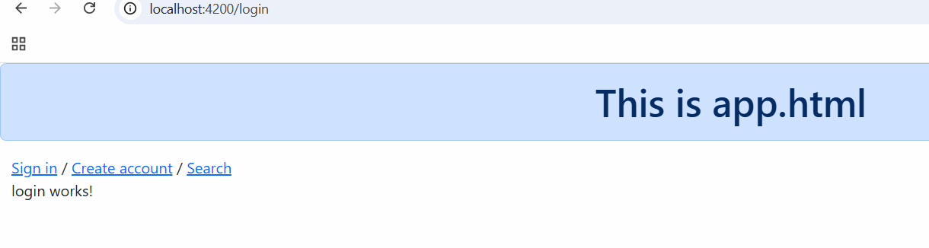
Activity: use Model driven form that creates Login Form, Registration Form and Search Form in the components Login, Register & Search, Apply bootstrap css to them to make them look good.
Note: When you submit any form just alert some message
Solution:
Add FormsModule & ReactiveFormsModule in app-module.ts
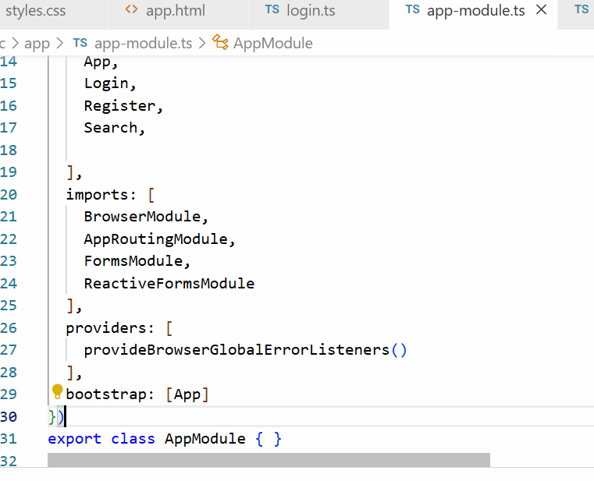
login.ts will have form group and form control and a function to print the username
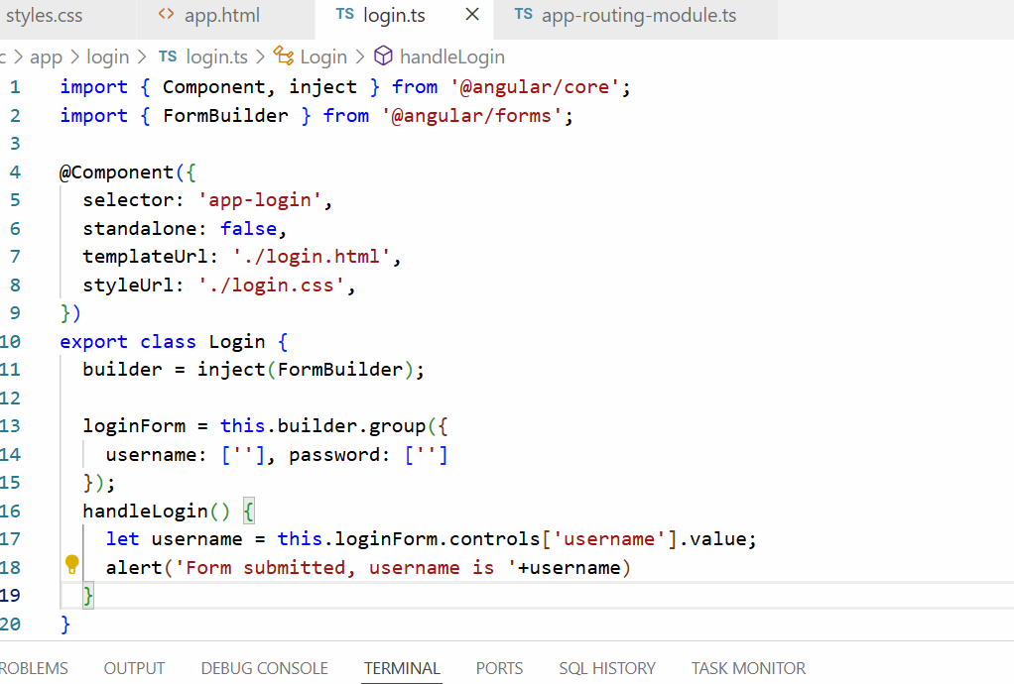
login.html
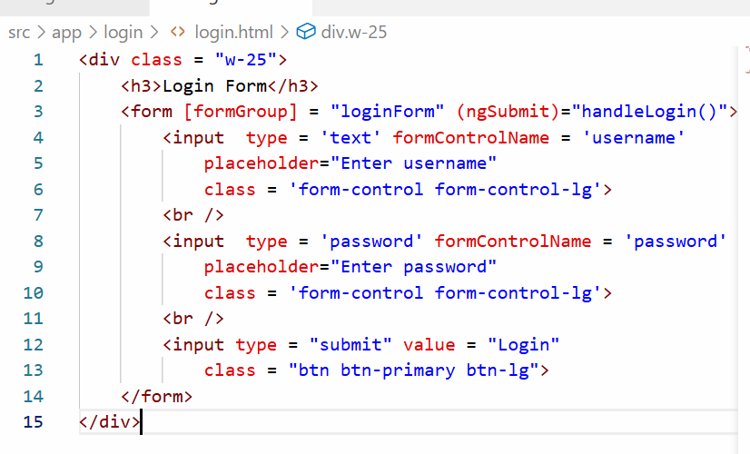
Output:
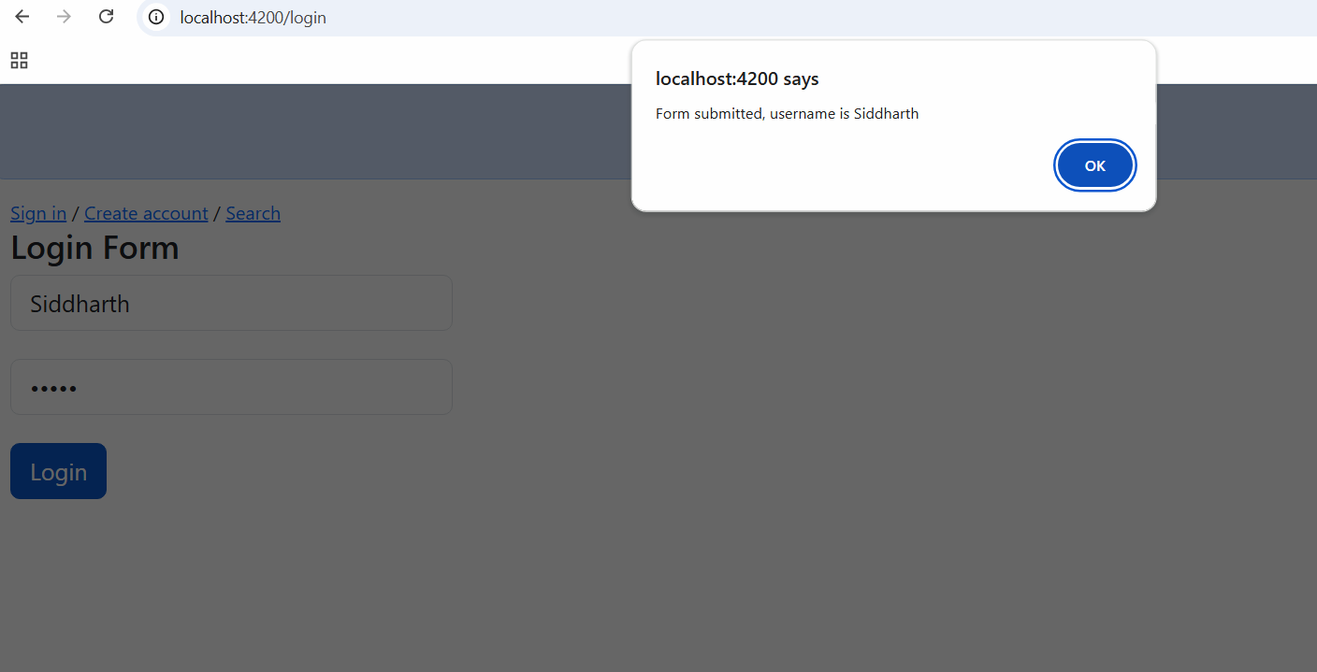
Child routing or nested routing
Child routes allow you to nest routes inside another route

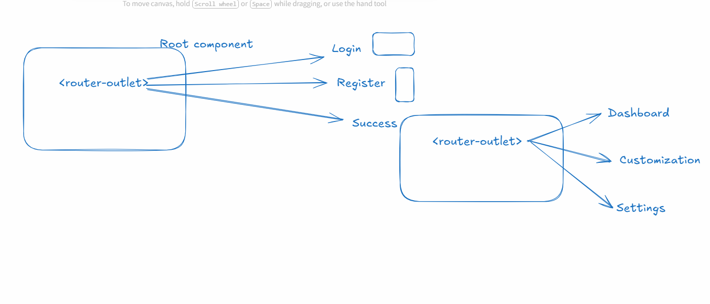
When it comes to navigating from one component to another component angular provides two types of navigation
- routerLink: <a routerLink = “url”>LinkName</a>
- Router object: It has a navigate([“url”]); method - this is used inside the code when the application wants to decide the navigation based on some condition
You just need to tell angular to inject the Router object using the following code
router = inject(Router);
To create the routes for the following diagram
We need to use <router-outlet> that can navigate to 3 different components in Root component & success will have <router-outlet> that can navigate to other components, but those components are part of <router-outlet> inside success, not inside Root component
app.html
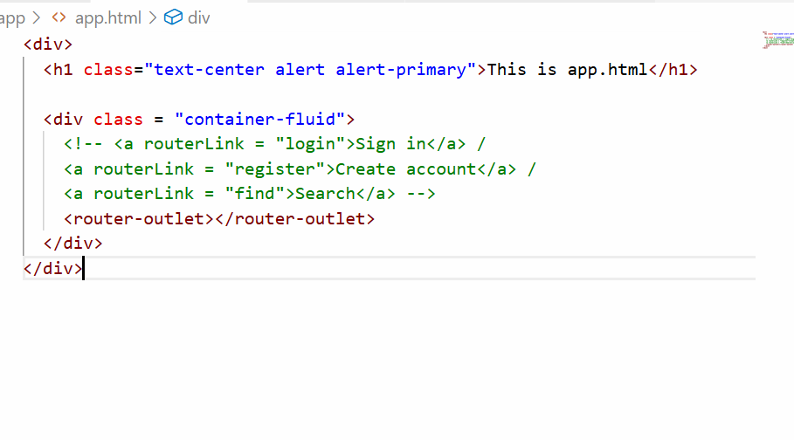
Components required
- login
- register
- success
- search
- dashboard
- settings
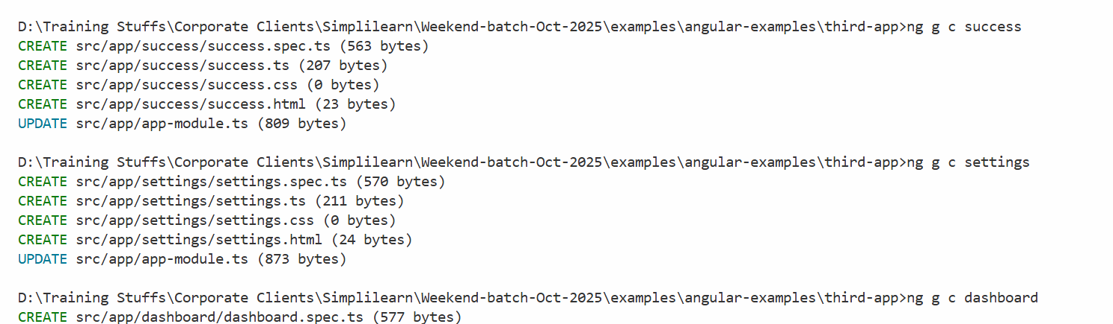
Child routing is configured with children property
{path : ‘success/:user’, component : Success, children : [ {…}, {…} ] }
We need to configure the routes once again to have child routes in the app-routing-module.ts
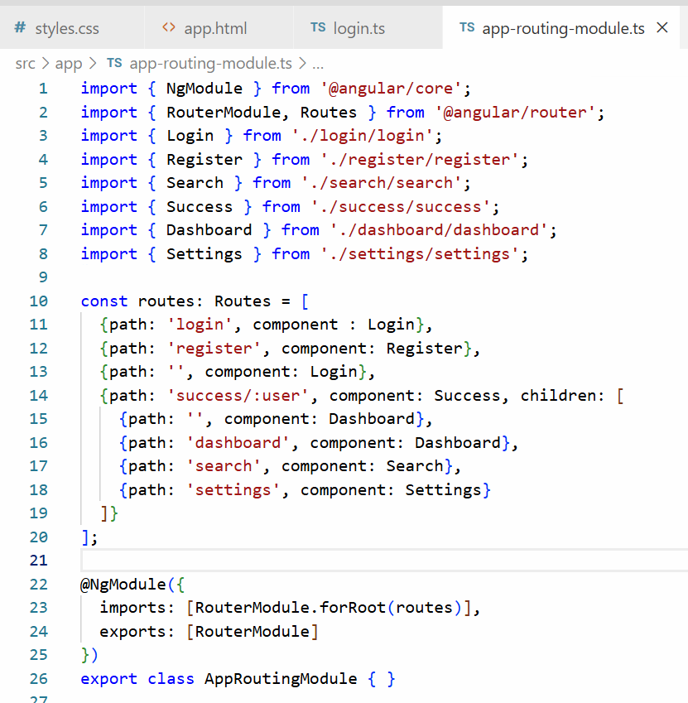
What success/:user does is it is a dynamic path, where user is a path parameter and can accept various values, it matches like success/Kishor, success/Atharv, success/Siddharth and so on, the user is parameter that holds value like Kishor, Atharv, Siddharth when the success components loads, so that you can read those parameters
What login component does
router = inject(Router)
username = usernameValue
if(valid) router.navigate([“success”, username]); success/username
else router.navigate([“/login”])
What success component does
active = inject(ActivatedRoute)
ActivatedRoute can read route parameter like success/:user, that :user value it can read using some built-in functions
active.params.subscribe(obj) -> returns the value associated with :user
login.ts
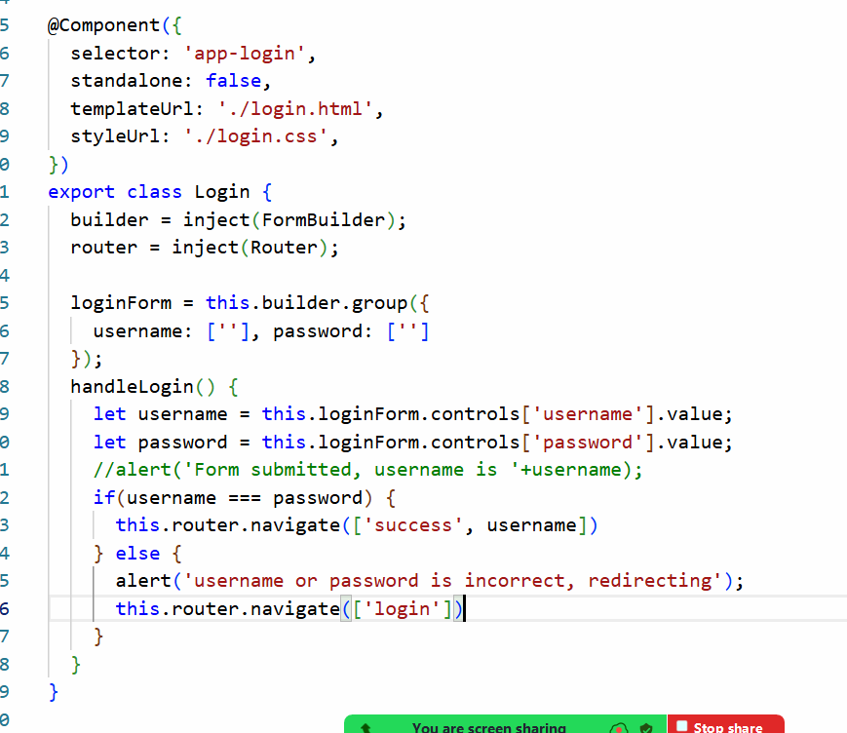
success.ts
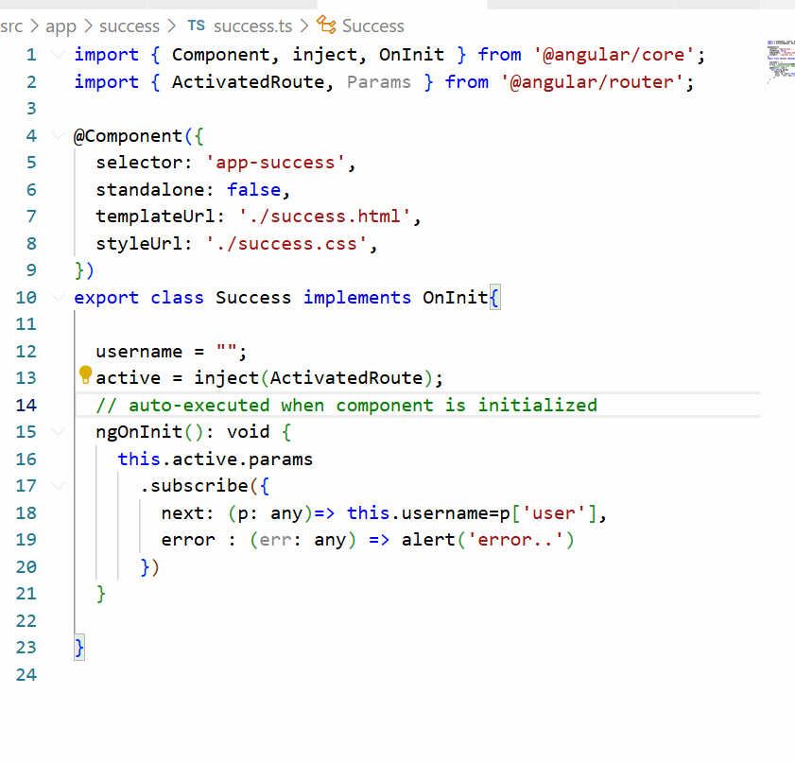
success.html
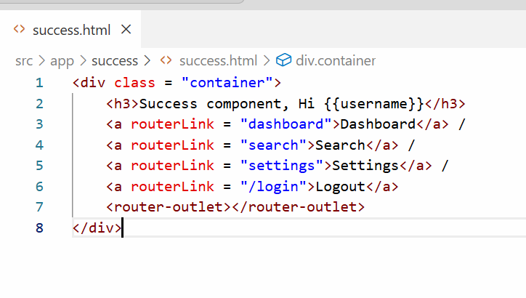
Output:
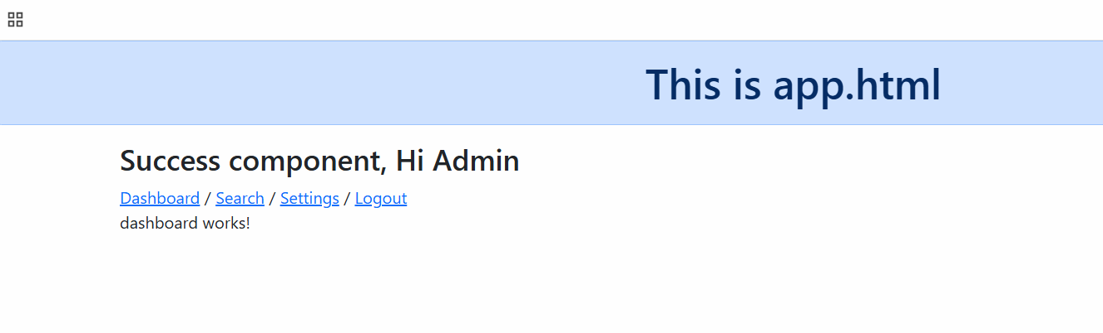Session 17
20-12-2025
The above application let you navigate to child routes even if you have not logged in, which means after logging out you are still able to route to the child components that must be restricted.
Authentication Guards
These are guards which behind the scene invoke some methods and lets you to navigate to the child route or block to navigate to the child route
In these methods you must write the logic to verify the user has logged in or not
In Angular you can create authentication guards using ng generate guard <<auth-name>>
Summary:
Authentication guards prevent unauthenticated users from accessing protected pages, it actually protects routing to the pages like
- inbox
- dashboard
- profile
- admin pages and etc.
Authentication guard uses a guard name called CanActivate which allows / denies route access
ex:
{ path : “success/:user”, component : Success, canActivate : [CanActivateImpl] children : [ { … }, { .. }, { … } ] }
Note: CanActivateImpl is just a class/variable that implements CanActivate interface, you need to create that class using below command
Command to generate the canActivateImpl is ng generate guard <<guard-name>>
The command you can enter is
ng generate guard <<name>> --implements CanActivate
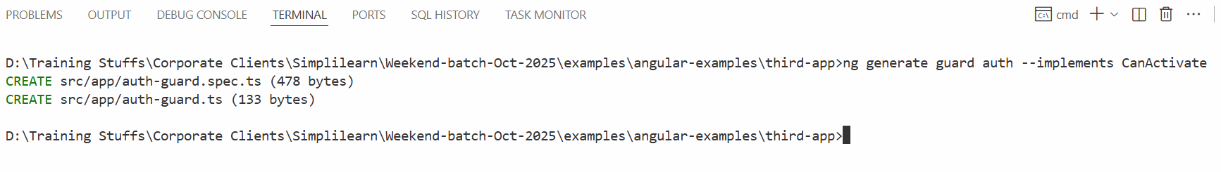

app-routing-module.ts
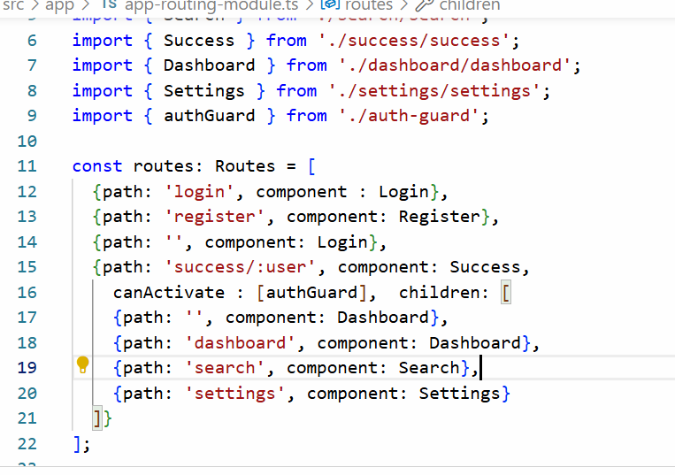
auth-guard.ts
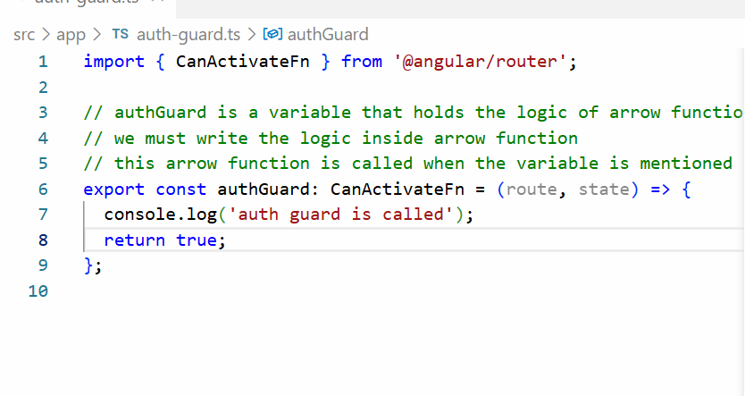
Output
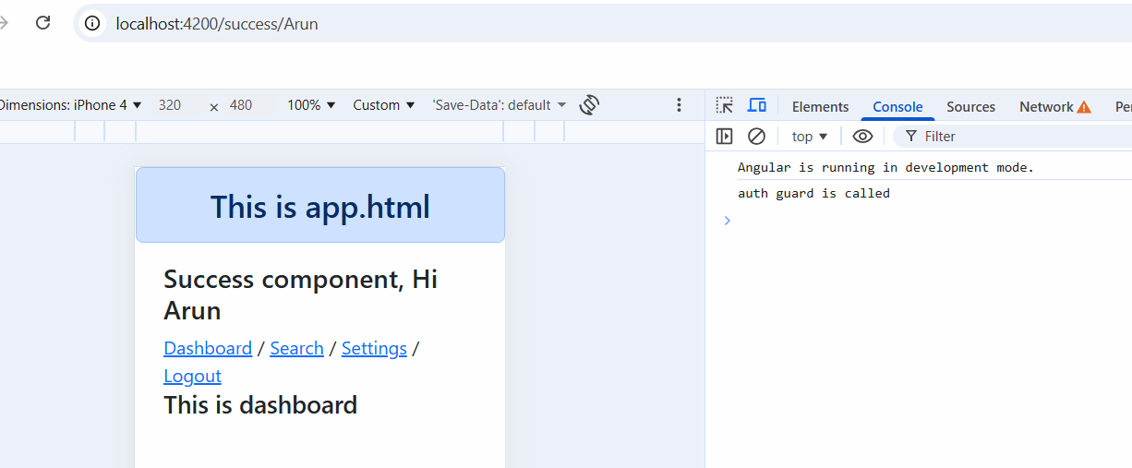
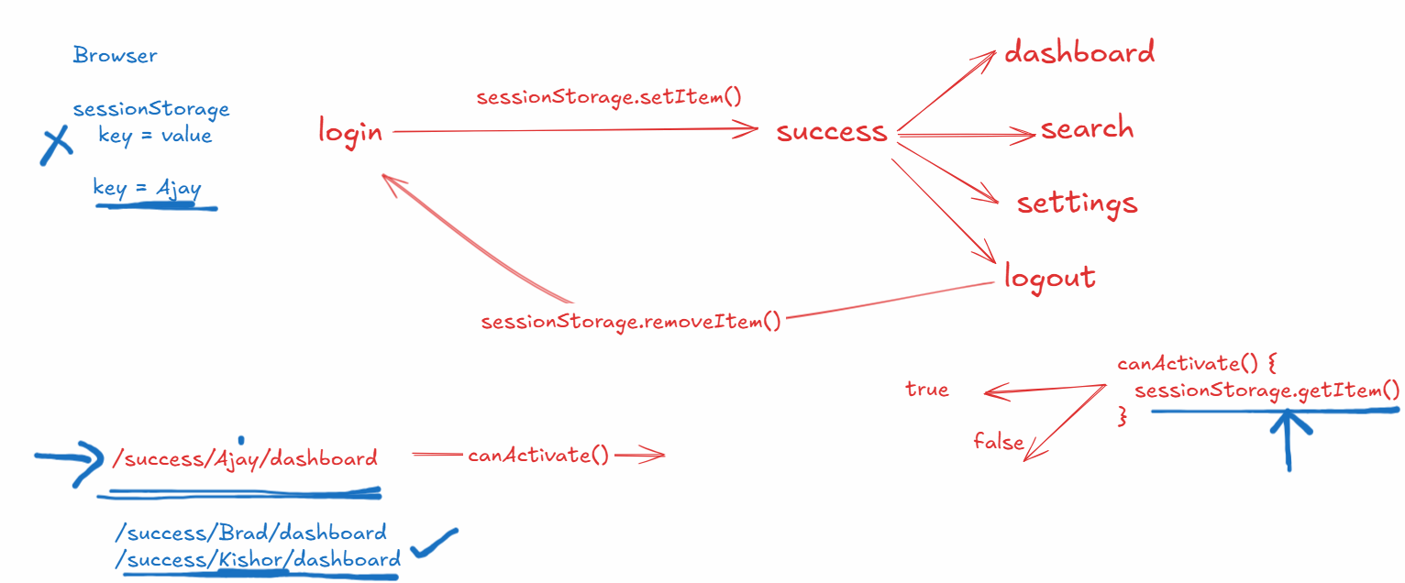

In certain applications user session are stored in the browser, in such cases user can still access certain pages without entering the username or password because the session is not closed yet, however in secured applications like bank sites, the moment user close the browser session data will automatically terminated, in that case user can’t enter to certain pages without logging in
How to store the data in a browser
sessionStorage is a Javascript object that has methods like
- setItem(“key”, “value”)
- getItem(“key”)
- removeItem(“key)
When username & password is valid you can setItem()
When user logout you can removeItem()
When user navigates to the page that needs authentication then you can use getItem()

Store the user who has logged in with a key in login.ts
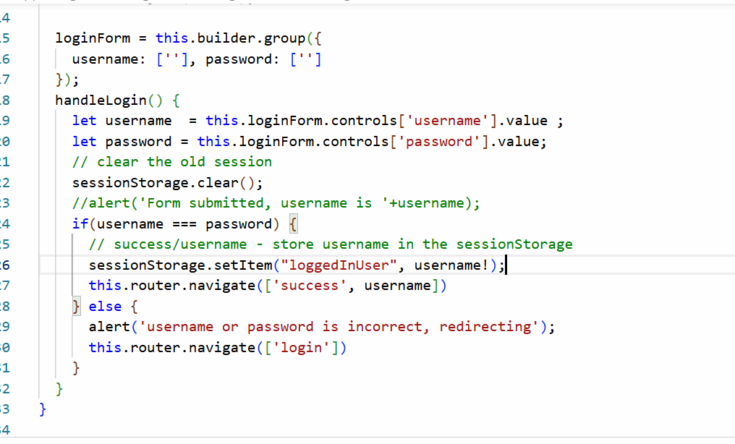
verify if the user has logged in or not in the auth.guard.ts
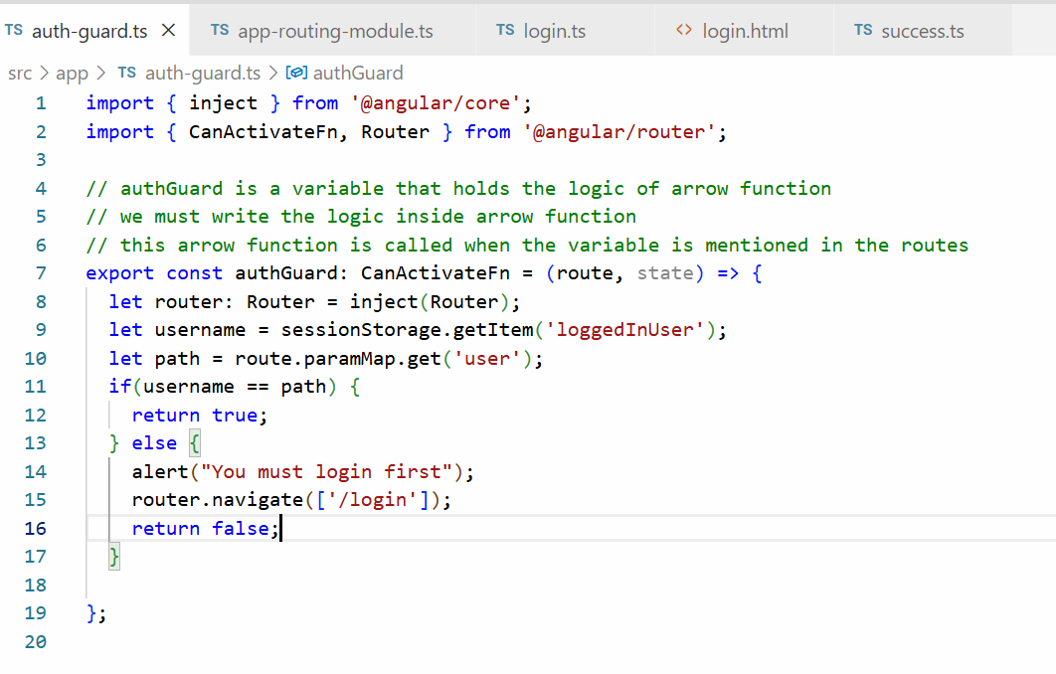
Output:
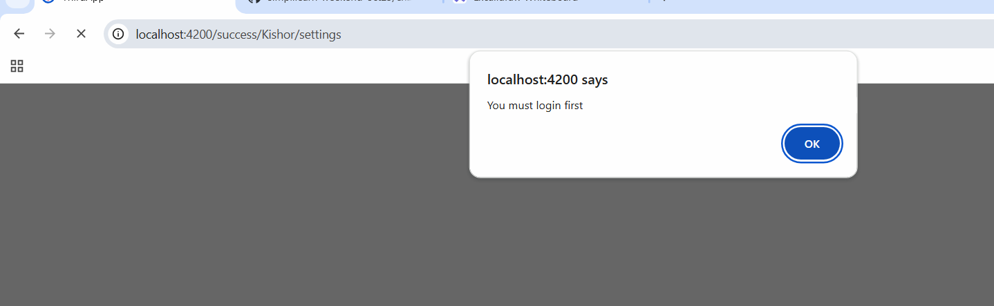

Summary of Angular framework
- Angular creates SPA
- Building blocks of angular - components, services, data binding, pipes, directives
- Databinding - Interpolation, Property binding, Event binding, Two way databinding
- @Input() & Output()
- FormsModule, ReactiveFormsModule
- Services - @Injectable()
- HttpClient - provideHttpClient()
- HttpClient verbs like get, post, put & delete return Observables
- Router, Routes, ActivatedRoute, routerLink, router-outlet
React.js
React.js is a library developed by facebook to create rich UI’s just like angular, but React doesn’t have any design principles like angular
Whatever UI you create in Angular, you can create with React.js as well, however React.js enables developers to freely use other libraries in it.
React is a flexible UI library and you can quickly create front end application
Angular is a complete framework for large, structured applications.
React.js you can use when the websites UI often changes due to customer demand like social media apps, food delivery apps
Angular Framework is like already defined structure, you can use it when the changes are not too much, like banking apps, health sector applications
Since React.js is a library you don’t get all the features, you need to download them as a library ex: routers, http libraries
Software’s required
- Node.js - npm & node
- VS Code
- Create React App tool kit - npx create-react-app <<app-name>>
How to create our first react application
- npx create-react-app my-app
In React.js you can create components using a function followed by the name, but the component name must be in upper case
React.js uses 2 technologies
- HTML
- JSX (Javascript XML): This helps to write HTML inside Javascript in a simple way
App.js
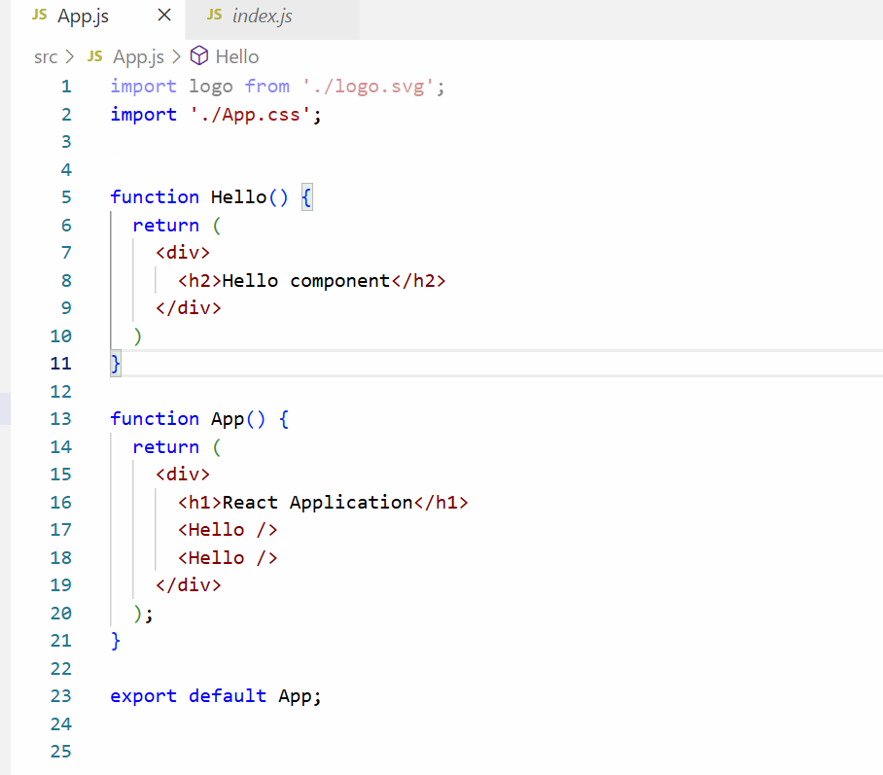
Session 18
21-12-2025
In React.js you can display the variable using {expression}
You can share the data from one component to another component using props
props: These are data a component shares to another component, the component function would use props as a parameter to accept the data from another component
function Hello(props) {
{props.property}
}
App.js
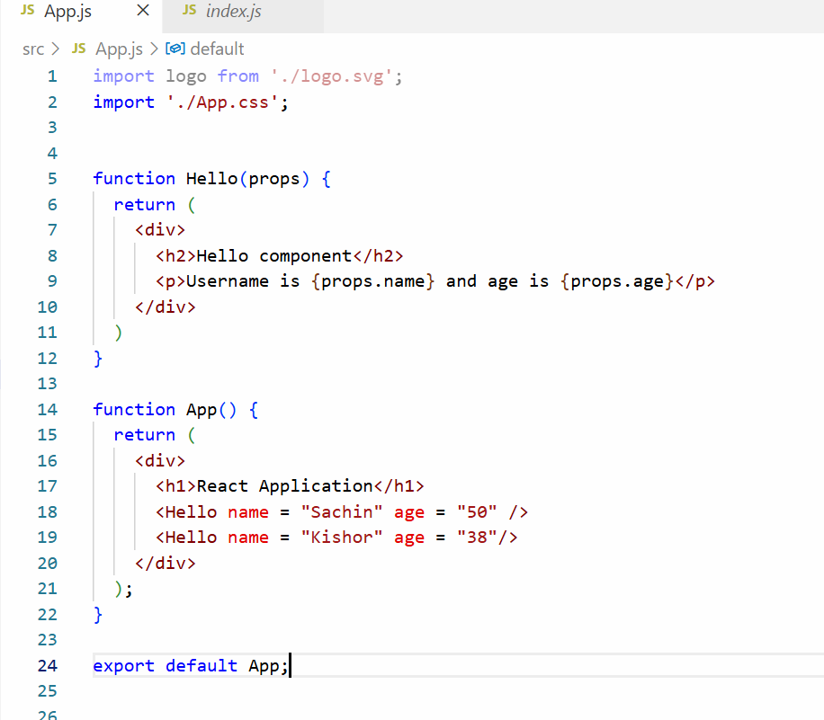
Output:
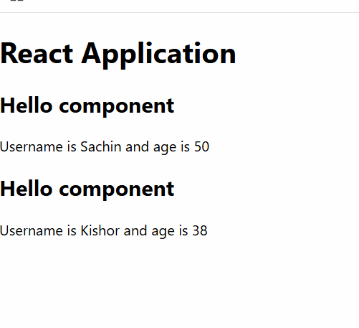
Sharing a dynamic data & complex object to a component from another component
let userName = “Alex”;
let userAge = 35;
<Hello name = {userName} age = {userAge} />
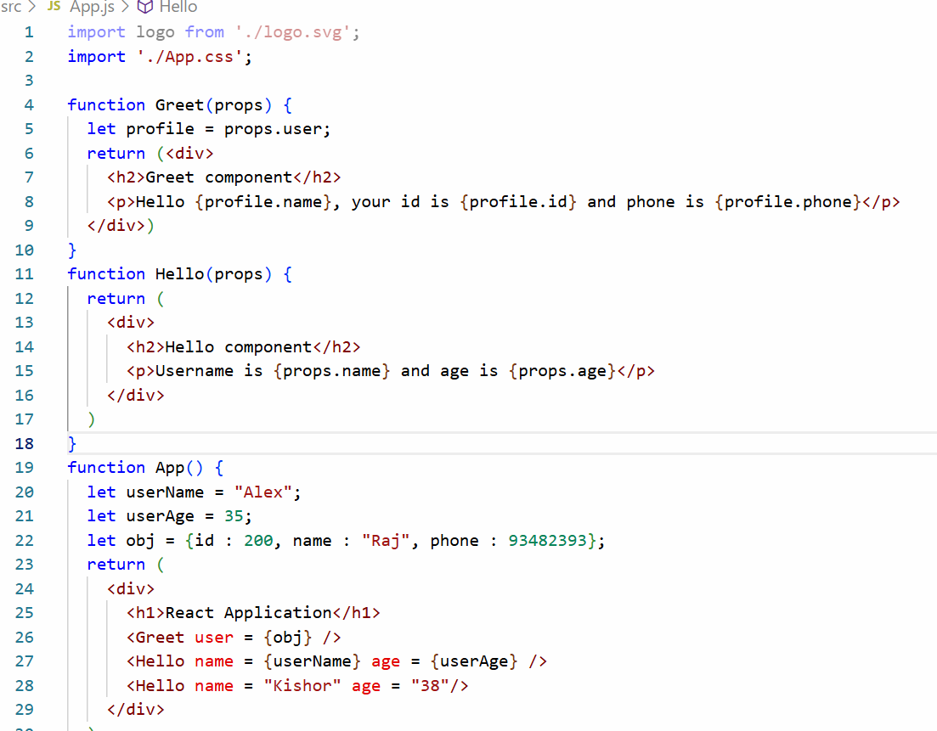
Output:
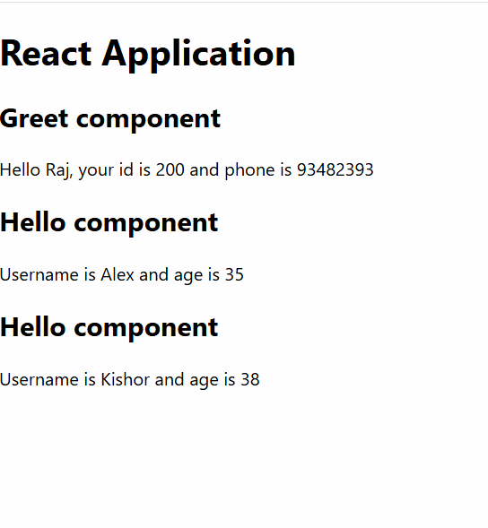
How to create components outside the App.js and import them
Greet.js
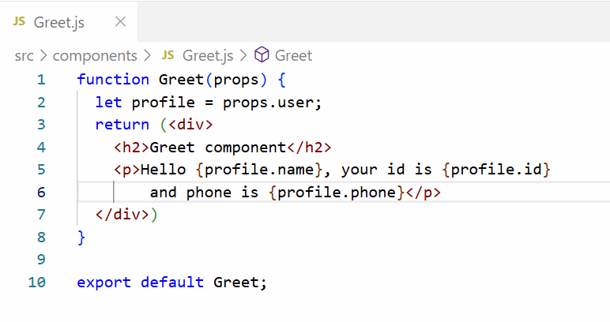
Hello.js
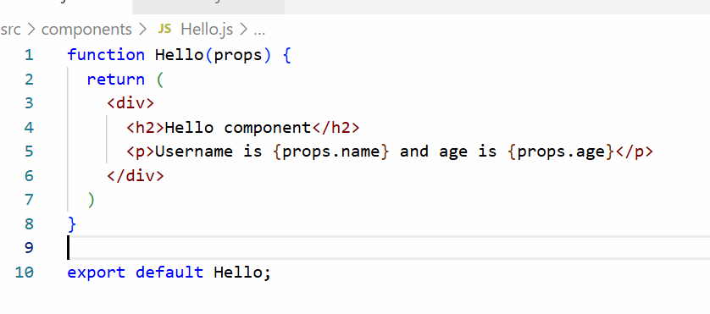
App.js
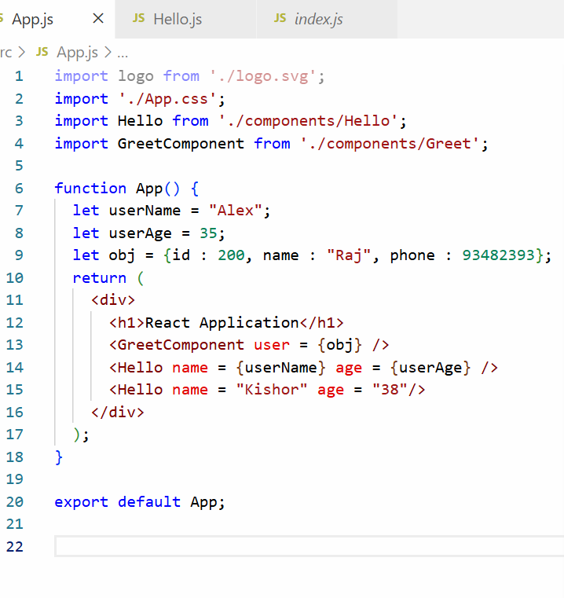
Output:
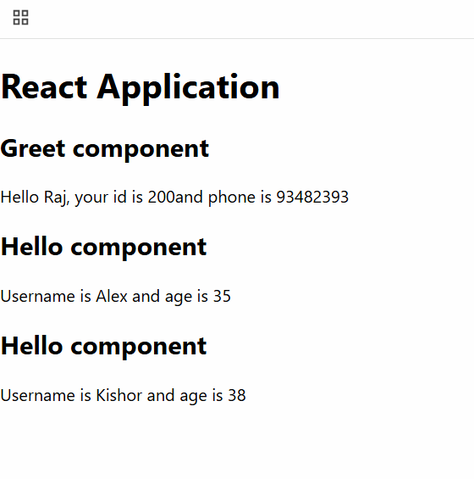
Props Destructuring
let { id, name, phone } = user;
Props Destructuring is nothing but Javascript object Destructuring, which simplifies accessing the object properties without extra line to assign values
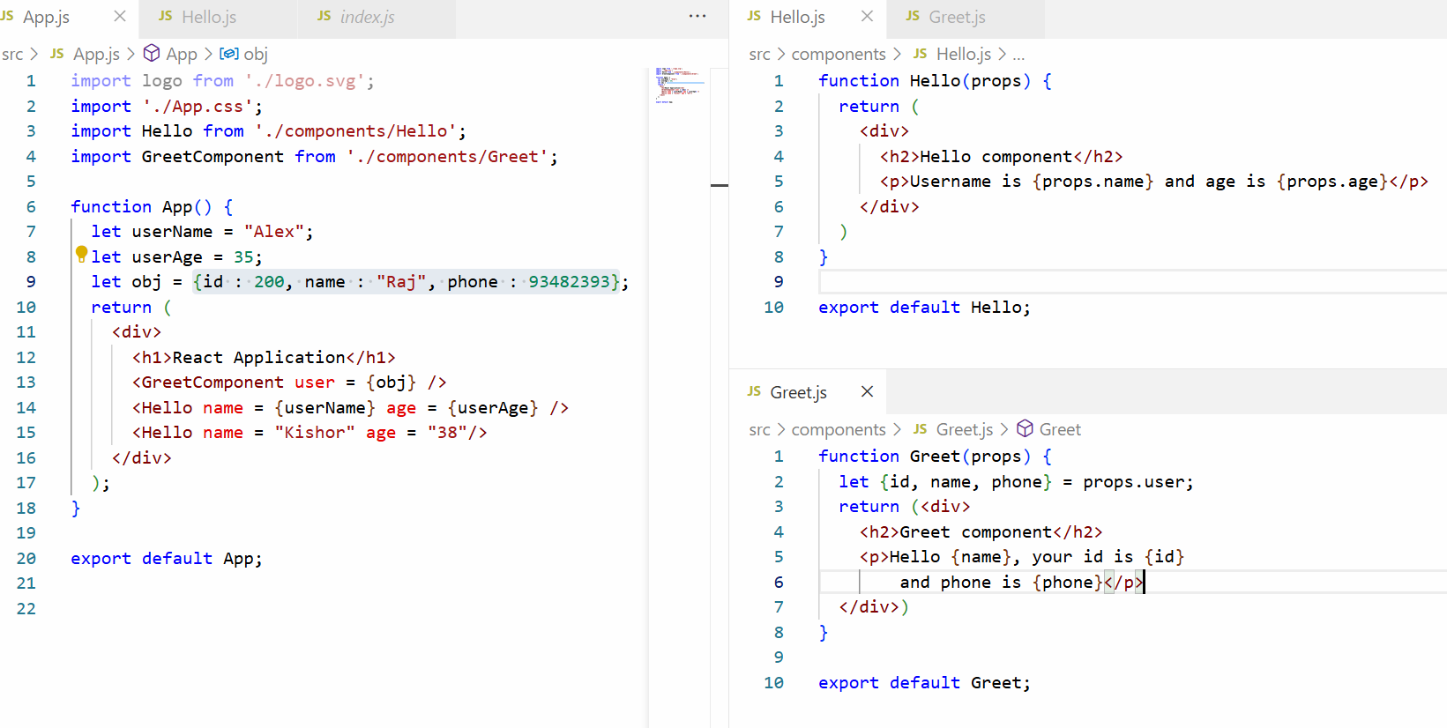
Output:
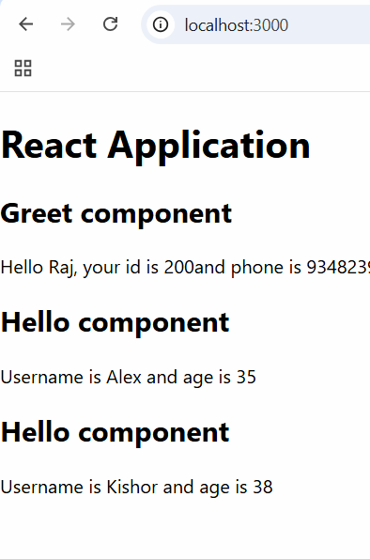
Activity: Use multiple child components that is nesting a child with another child component and display profile, image and comments

How to add bootstrap in React.js
npm i bootstrap
Note: In React.js you must use className to apply css classes, because class is a keyword in Javascript
index.css
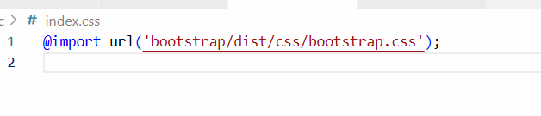
List & Keys
In React.js you can iterating the arrays which are lists and each iterated elements must have an unique id, hence you must use key attribute while iterating
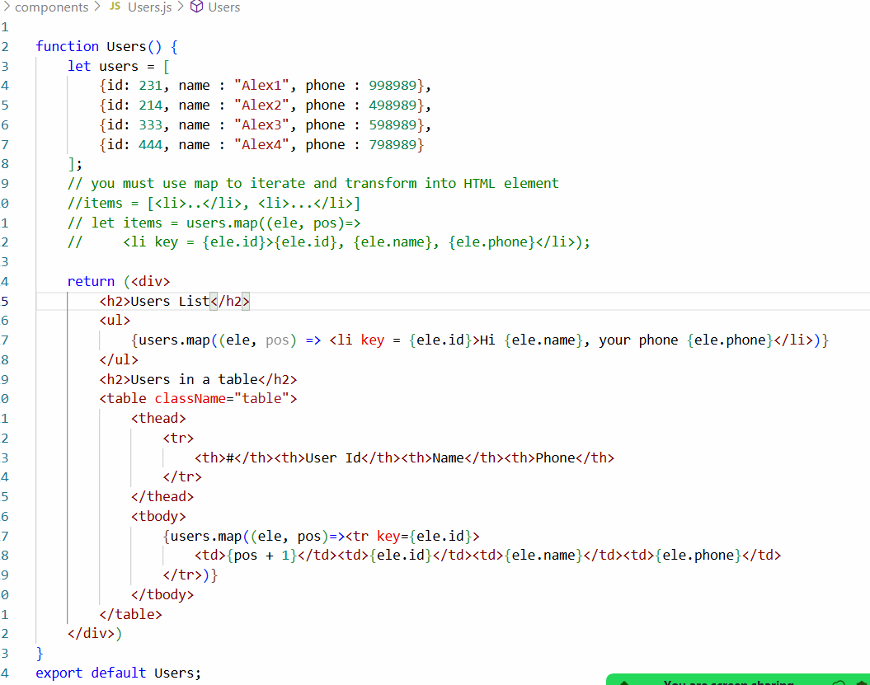
App.js
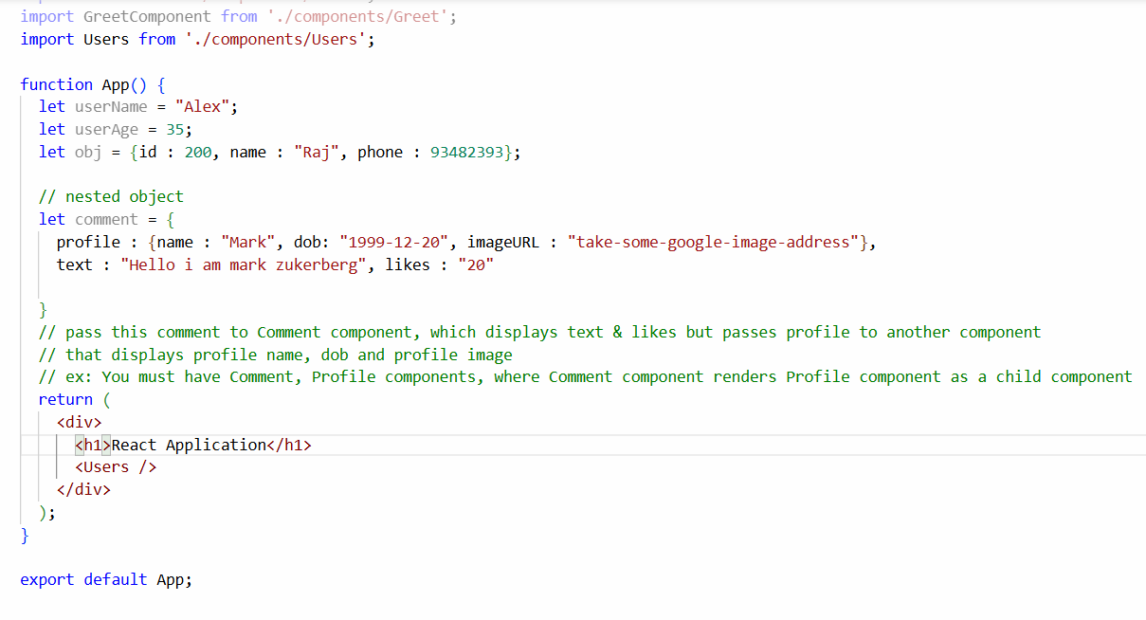
Output:
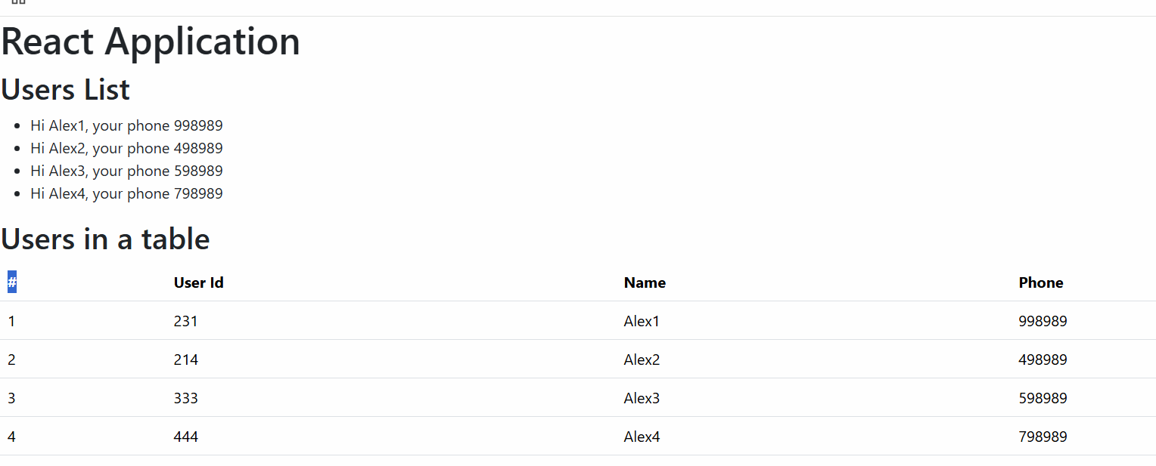

Session 19
10/01/2026
Interview Questions on Angular

- Difference between Angular JS & Angular Framework
Angular JS | Angular Framework
Javascript | Typescript
Slower | Faster & Optimized
Deprecated | Active
MVC | Component based

- Building blocks of Angular?
  - Components
  - Templates
  - Directives
  - Services
  - Pipes
  - Dependency Injection
  - Modules
- What is a Component?
  - It is a UI which users sees, it consist of Typescript class, HTML template & CSS files
- What is a module?
  - It’s a logical container that groups related components, services, pipes
ex: NgModule
- What is data-binding?
  - It connects component data & template
  - interpolation, property binding, event binding, two way data binding
- What is dependency injection
  - A design pattern where dependencies are injected rather than created
- What are services & why are they used
  - Services are classes that will have reusable logics, components can invoke the services to reuse these logics, they are mainly used to share business logics across the components
- What @Input() & @Output decorator does
  - It is mainly used for component to component communication, @Input() is to share data from parent to child & @Ouptut() is to share data from child to parent.
- What are routers in angular
  - These are modules that help to navigate from one component to another component
- What are the types of forms angular supports and their differences
  - Template Driven & Reactive Forms
  - Template Driven are for simple forms, they have less control & HTML based
  - Reactive forms are for complex forms, they have more control & Typescript based
- Rxjs Observables vs Promise
  - Observables: They can consume multiple values & are cancelable
  - Promises: They can accept single value, not cancelable
- What is HttpClient
  - They are services used to make HTTP requests using http methods like GET, POST, PUT & DELETE
- Router vs ActivatedRoute
  - Router is used for programmatic navigation
  - ActivatedRoute: Access route parameters
- How to create input validators in the forms
  - We have build int validators in the form builder that helps to create validators like FormBuilder.group({ username : [“”, Validators.required, Validators.maxLength(10)})
- What are route guards?
  - They are used to control access to routes based on authentication or authorization conditions like login status or user role), this is to prevent unauthorized access or accessing a route without logging in.
- What are pipes in angular?
  - It is used to transform data in the template before displaying it to the user
- Will pipe change the original data ?
  - No
Git Interview Questions
- What is Git?
  - It is distributed version control system used to track code changes, collaborate with teams.
- Git vs Git Hub?
  - Git is a version control tool
  - Git Hub is a cloud platform for hosting GIT repositories
- What is a repository?
  - A repository is a place where project files and their version history are stored
- git pull vs git fetch
  - git fetch downloads changes but does not merge
  - git pull = git fetch + git merge
- What is git commit
  - A commit saves a snapshot of changes in the repository with a message.
- What is a branch
  - A branch is an independent line of development
- What is git stash
  - Temporarily saves uncommitted changes without committing.
- Is it possible to undo a commit?
  - Yes
- How do you undo a commit
  - Soft reset: changes are not lost
  - Hard reset: changes are permanently lost
- What is .gitignore?
  - It specifies what not to track.
Javascript interview questions
- What is an arrow function
  - It is shorter syntax for a callback functions
- What is a promise
  - An object that represents the eventual completion or failure of an async operation.
- Promise vs async/await
  - Both are used to handle asynchronous operations, but async/await is a built on top of promise to make async code easier to read and maintain.

React.js contd.
Vite: A react community, you can use this to create a light weight react project
npm create vite@latest app-name --template react
Why vite?
It helps to create a light weight react project that can quickly run withing few milliseconds.
npm run dev: This is the command to launch the application.
src/components/Users.jsx
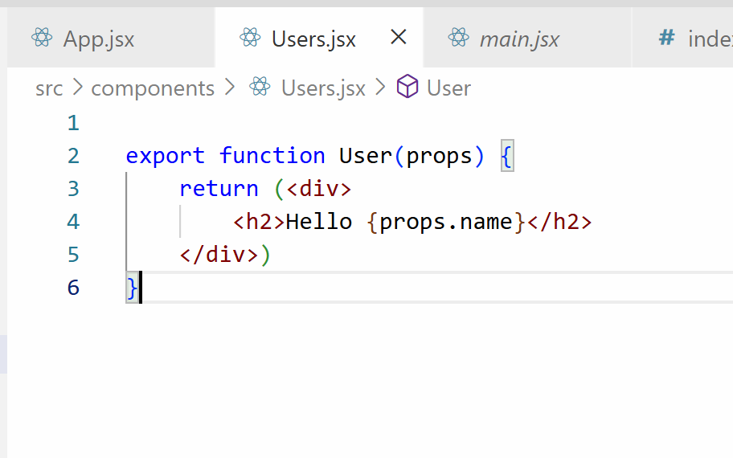
States: These are the data of the components which you can update, usually states are used when React components wants to handle form data or the data coming from the backend
States vs Props
Both are used to handle the data, props are read-only whereas states are writable.
In React you can create states using useState() hook functions, they are used with 2 properties one is to store the data and another is a function to update.
User.jsx
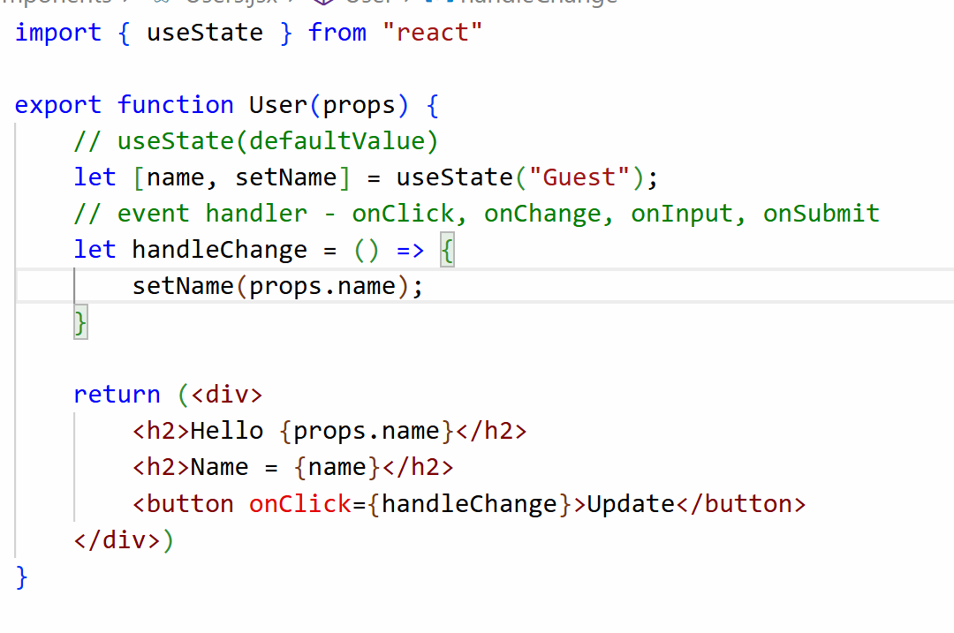

How to create form in react and read the form input
In react you can create forms with HTML input element and you need to handle each input using event handlers
event.target.value: This statement accesses the element that generated the event and the value associated with the element
You can use handlers in the same line where you mention the event name.

User.jsx
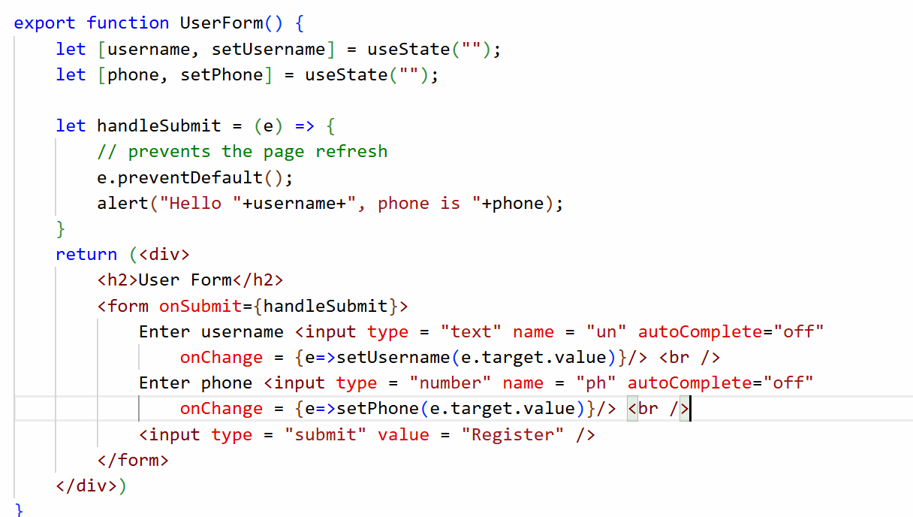
App.jsx
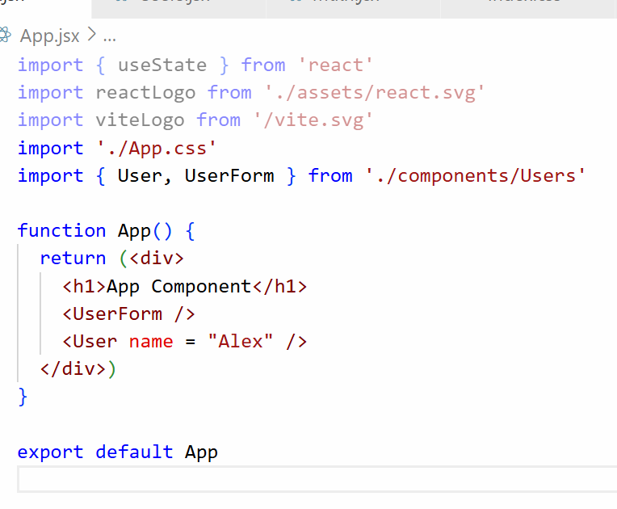
Output:
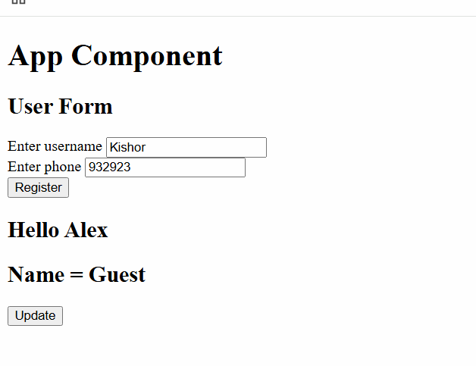
You can handle the form inputs by creating a reusable handler function but you need to use the input element name to update separate states.
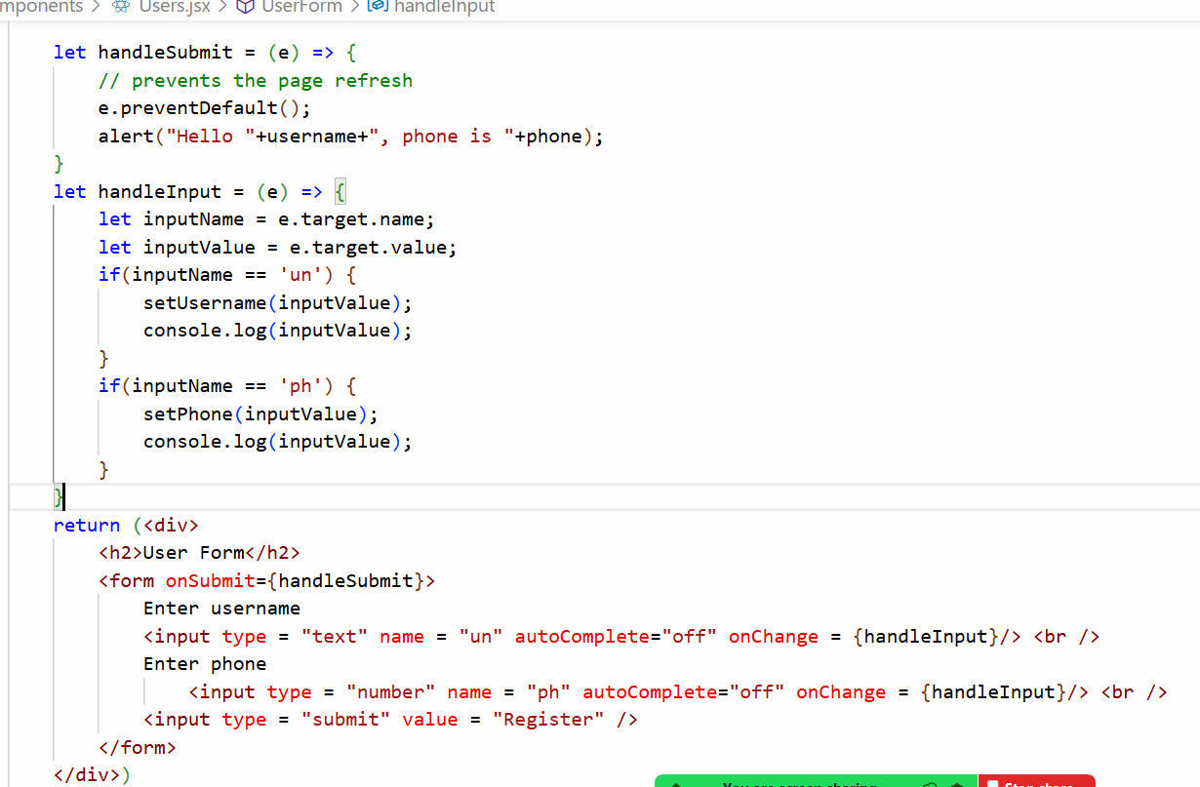
Output:
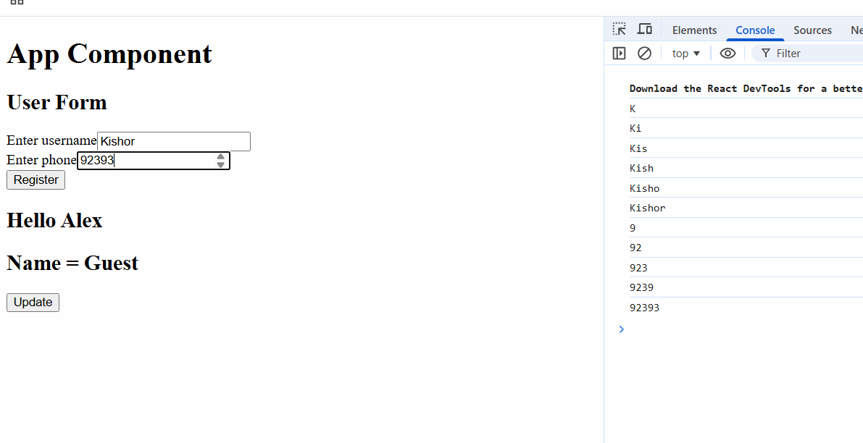
Try to clear the input boxes when you click on the submit button
Adding bootstrap.js and using them in the react components
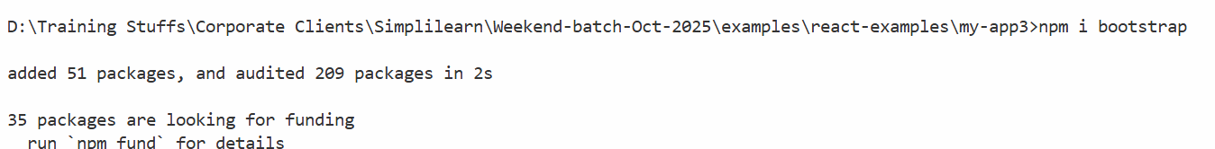
index.css
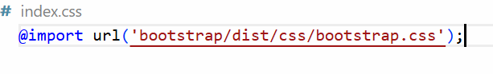
Use bootstrap classes in the form elements
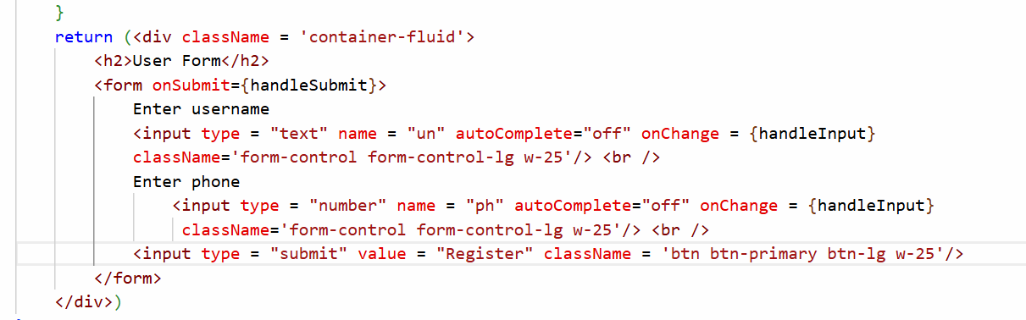

Axios library
It is used to make HTTP calls to the backend APIs with HTTP methods, it provides http methods like get(), post(), put() and delete()
npm install axios
The above command installs the axios library
App.jsx
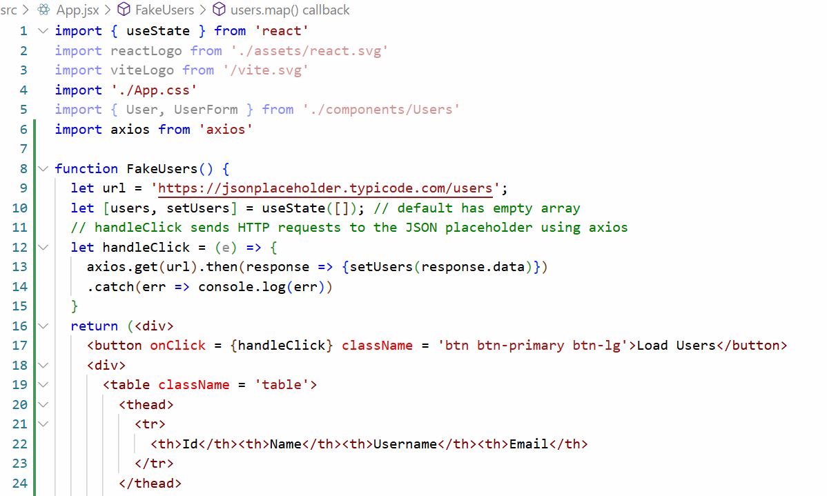
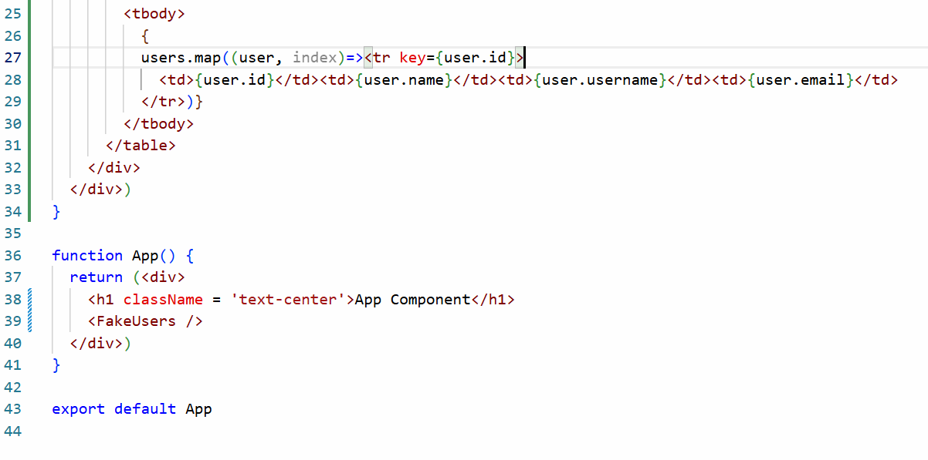
Output:
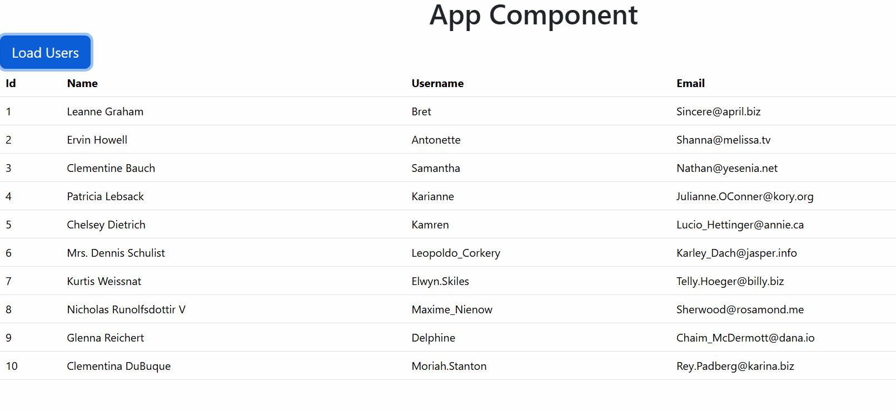
Activity:
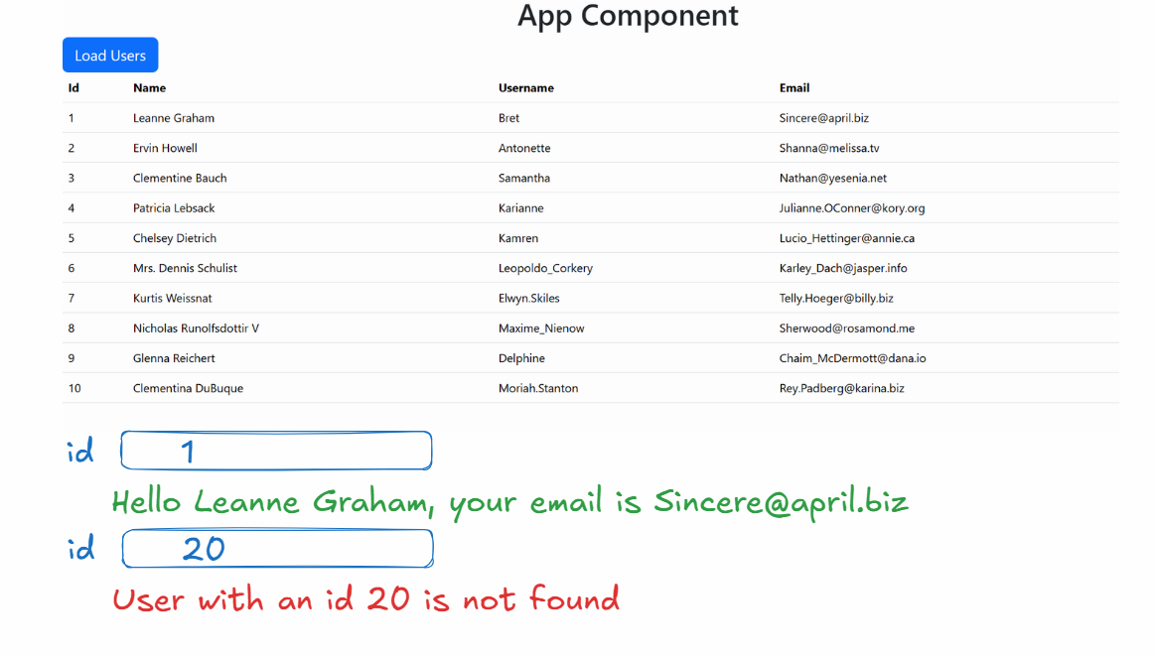
JSON Server: It is used to create back-end to test your front end applications, where you can perform all the HTTP operations like post, put, delete, get
npm install json-server
json-server db.json --watch
create db.json and store some data in the users key
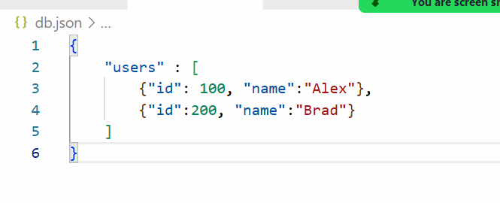
Activity:
- Create an input box that accepts id of the user and send a delete request using axios.delete(URL) -> this deletes the data in the json server
- Create an input box that accepts id and name of the user and send a put request using axios.put(URL, data) -> this updates the data in the json server
- Display all the users from json server in a component
Session 21
17-01-2026
Project session: We will create a react app with Vite where you can search the movies based on following criteria like name, title, ratings, genre and display the movie lists
Steps:
- create a json file and run with json-server
- Install axios, bootstrap in the project using npm install
- Create MovieSearch component and use that in the root component.
- In the MoiveSearch write the logic to search
movies.json
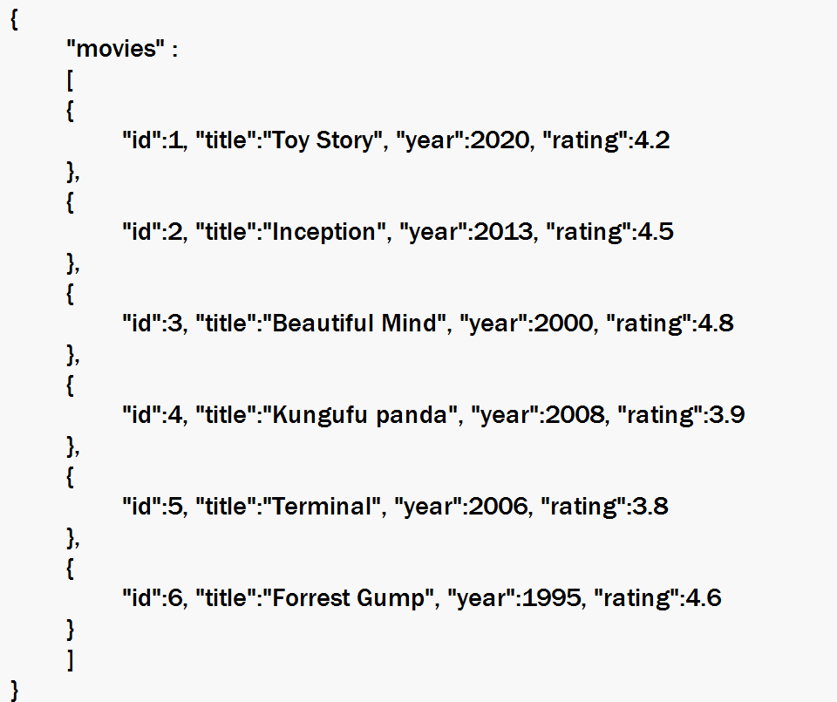
Run the json-server to serve this file from command prompt.
json-server movies.json --watch
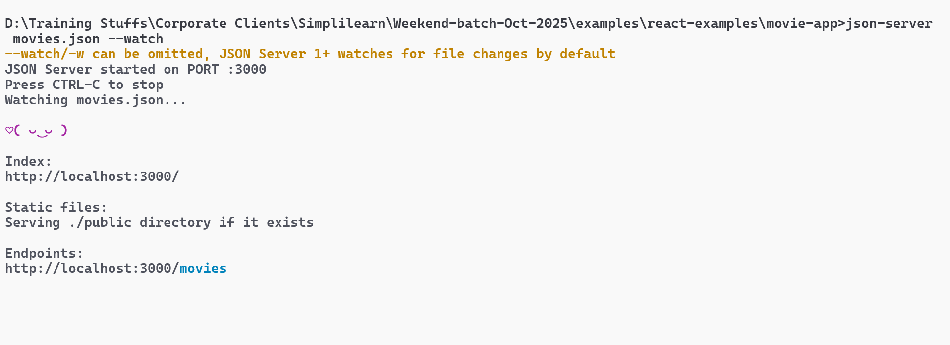
In the browser you can test few urls like
http://localhost:3000/movies?title=Inception
http://localhost:3000/movies?rating_gte=4.3
http://localhost:3000/movies?year_lte=2010
First we will search movies based on name or year
We will create a component with a search box that takes Enter year and Enter name and below the text box we can display all the movies matching to filter.
App.jsx
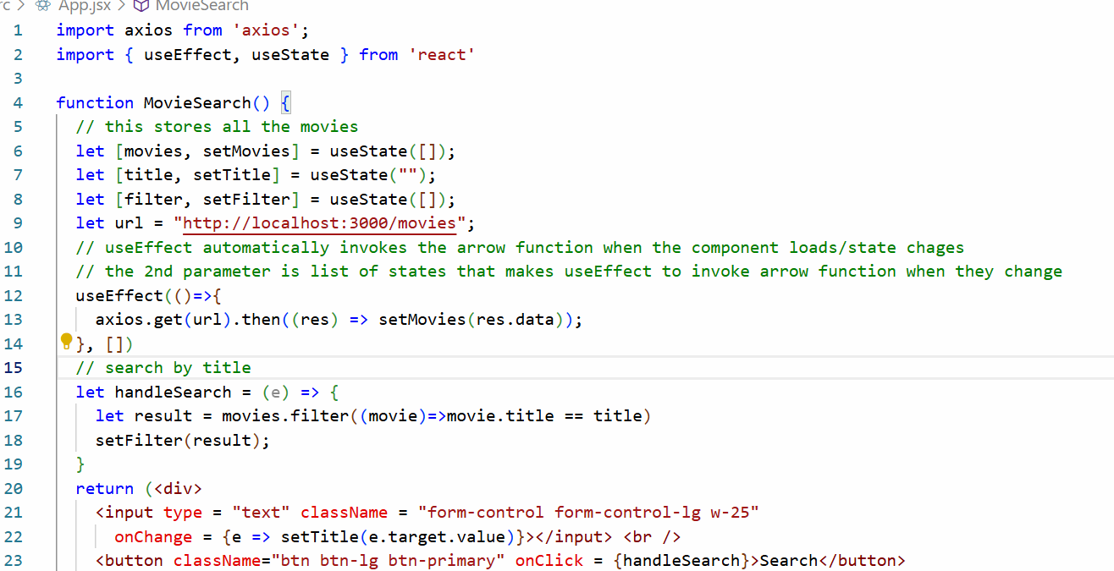
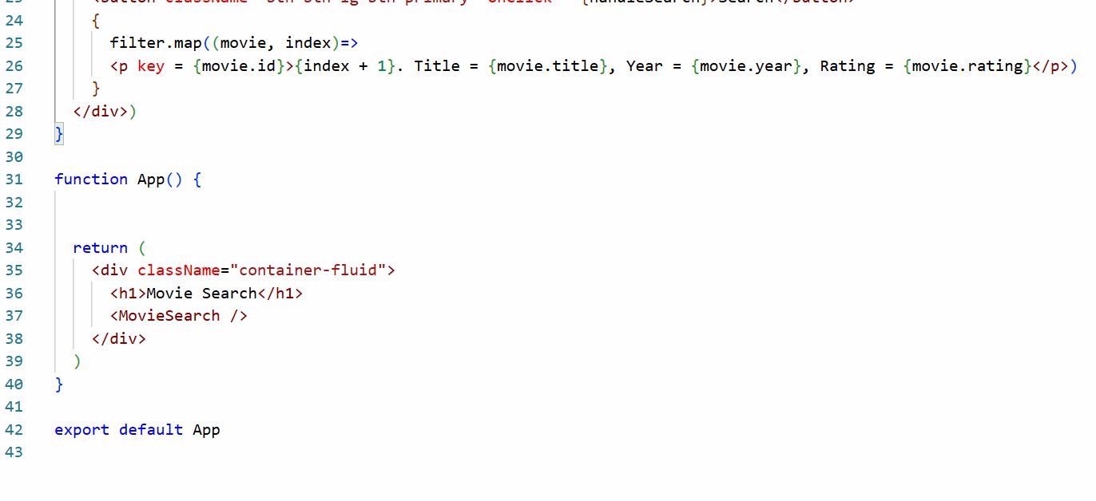
Activity:
Create 5 elements that will generate values from 1 to 5, which looks like *(star) [or] create a drop down from 1 to 5 and when you select any drop down list the movies that matches to greater than equal to the value should be displayed, you can use the search box to enter the title the movie

